**International Trade Data Analysis for the Impact of Brexit**



**Marios Menikou**

F133746

Department of Computer Science

Loughborough University

21COP328: MSc Data Science

Supervisor: Dr Yanning Yang

SEPTEMBER 2022

# Abstract

Brexit was one of the biggest changes in the economy of UK and EU. The aim of this study was to examine the international trades of both goods and services from the period before Brexit announced until today. In addition, analysis has been made in order to investigate any fluctuations and actual impacts of the UK trades during the announcements after Brexit referendum until it actually happened. A further step has been taken to predict the scenario that Brexit never happened and to predict the future of trades in UK after the Brexit. A descriptive analytical and trend analysis was conducted to understand better the impact of the UK’s international trades in goods and services. Moreover, a prediction model called ARIMA used to make the forecasts. The results of this study showed that overall, in all years the total exports from UK to EU and Non-EU countries were higher than the imports. The announcements before the Brexit affected the trades on goods and services mainly in EU countries. For the predictions of the scenario of no Brexit the exports and imports in goods and services were predicted lower than the actual ones whereas the future predictions showed an increase on the trends.

# Acknowledgment

First and foremost, I would like to express my deepest gratitude to my supervisor Dr Yanning Yang for all her unlimited support and unconditional guidance during this project. Her knowledge, devotion and the outstanding feedback were invaluable. It has been an amazing experience working with her and if I had the opportunity, I would love to work with her in the future.

I would also want to thank the entire department of Computer Science for all the knowledge and support they provide to me the past year.

Finally, I want to thank my family for being there for me during this time.

Table of Contents

Abstract 2

Acknowledgment 3

List of Figures: 5

List of Equations: 6

List of Tables: 6

1. Introduction 7

2. Literature Review 9

3. Methodology 12

3.1 Datasets 12

3.1.1 Total Trade in all countries 13

3.1.2 Imports / Exports of Goods by Commodity 13

3.1.3 Imports / Exports of Services by Service Type 13

3.1.4 Trade in Services (Imports / Exports) 14

3.1.5 Trade in Goods (Imports / Exports) 14

3.1.6 Cleaning the datasets 14

3.2 Descriptive Analysis 14

3.3 Trend & Plot Analysis 15

3.4 Predictive Analysis 15

3.4.1 Time Series Analysis 15

3.4.2 Forecasting with ARIMA model 16

4. Implementation & Results 19

4.1 Descriptive Analysis 19

4.2 Trend & Plot Analysis 24

4.2.1 General Analysis in all years 24

4.2.2 Timeline Before Brexit Referendum (2012 – 2015) 27

4.2.3 Timeline from when Brexit announced until it happened (2016 – 2019) 28

4.2.3 Timeline after Brexit (2020 - 2021) 40

4.3 Predictive Analysis 43

4.3.1 Forecasting the scenario if the Brexit never happened 43

4.3.2 Forecasting the future 49

5. Evaluation & Discussion 53

5.1 Descriptive Analysis 53

5.2 Trend Analysis 53

5.2.2 Timeline Before Brexit Referendum (2009 - 2015) 54

5.2.3 Timeline from when Brexit announced until it happened (2016 - 2019) 54

5.2.4 Timeline after Brexit until today (2020 – 2021) 55

5.3 Predictive Analysis 55

5.3.2 Forecasting the scenario if the Brexit never happened 55

5.3.3 Forecasting the future 56

6. Conclusions & Future Work 57

References 58

Appendix 61

# List of Figures:

Figure 1: Box plots of Goods Annually in millions (£) 17

Figure 2: Histograms of Exports in Goods Annually in millions (£) 18

Figure 3: Histograms of Imports in Goods Annually in millions (£) 19

Figure 4: Box plots of Services Annually in millions (£) 20

Figure 5: Histograms of Exports in Services in millions (£) 20

Figure 6: Histograms of Imports in Services in millions (£) 21

Figure 7: Average of the Top 10 higher countries trade Goods (%) 22

Figure 8: Trade of Goods based on the area in millions (£) 23

Figure 9: Total Trades of Services in millions (£) from 2012 – 2015 25

Figure 10: Total Trades of Goods in millions (£) from 2012 – 2015 25

Figure 11: Change of Exports based on the previous quarter in EU countries (%) from 2016 – 2019 26

Figure 12: Exports in EU countries per quarter in millions (£) from 2016 – 2019 27

Figure 13: Change of Imports based on the previous quarter in the EU countries (%) from 2016 – 2019 28

Figure 14: Imports in EU countries per quarter in millions (£) from 2016 – 2019 28

Figure 15: Top Exports of Goods/Services in EU countries in millions (£) from 2016 – 2019 29

Figure 16: Exports of Goods in Top 2 EU countries quarterly in millions (£) from 2016 – 2019 30

Figure 17: Exports of Goods in Top 2 Non-EU countries quarterly in millions (£) from 2016 – 2019 31

Figure 18: Top Imports of Goods/Services in EU countries in millions (£) from 2016 – 2019 32

Figure 19: Imports of Goods in Top 2 EU countries quarterly in millions (£) from 2016 – 2019 33

Figure 20: Imports of Goods in Top 2 Non-EU countries quarterly in millions (£) from 2016 – 2019 34

Figure 21: Top 10 Categories of Good Exports in EU countries in millions (£) from 2016 – 2019 35

Figure 22: Top 4 Exports of Goods in EU countries quarterly in millions (£) from 2018 – 2019 35

Figure 23: Top 10 Categories of Good Exports in Non-EU countries in millions (£) from 2016 – 2019 36

Figure 24: Top 4 Exports of Goods in Non-EU countries quarterly in millions (£) from 2018 – 2019 37

Figure 25: Exports/Imports of Goods in EU and Non-EU countries monthly in millions (£) (2020 - 2021) 40

Figure 26: Exports/Imports of Services in EU and Non-EU countries Quarterly in millions (£) (2020 - 2021) 41

Figure 27: 1st and 2nd Differencing and Autocorrelation plots for trade in Services Worldwide 42

Figure 28: Seasonal Decompose plot for trade in Services Worldwide 43

Figure 29: 1st Differencing - Partial Autocorrelation - Autocorrelation plots for trade in Services Worldwide 44

Figure 30: Actual and Predicted exports of Services Worldwide in millions (£) 45

Figure 31: Actual and Predicted Imports of Services Worldwide in millions (£) 46

Figure 32: Actual and Predicted imports of Goods Worldwide in millions (£) 46

Figure 33: Actual and Predicted trade of Goods Worldwide if the Brexit never happened 47

Figure 34: Actual and Predicted Exports of Services Worldwide in millions (£) 48

Figure 35: Actual and Predicted Imports of Services Worldwide in millions (£) 49

Figure 36: Actual and Predicted Imports of Services Worldwide in millions (£) 50

Figure 37: Actual and Predicted Imports of Services Worldwide in millions (£) 50

# List of Equations:

Equation 1: Autoregressive (AR) model equation with 3 numbers of lags 13

Equation 2: Integration (I) showing the number of differences 13

Equation 3: Moving Average (MA) model equation with MA = 2 14

Equation 4: ARIMA model general equation 14

Equation 5: SARIMAX model general equation 15

# List of Tables:

Table 1: Top 5 categories of Goods that trade the most in millions (£) 23

Table 2: Top 5 categories of Services that trade the most in millions (£) 23

Table 3: Top 10 countries that UK Exports Goods in 2020 and 2021 in millions (£) 37

Table 4: Top 10 countries that UK Exports Services in 2020 and 2021 in millions (£) 38

Table 5: Dickey Fuller test after differencing for Export in Services Worldwide 42

# Introduction

Economic shocks seem to be one of the main ways to injure an economy. Looking back, from the Great Depression of 1929 to the Economic crisis of the 1970s and Great Recession of 2008, it can be noticed that the consequences are enormous. One of them was Brexit. On 23rd of June 2016, the referendum took place with a majority of 51.9% voting for Brexit (Statista, 2016). That was indeed unexpected considering the economic integration globally. Almost a year later, on 29th of March 2017 the Prime Minister Theresa May wrote to European Council President to inform him of the UK’s intentions to leave the European Union (EU). On this date UK triggered the Article 50 which can only be applied in case that a member of the EU wishes to exit (European Union, 2012). If no agreement was reached within 2 years from the day that the article activated, UK would leave the EU without any deal unless European Council in agreement with UK unanimously decided to extend this period (European Commission, 2016).

Right after the announcement of the Brexit a fear of what was going to happen was the main topic of discussion especially from the people who voted against it (Carl N., 2018). Nevertheless, even before the referendum studies have been made about the alternatives of UK trade agreements, one of them was divided into three models: 1) The Norway model where UK would be member of European Economic Area (EEA), but not EU, 2) Biliteral free trade agreements between Switzerland, Canada, Korea and Turkey and 3) rules under the World Trade Organisation (WTO) (Hammond P., 2016).

The two years countdown officially started and expected to take place on 29th of March in 2019. However, the period in between, from 2016 until 2019, UK did multiple announcements and asked for extensions for the Article 50. During these four years, a lot of papers have been published about the consequences of Brexit on the international trade and economy. Most of them were theoretical using economical models because no empirical data were available since Brexit was far along before it happened. Even when there was a big range of possible future scenarios, the results were not always alike mainly because authors used different assumptions to build the model (Hosoe N., 2018). Moreover, from the moment of the Brexit announcement and forward, some empirical models have been used using the existing monthly data to show how this shock for both companies and markets affected the exports and imports even before the UK leave EU (Douch M. *et al*, 2018). Finally, on 12th of December 2019 Boris Johnson was elected as prime minister and reaffirmed that he was going to make Brexit happened on 31 of January 2020 and he did it indeed.

Even though other studies have been made in the past few years on the possible consequences on trade of the withdrawal UK from EU, Brexit happened only recently, and a lot of research is yet to be made to see the actual results of it. Furthermore, looking back, authors focused more on the different agreement scenarios between UK and the rest countries to see what was going to happen on each case, ignoring the already existing consequences on this time.

Overall, some gaps were noticed while doing the literature review. First, there were not many studies indicate how the referendum announcement affected the trades of goods and services in the UK the period from 2016 – 2019 based on governments important key events. Secondly, the analysis and predictions on the impact of Brexit on international trade after 2020 have rarely been studied directly.

A series of questions has been made in order to have a better view of the steps made to solve the problems. First of all, arise the question of how the international trades were before the referendum and whether the announcements to take an extension for the Article 50 during 2016 and 2019 (after the referendum) affected the trends of imports and exports. The second question was what the impacts of Brexit from 2020 until today are on trades of goods and services. Thirdly, what is the future impact of UK and what would have happened to UK’s imports and exports if the UK had never withdrawn from EU.

The aims of this project is to investigate the general trends of the imports and exports and to analyse the impact of Brexit on the international trade before and after the Brexit. Moreover, another task is look into any connections between any important announcements before 2020 and changes of the trends of UK trades. Moreover, to predict any future consequences due to Brexit as well as forecasts of the case that UK never left the EU.

The objectives were partially met by developing different methods. Firstly, set a sort of research questions of the problem that needs to be solved. Moreover, go over the literature review on papers released the past few years on Brexit impacts and review the methods and results that have been found. Furthermore, collect the data and manipulate them to provide a better and clearer view of the results. Finally, with the use of this data and a suitable model, predictions on different scenarios will be made.

Following it is briefly mentioned the structure of this paper. On Section 2 mentions the findings of the literature review on similar papers around the topic of Brexit as well as gaps noticed along the way. Section 3 describes the methods that are used and following section 4 an explanation of the results is given. Going to section 5 an Evaluation & Discussion is given on the results, where in Section 8 there is the conclusion with the limitations.

# Literature Review

From the day that UK announced the withdrawal from EU a lot of studies were published to estimate the possible consequences of Brexit on the international trade and the economy of the country in general. Most of the studies aimed to find how the imports and exports are going to be affected based on multiple scenarios of trade agreements between UK and the rest of the world after Brexit.

One of the most popular methods to predict the future, mainly before Brexit, is the Computable General Equilibrium (CGE) model. CGE models use economic theories and data to provide any impacts on an economy. It relies on companies and households as well as the government to gain the data needed. A lot of papers used different scenarios in order to predict the effects of the Brexit. Two of the most common scenarios where 1) Optimistic, “Soft Brexit”, where UK remains on the single market and there are not added tariffs on trades between UK-EU and 2) Pessimistic scenario, “Hard Brexit” where UK trades under the Word Trade Organisation (WTO) rules.

On Dhingra S. et al (2017) and Latorre M.C et al (2019) a use of optimistic and pessimistic scenarios has been made to analyse the welfare impact of Brexit on trades (goods or services), incomes and foreign investments. The first paper findings for “Soft Brexit” were that a year after Brexit the UK exports and imports to EU would decrease by 14% and 13% respectively where for the “Hard Brexit” the losses were more than double compared to the optimistic scenario with 36% and 34% (Dhingra S. et al, 2017). On the other hand, on Latorre M.C et al (2019) a more optimistic scenario was that imports and exports (on aggregated services) from EU were lower by -5.27% and 6.62% whereas on a pessimistic scenario decreased 9.01% and 13.97% respectively. The reason why from the first view the results differ on these two papers is because on the first the imports and exports were for both goods and services were on the second one the results were only for aggregated services. A prediction of the period after Brexit, according to an optimistic scenario the trade costs of trading in EU countries would expect to fall 20% faster compared to the rest of the world whereas in the pessimistic scenario would be expected to fall around 40% (Dhingra S. et al, 2016).

Moving to Hosoe N. (2018), with the use of CGE model he calculated the impacts firm exit on the international trades. When it came to dividing into the possible scenarios, rather than just staying on the optimistic and pessimistic, he created two more scenarios of Free Trade Agreements (FTA) with Japan and United States (US) which meant that these countries would reduce or eliminate any trade barriers between them. The results showed that on the “Soft Brexit” exports in services will slightly decrease, on “Hard Brexit” the bilateral trade between UK and EU would have greater impact on manufactured (goods) exports because of the higher tariffs and the FTA with US will offer export opportunities whereas they won’t be any visible changes with Japan.

Yi C.D. (2022) followed that method Hosoe N. (2018) and focused on three more scenarios of FTA except Japan, Korea and the Rest of the Word (RW). The findings showed that trades with EU would decrease where at the same time exports and imports to Korea, Japan and the rest of the world would rise. Indeed, on a study of Fucacchia I. et al (2022), after an analysis of CGE model and the Trade and Cooperation Agreement between UK- EU the results showed as expected that the imports and exports between UK and EU reduced around 40% where it increased on the other countries in RW.

Another popular economic model used the past years is the Gravity Equation Model (GEM) which predicted the bilateral flows changes of an economy. To start with, on both papers, Brakman S. et al (2018) and Stack M.M. and Bliss M. (2020) a use of GEM has been used to analyse the impacts of Brexit focusing on the possible scenarios of trade agreements. On Bliss M. (2020) the results were theoretical and estimating that in case of UK trade under WTO there would be a noticeable decrease on trades of goods and services similar to the ones if UK leaves EU but manages to keep all the trade agreements with Non-EU countries. With empirical estimations Brakman S. et al (2018) confirmed it by concluding that in the first scenario there would be a decrease of around 39% and on the second scenario a decrease of 32% on trades respectively. Furthermore, Campos Rodolfo G. and Timini J. (2019) used an empirical approach of Gravity model to estimate the impact of trade based on the “Hard and Soft Brexit”. The findings in contrast of the two previous studies showed that in the scenario under the WTO rules there would be a drop on the trend of goods around 30% where in the scenario of FTA the drop would be half around 12%. A decrease in trade of goods in Ireland were no tariff barriers apply would be around 9.6% (Byrne S. and Rice J., 2018). In oppose to that, on the scenario of tariff costs between UK-EU imports and exports would be 5.2% and 3.9% with higher impact on UK rather than EU.

Compared to the multiple types of models and methods for this topic, the dominant method applied was an empirical analysis of existing data. On Nikolova I. (2021) the data analysis on research that already has been done in the past resulted that until 2020 the imports of UK were always higher than exports but also that the higher trading partner of UK all these years was EU with almost half of its total trading. Those findings came into agreement with more recent findings of Ballicu G. et al (2022) were the following noticed. From 2016 until 2020 the total imports and exports on goods were higher in EU countries rather than in Non-EU countries.

In Ward M. (2021) a 14% decrease on imports and exports of goods in EU countries was observed based on the analysis, results that came into agreement with a more recent finding of Hu X. and Guo Y. (2022) where the imports and exports in EU countries were 17.7% and 14% respectively. Both papers on the other made some further analysis and came with more findings. The exports and imports in services in Europe the years of 2020 and 2021 were higher at the amount 14% and 32% (Ward M., 2021). Also, from 2019 - 2020 the imports where higher from the exports to Non-EU countries (Hu X. and Guo Y., 2022). An analysis on the current prices in 2022 showed what was predicted that after Brexit the exports and imports of goods decreased 3.9% and 4.1% in EU countries and 11.9% and 2.1% respectively in Non-EU countries (Casey A., 2022). Similar results have been observed on Douch M. et al (2018) where they used a Synthetic Control Method (SCM). They separated the results into two categories, the actual ones and the “synthetic” which there was the ones that they have not received any treatment from the Brexit referendum announcement. The actual imports and exports in EU and Non-EU countries were decreased as expected whereas the “synthetic” decreased but in a smaller percentage.

Furthermore, Fernandes A.P. and Winters L.A. (2021) used a mixture of theoretical predictions and empirical findings in order to apply them in a Difference in Differences method. The results were mostly theoretical showing that the next month right after the referendum announcement there was a decline of 3% on exports where there wasn’t a decrease on exports of the same products and firms in other markets showing that Brexit had indeed an impact. Following this model, Shepotylo O. and Du J. (2022) analysed the consequences of the referendum on the exports of services. The findings showed that UK exports in UK in 2016 and 2019 were around 14.8% and highlight that compared to the scenario that UK never left EU, the UK aggregated services exports were lower 5.7% in 2019.

On Pisani M. and Vergara C.F. (2019), the authors are estimated the macroeconomic effects of UK based on the trade-tariff regimes in three scenarios, where the first two were the same as the Soft and Hard Brexit and the third one was the UK open trade (OUK) which UK would not have any trade tariffs on its imports from EU and the rest of the world, but the tariffs of exports would be the same as WTO. On the “Soft Brexit” the exports would be lower compared to the Hard Brexit where the exports dropped dramatically because of the enormous increase on the tariffs. These findings contradict Looi K.H. and Nicita A. (2017) observations because with the Overall Trade Restrictiveness Index (OTRI) which takes into consideration the products weighted by its total imports showed that in case of the “Hard Brexit” the exports would decrease slightly. This theory stands on the fact that the higher tariffs would be on less elastic products (products that even when the price increased the demand would be the same) and the lower tariffs on the less elastic products (products that if they price increase then the demand will lower).

According to the literature review that has been made for this project, a sort of strengths and weaknesses has been noticed. To start with, there is a big range of methods and models that used to give a good view of the possible impacts of Brexit. Moreover, Brexit took almost four years from the day that it was announced until it took place. This gave the opportunity to the papers released each year to cover with empirical results the findings of the previous ones. One more thing is that most of the authors implement multiple possible scenarios of the trade agreements between UK and the rest of the world and that gave a better image of what was going to happen in any of the different cases. On the other hand, some weaknesses have been observed. First, most of the models that have been used are economic models which in order to use them they need to create some assumptions. This caused a confusion on the results because although a lot of papers used a specific economic model, the results were different. Furthermore, a lot of work has been made for the period before Brexit but after that there are not enough studies.

With a closer look to the literature, there are some gaps that need to be addressed. The main one is that from 2016 until 2019 where they were repeatedly announcements of extensions of the Article 40 no research has been found on the effect of those key events on the trades of UK. One more thing is that although few studies estimated the impact of Brexit on the international trade, the predictions were with economic and not statistic models. In addition, different scenarios have been observed for Brexit but there was not the scenario of what would happen if Brexit never took place. Bearing in mind the above, this project aims to analyse the impact and the connection of the key announcements on the imports and exports of UK and to predict with statistic model the future of Brexit on the international trade as well as the scenario if UK stayed in EU.

# Methodology

## **3.1 Datasets**

The datasets for this project obtained from the Office for National Statistics of UK government (International trade, 2022). The existing range of data varying depend on the needs of a research. That is why for this analysis six different datasets have been used. In each of them different definitions will be given so it will be more familiar to understand the meanings. First, the word “Trade” means the exports / imports of goods or services where “Total Trade” is the exact same but for goods and services together in total. Secondly, “goods” are any tangible items like cars and clothing whereas “services” are activities provided by other people like financial services and construction. Third, “commodity” the type/category of goods.

Moreover, GDPR and the Data Protection Act 2018 can decide if and how an organisation can hold and treat on data. All the data of the Office for National Statistics are open to use (2020, Data Protection).

### **3.1.1 Total Trade in all countries**

Total Trade contains 6 different tables of data. The first two are the total trades of goods services by country annually and quarterly. The next four are the trades on goods and the services divided quarterly and annually. The annually data are from 1999 until 2021 whereas the quarterly are from 2016 quarter 1 until 2022 quarter 2. In all tables the data are shown by country but also the Totals of European countries, Non- European countries, and the totals in the Whole World. Moreover, the data are in current prices and in millions of pounds (£) (UK total trade: all countries, 2022).

### **3.1.2 Imports / Exports of Goods by Commodity**

These two datasets contain the trade (one the imports and the other one the exports) of goods by commodity and in current prices in millions (£). The data are also divided by country as well as the Total EU, Non-EU and World. There are three tables, for annually the data start from 2018 until 2021, on quarterly from 2018Q1 until 2022Q2 and for the monthly.

(Trade in goods, 2022).

### **3.1.3 Imports / Exports of Services by Service Type**

This dataset has time series about the trade (imports/exports) of services by service type and partner country in current prices in millions (£). There are a lot of tables showing each year the trades by country in detail by for practical reasons only the one table has been used which includes all service types and countries (including the totals for EU, Non-EU and World), annually from 2016 -2021 and quarterly from 2016Q1 – 2022Q1. (UK trade in services: service type by partner country, 2022).

### **3.1.4 Trade in Services (Imports / Exports)**

In this dataset there are time series of both goods and services of imports and exports in current prices in million (£). For all this, a selection of only the Imports and Exports from 1997 until 2022 for annually, monthly and quarterly data have been made in terms of total in the Whole World. Unfortunately, no indication of data for EU and Non-EU countries as it concerns the services has been found (UK trade time series, 2022).

### **3.1.5 Trade in Goods (Imports / Exports)**

This dataset includes the exports and imports of goods by country (including the totals for EU, Non-EU and World) in current prices in millions (£). The data are again in terms of years, quarters and months starting from 1999 until 2021 for the yearly and until the end of the first quarter of 2022 for the quarterly and monthly ones (Trade in goods, 2022).

### **3.1.6 Cleaning the datasets**

All the datasets without any change are not able and ready to be analysed. That is why in order to provide meaningful results, the data had to be cleaned. A sort of cleaning has been applied on each dataset like removing incomplete records, modify the type of columns in a more suitable one, renaming and removing any irrelevant data as well.

## **3.2 Descriptive Analysis**

Descriptive Analysis (statistics) is a data analysis method which is focusing on the population of a given dataset. It can provide a summary by filtering the data into a more meaningful result. Main measurements for this method are by calculating the frequency, the central tendency or the position of the data (Bush T., 2022)

For this analysis two kind of plots have been used to obtain the desirable results. First, box plots which they show the median values, the outliers and quartiles and secondly histograms which represent the data in the form of groups, the frequency of each group and the modes. Both kind of plots have been made for EU, Non-EU countries and Worldwide, annually and quarterly.

## **3.3 Trend & Plot Analysis**

For the trend analysis of the data, a structure as follow has been used. The first step was to plot the total trades of both goods and services in the world together to see in general how the data are distributed and to observe any important trends. The second step was to create a clearer view by dividing the data into European and Non-European countries. The third step was to compare the trends of imports and exports on goods and services between them and between the years/quarters in case of any changes because of the seasons.

Moreover, for the period of the referendum until Brexit further analysis has been made and the results observed based on the important key events of this period. The imports/exports of goods and separately services have been plotted together for EU/Non-EU accompanying with a graph of the changes in terms of percentage based on the quarter before. Afterwards a calculation for the top countries has been made as well as for the top commodities of goods and service types. This led to the last step which was to visualise the top countries and goods/service type to see their trends and how they change throughout the time from 2016 to 2019.

## **3.4 Predictive Analysis**

### **3.4.1 Time Series Analysis**

Time series analysis is another method of data analysis and focuses mainly on the understanding of time series datasets and the initial preparation for them in order to make predictions.

The first step is plotting the data to investigate if any stationarity exists. This can also be done with Augmented Dickey-Fuller (ADF) test. Since the null hypothesis of this test assumes that ADF’s p-value is greater than 0.05, the aim is to reject the null hypothesis to prove that the series are stationary.

If the data are not stationary, then the next part is to calculate and plot the first difference. In case of no trend (upwards or downwards) on the first differencing it probably means that stationarity exists and if not then the same steps for the second differencing are being applied. Then on the number of differences that no trend existed an Augmented Dickey fuller test is being made to check for sure if the null hypothesis is rejected and the series are stationary.

Now that the right number of differences (d) has been found, on this number of d, an ACF and PACF plot needed to get an idea of which number of AR(p) and MA(q) will be a good fit to build a good ARIMA model. Then with the help of seasonal decompose plot it can be identified if there is any seasonality and whether an ARIMA or SARIMAX model will be used.

### **3.4.2 Forecasting with ARIMA model**

To make the prediction the data needs to be spited into test and train and apply and fit the ARIMA model into the train set. A good way to understand if the model is good is to check the AIC and the lower it is, the better the model. A further way to find the best fit for the model (rather than ACF and PACF plots) is by using a manual function of python.

The final part is the predictions on the test data. From the plot of the actual and predicted data it can be seen if those two are close to each other. Then a forecast on the future dates is made.

Another good way to except AIC to check if the model is good is to use the mean-square deviation (mean) and the root-mean-square deviation (rmse). If the rmse is smaller than the mean, then the model is good.

**ARIMA and SARIMAX model**

For the forecasting of this project, a statistical model for time series called Autoregressive Integrated Moving Average (ARIMA) model has been used. This model is very common in statistics and econometrics for forecasting time series with stationary data. If not, one of the functions of ARIMA model, the Integration (I) is that by differencing (d) it removes any trends or seasonal effects and converts the data into stationary to do the predictions. If any seasonality is observed on the data, a SARIMAX model is used and the difference with ARIMA is that it can predict bearing in mind any seasonal effects and exogenous factors. Moreover, it is important to mention that ARIMA models are a combination of Autoregressive model (AR), Moving Average model (MA) and of course the Integration (I) whereas in SARIMAX the difference is the Seasonality (S) and any exogenous (X) factors (Nau D., 2020).

Non – seasonal ARIMA models have the following parameters (p, d, q) where p is the number of lags of the autoregressive model (AR), d is the number of differences to make the data stationary and q is the moving average (MA). On the other hand, SARIMAX model includes as the first part same components as ARIMA (p, d, q) but also (P, D, Q, s) which are the same as before accordingly with s the seasonality (Verma Y., 2021).

**Mathematical Analysis and Interpretation of the ARIMA model**

Equation 1: Autoregressive (AR) model equation with 3 numbers of lags

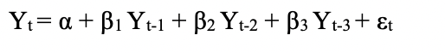

Yt:the function of the lags of Yt (observation value)

α: intercept

Yt-1: the lags of the time period t-1

β1:coefficient

Autoregressive (AR) model shows if the current value of Yt is impacted by the number of lags. Then if the Yt is affected by 2 lags then the p = 2. (Nau D., 2020)

Equation 2: Integration (I) showing the number of differences



Integration represents the differencing of the observations for the time series to become stationary. It can be interpreted mathematically from the Equation 2 with number of differences (d or Δ) = 2

To give a more detailed explanation, Yt is the base line period, (Yt – Yt-1) is the first differencing and then another difference (Yt-1 – Yt-2) is being made on the first different to succeed the second difference (Nau D., 2020).

Equation 3: Moving Average (MA) model equation with MA = 2

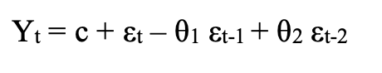

Moving Average (MA) model is defined mathematically with the Equation 3.

c: constant

εt: white error

θi: coefficient

The order of q in this model defines the total number of errors in the past that affect the present value (Peixeiro M., 2021). If for example two errors affect the present value (Yt) then the q = 2.

Equation 4: ARIMA model general equation

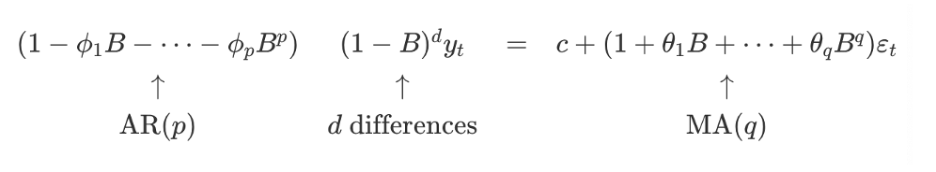

BYt = Yt-1

B2 Yt = B (BYt) = B (Yt-1) = Yt-2

In general terms: Bn Yt = Yt-n

In Equation 4 the ARIMA model presented where the first part on the left side (AR) counts the lags (p), the second part (I) the differences (d) whereas the right side of the equation (MA) the errors (d).

Equation 5: SARIMAX model general equation

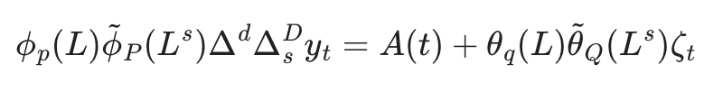

Φp (L): autoregressive lags (number of AR)

p (Ls): seasonal autoregressive lags (number of SAR)

Δd ΔsD yt : number of differences of both seasonal and not seasonal (d and D)

A(t) : the trend of the polynomial

θq (L) : number of moving average (MA)

Q (Ls): the number of seasonal moving average (SMA)

In Equation 5 the SARIMAX model is represented which is ARIMA model that includes seasonal effects and exogenous factors.

**3.5 Resources (Software and Tools)**

The software that has been used is the programming language Python. A lot of research has been made whether to use R or Python. Although R is really good for statistical calculations and plotting, Python had some libraries that were easier as well as better for this analysis. Moreover, Python is open and accessible to community so it is easier to find problems that can be faced while coding.

For the analysis a sort of important libraries/packages has been used for both cleaning and analysing the data. The most important library that was used is pandas that was essential for the data manipulation and analysis. After tidying the data, “matplotlib” have been used for standard plots whereas “seaborn” was better to create statistical plots. For some statistic measurements such mean and the sum, the libraries “statistics” and “numpy” have been used and “DateFormatter” to make easier the data for plotting the dates.

For the forecasting, essential libraries were “pmdarima.arima” for “auto.arima” to find the best Arima model and “statsmodels.tsa.statespace.sarimax” to create the SARIMAX model. Finally, for the evaluation part of the model, two libraries were used, “sklearn.metrics” and “math”.

**3.6 Risk and Challenges**

During the procedure of this project, there were some risks and challenges that have been faced. On the one side, there was the technical part of the coding and saving the data. It would be possible that during a damage of the computer the files would be lost so that is why a daily backup have been made.

On the other side of the analysis of the project, they were some risks and challenges as well. During the years that the Brexit happened there was the outbreak of Coronavirus. That created a big confusion to the analysis whether the change of imports and exports was due to of Brexit or Covid. Moreover, the literature review was mainly made by the use of economic models rather than statistic models which was difficult not having a similar comparison of the findings. Finally, predictions have been but because of the lack of data which they were not enough monthly but more quarterly the results were not as accurate as expected.

# Implementation & Results

## **4.1 Descriptive Analysis**

On this part a general statistical analysis has been made in order to have a clearer view of the annual and quarterly datasets and that accomplished with the use of boxplots, histograms and line graphs.

**Trade in Goods Annually and Quarterly**

On Figure 1 there are two boxplots of which they represent the distribution of UK total exports and imports in Goods based on 3 different areas, EU, Non-EU countries and in the whole world. Although the boxplots show the median, the upper and lower quartiles and the minimum and maximum values, the focus is going to be on the median. The boxplot of Exports in Goods shows that for the total exports in EU countries the median in terms of millions is around 14000£, for the Non-EU countries the median is 125000£ and for the whole world is 270000£. For the imports in goods on Figure 1 the median in EU countries is 190000£, for Non-EU countries 185000£ and worldwide 280000£.

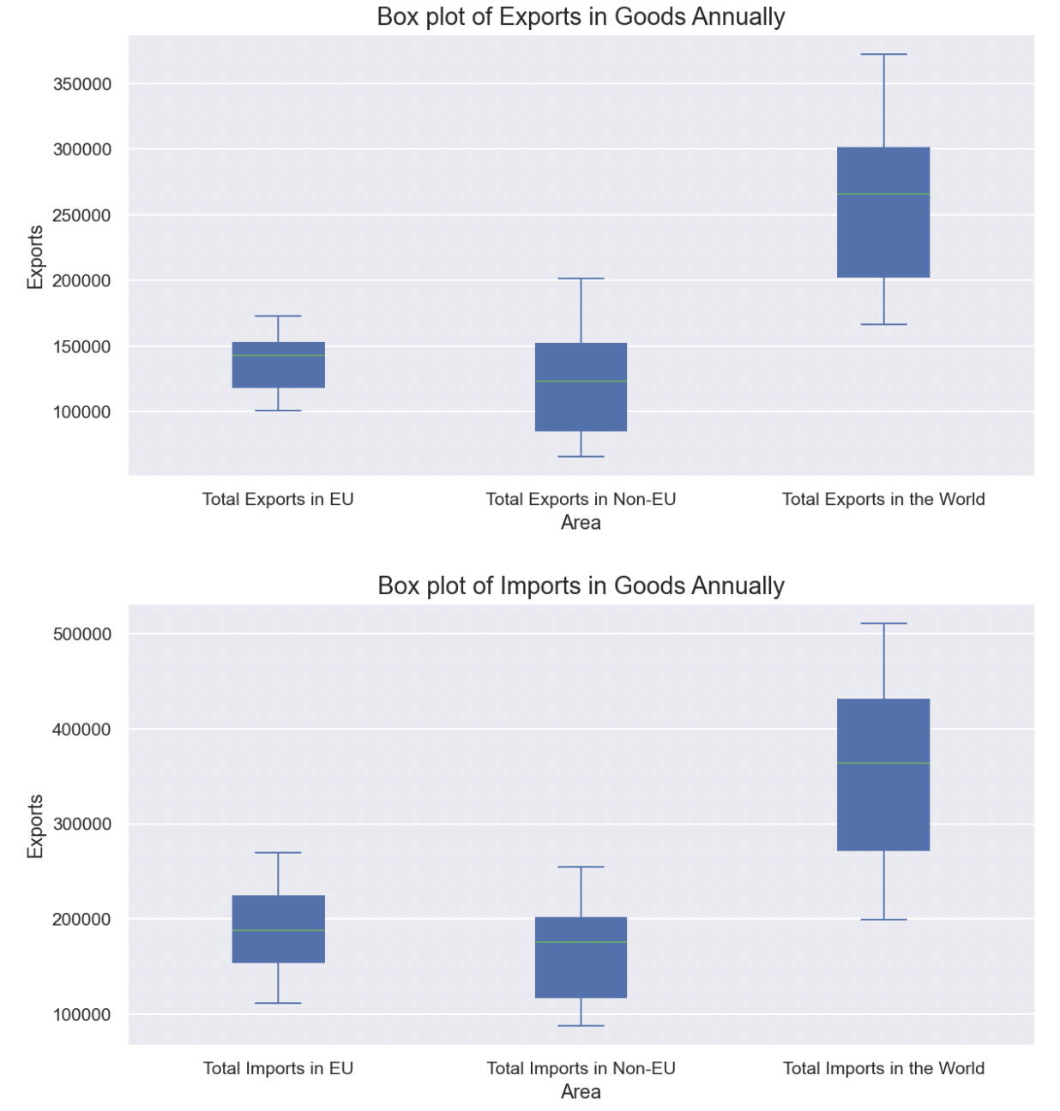

Figure 1: Box plots of Goods Annually in millions (£)

For the quarterly exports in goods median of exports in goods quarterly in EU countries is 40000£, in Non-EU countries is 45000£ and worldwide is 81000£. The imports of goods from EU countries are 67000£, from Non-EU countries 44000£ and for the whole world 85000£. As for the imports in goods the median is higher, from EU countries is 65000£, from Non-EU countries around 55000£ and 120000£ worldwide. The interquartile range of the quarterly is smaller than the annually ones for all the areas (Appendix, Figure A1).

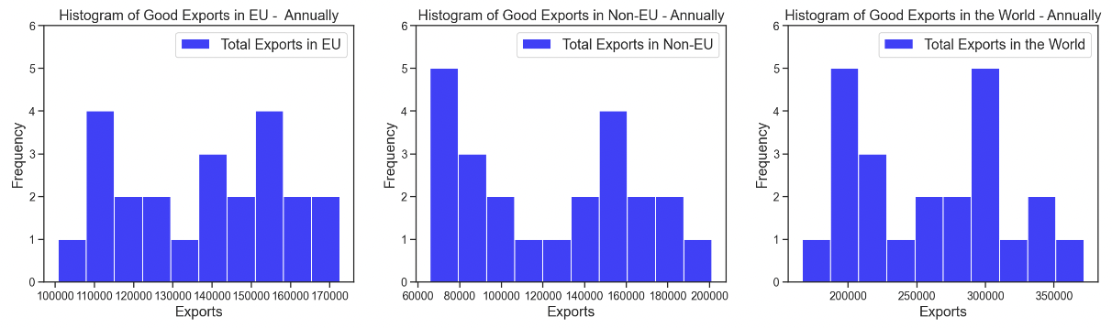

Figure 2: Histograms of Exports in Goods Annually in millions (£)

On Figure 2 there are three histograms showing the exports in goods annually. More specifically a histogram represents the frequency of each number of exports, for every amount of exports in millions how many times it is shown in the data. For the exports in EU countries, there are two frequent amounts of exports (bimodal) in millions of pounds (£) are 111000£ and 155000£, the Non-EU is unimodal with 70000£ and as for the countries all over the world it is bimodal with the top frequency seems to be on 200000£ and 300000£ millions. The distribution for all three histograms is non-symmetric.

The distribution on the exports quarterly is non-symmetric and in EU countries there is only one mode of 42000£, in Non-EU countries 45000£ and unimodal worldwide of 85000£ (Appendix, Figure A2).

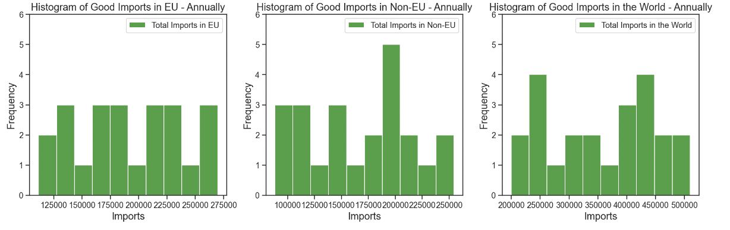

Figure 3: Histograms of Imports in Goods Annually in millions (£)

On Figure 3 the imports of goods from EU are multimodal, from Non-EU countries are unimodal with 200000£ and from the whole world is bimodal with 250000£ and 425000£. All three histograms are non-symmetric.

On the quarterly analysis of the imports in goods no symmetric noticed. All areas of EU, Non-EU and Worldwide have a single mode of 65000£, 52000£ and 115000£ accordingly (Appendix, Figure A3).

**Trade in Services Annually and Quarterly**

The results the exports and imports annually on Figure 5 shows a wider interquartile range. For the annual exports of Services to EU and Non-EU countries the median are around 55000£ and 120000£ where worldwide is around 175000£. The median of import services annually is 60000£ from EU and Non-EU countries and 175000£ from the whole world.

For the quarterly data of the exports in services the interquartile range is smaller with the median being around 28000£ for EU countries, 45000£ for Non-EU countries and 73000£ worldwide. On the other hand, as it concerns the imports of services only the interquartile range of import in Non-EU is smaller. For the area of EU the median is around 22000£, for Non-EU countries is 25000£ and the whole world is around 44000£ (Appendix, Figure A4)

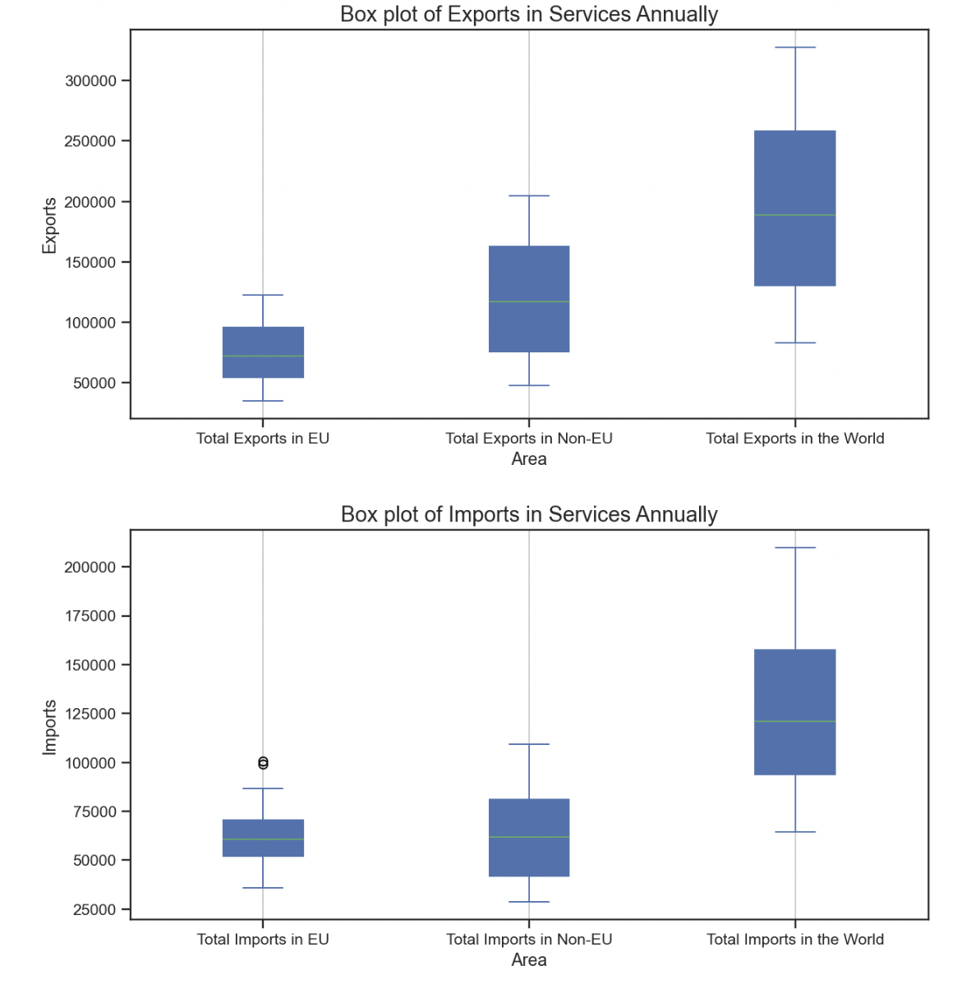

Figure 4: Box plots of Services Annually in millions (£)

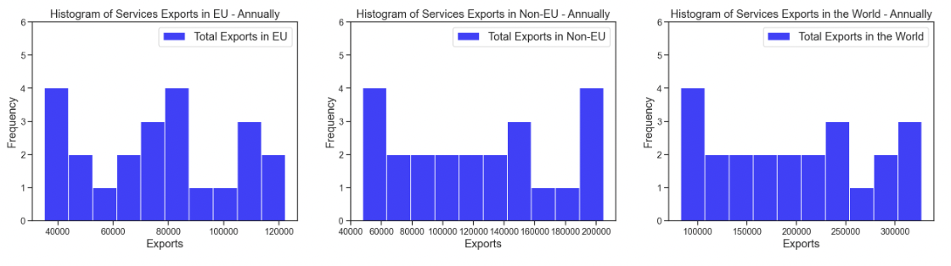

Figure 5: Histograms of Exports in Services in millions (£)

Presenting the histograms of the annual exports in services on Figure 5, EU countries histogram is bimodal with 40000£ and 80000£, Non-EU is bimodal as well with values of exports 58000£ and 195000£ where the worldwide histogram is unimodal with 100000£.

On the quarterly histograms of exports in services in EU countries the unimodal value is 27000£, for the Non-EU countries is 46000£ and the worldwide is bimodal with values around 72000£ and 75000£ (Appendix, Figure A5). None of the annual or quarterly histograms are following a symmetric distribution.

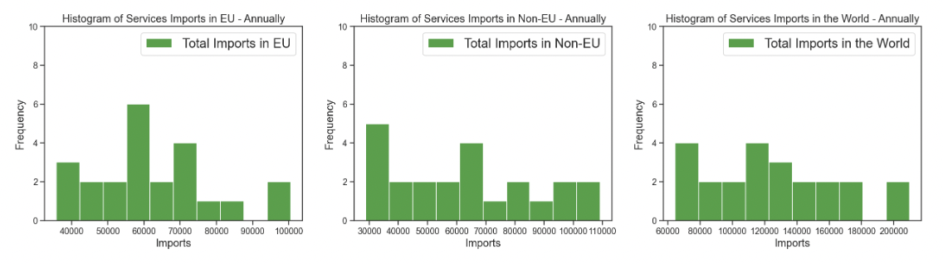

Figure 6: Histograms of Imports in Services in millions (£)

For the histograms of the imports in services annually on Figure 6 from EU and Non-EU countries have a single mode of around 58000£ and 32000£ where from the whole world imports are bimodal with values 70000£ and 118000£ respectively.

On the other hand, the imports of services in all areas are unimodal with 25000£ from EU, 23000£ from Non-EU and 38000£ from the whole world (Appendix, Figure A6). All annual and quarterly histograms are non-symmetric distributed.

## **4.2 Trend & Plot Analysis**

This part focuses on presenting the results of different line graphs and plots. This can give a better view on what categories, years or countries have a greater impact.

### **4.2.1 General Analysis in all years**

Before starting to analyse each timeline of Brexit, a general analysis have been made with the use of the mean in all years in order to understand the data in total. This succeeded with the used of pie chart and line graphs.

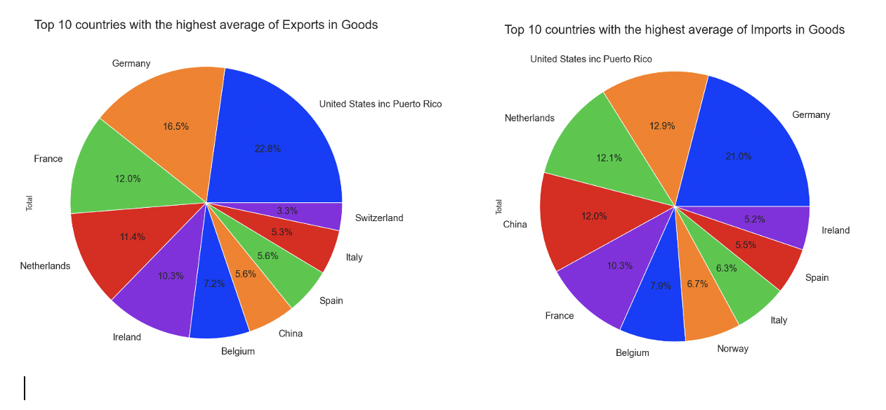

Figure 7: Average of the Top 10 higher countries trade Goods (%)

Starting with the Figure 7 it can be noticed that using the total average of all years, the country which UK have the higher exports in goods is United States inc Puerto Rico with a percentage of 22.8% in Non-EU area and the second higher country which is the top in EU countries is Germany with a percentage of 16.5%. For the imports in Goods UK traded more with Germany (21%) in Europe and with United States inc Puerto Rico in the rest of the world with 12.9%.

The same analysis has been made to the exports and imports in services. The top country UK export services is United States inc Puerto Rico with a percentage of 39.5% and Germany follows with 10.3%. For the imports again United States inc Puerto Rico gains the first ranking with 30.3% and France comes second with 13% (Appendix, Figure A7).

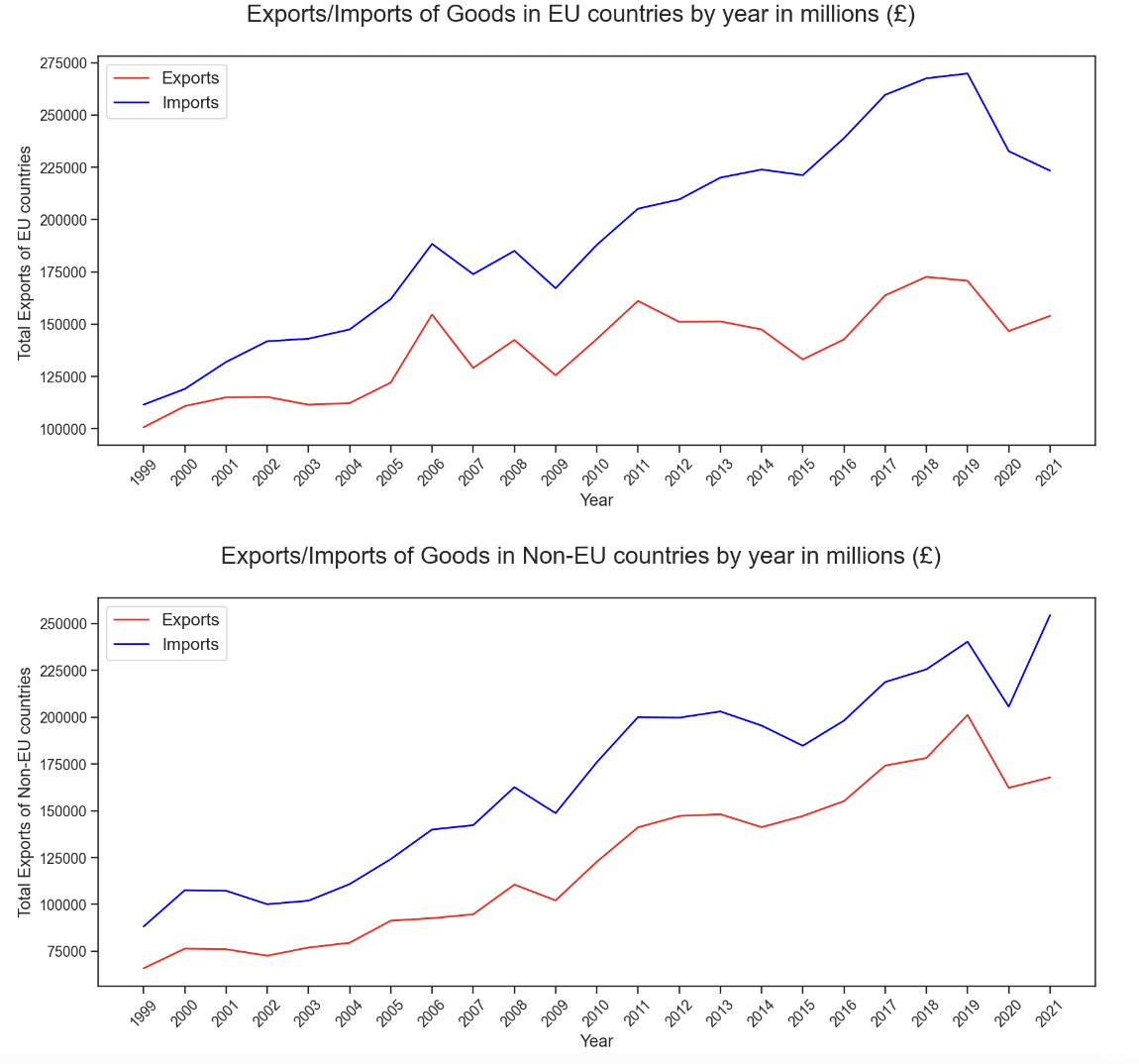

Figure 8: Trade of Goods based on the area in millions (£)

After finding the top countries that UK trade the most, the next step was to provide visual results of the trends in goods. On Figure 8 both trades of Goods in EU and Non-EU countries were increasing throughout the years and UK exports are always higher than imports. The exports and imports in European had intense fluctuations between 2006 and 2009 where after 2009 exports start rising, imports started falling. After 2019 there was a noticeable decrease in both exports and imports. For the trade in Non-EU area there was a general increase with a small decrease in 2008 and 2019. Both exports and imports in EU and Non-EU countries peak in 2019.

Going to the trade of services the first thing that have been noticed was that for the EU countries until 2004 both exports and imports were almost the same and then exports were higher. For the Non-EU countries exports were steadily increasing from 1999 until 2019 with exports being more than imports. The highest trade in all areas were once again on 2019 where there was a drop of the trends (Appendix, Figure A8)

Table 1: Top 5 categories of Goods that trade the most in millions (£)

|  |  |
| --- | --- |
| **Exports in Goods** | **Imports in Goods** |
| Cars | Cars |
| Mechanical power generators (intermediate) | Medicinal & Pharmaceutical products |
| Medicinal & Pharmaceutical products | Clothing |
| Crude oil | Telecoms & Sound equipment (capital) |
| Aircraft | Mechanical power generators (intermediate) |

Table 2: Top 5 categories of Services that trade the most in millions (£)

|  |  |
| --- | --- |
| **Exports in Services** | **Imports in Services** |
| Other Business Services | Other Business Services |
| Financial | Travel |
| Travel | Transportation |
| Telecommunications, computer and information services | Financial |
| Transportations | Intellectual property |

Using once again the average in all years an analysis has been made to find the top 5 categories of goods that UK trade the most (Table 1). The findings showed that UK exports and imports a lot of Cars, Mechanical power generators as an intermediate part of the production and Medicinal & Pharmaceutical products. Table 2 shows that UK’s highest categories of services that trade the most is Other Business Services, Financial and Travel.

### **4.2.2 Timeline Before Brexit Referendum (2012 – 2015)**

To understand the changes of the announcements of Brexit, a brief analysis has been made for a small period before UK announced that is going to exit EU from 2012 until 2015.

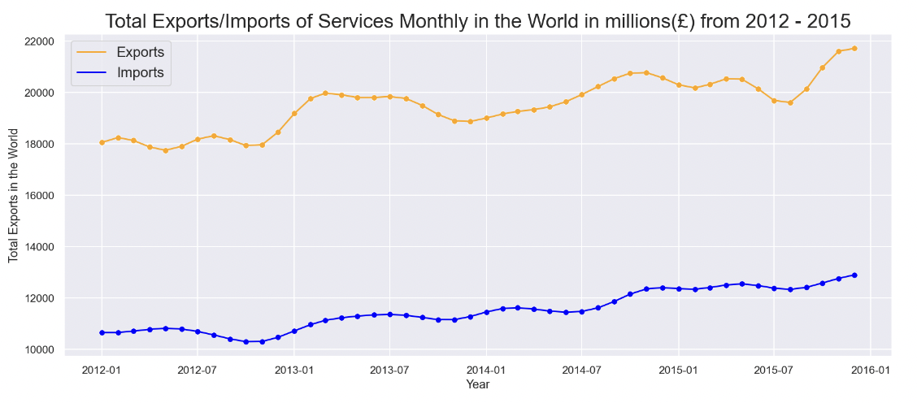

Figure 9: Total Trades of Services in millions (£) from 2012 – 2015

The exports of services on Figure 9 are around 10000£ higher than imports in all years. Both exports and imports seem to decrease on the 2nd quarter of each year whereas in total terms from 2012 until 2015 there is a slightly increase.

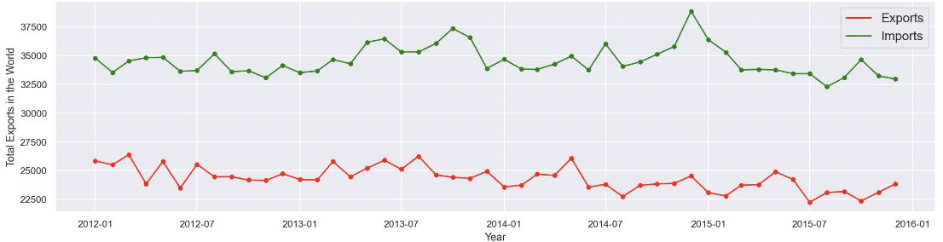

Figure 10: Total Trades of Goods in millions (£) from 2012 – 2015

On Figure 10 there are the trades in goods from 2012 until 2015. In contrast to the trade of services, in goods there are continuously fluctuations. The exports are higher than imports in those years presented and as notice before on Figure 10 there are general drops in every 2nd quarter of each year.

### **4.2.3 Timeline from when Brexit announced until it happened (2016 – 2019)**

On the 23rd of June 2016 UK officially announced that is going to leave the EU. On the referendum day and until the Brexit took place, they were some important announcements. The aim of this part of the analysis is to see the results of those dates and how they changed with the use of bar plots and line graphs. If there is a change it will be noticed the following quarter of the 5 following announcements:

1. 23rd of June 2016 (Referendum) **– 2016 Q2**
2. 29th of March 2017 (2 years countdown for Brexit) **– 2017 Q1**
3. 20th of March 2019 (Extend of the Article 50) **– 2019 Q2**
4. 2nd of April 2019 (Further extension of the Article 50) **– 2019 Q2**
5. 19th of October 2019 (Further extension of the Article 50)

and on the same quarter, 12th of December 2019 (Boris Johnson was elected and reassure that he was going to support Brexit) **- 2019 Q4**

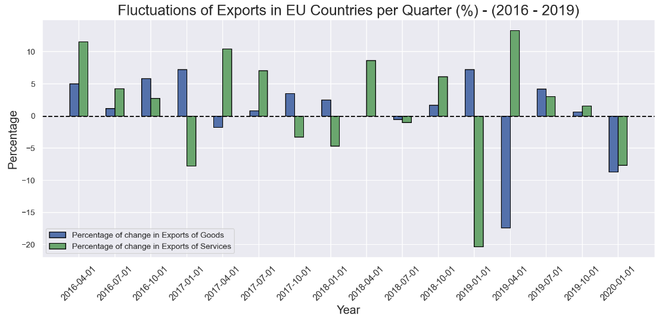

Figure 11: Change of Exports based on the previous quarter in EU countries (%) from 2016 – 2019

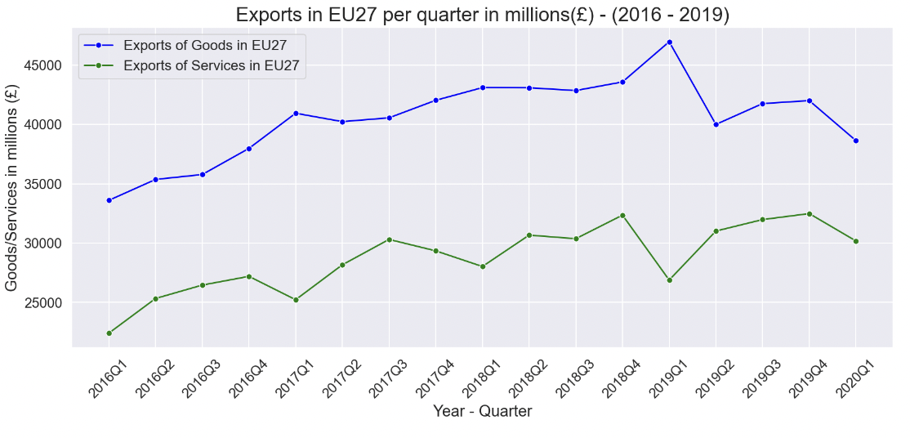

Figure 12: Exports in EU countries per quarter in millions (£) from 2016 – 2019

Figure 11 is showing the changes (increase or decrease) of imports and exports in EU countries compared to the previous period where on Figure 12 there is the trend of the trades in millions (£). On the 2nd quarter of 2016 there was the Brexit referendum and going to the quarter 3 (Q3) can be seen that export in goods increased with a lower percentage compared to services. The 2 years countdown for Brexit announced on the 1st quarter of 2017 and the next quarter the exports in services increased 10.44% whereas goods decreased a little bit. A further extension has been made on the 2nd quarter of 2019 and after that on Q3 the goods and services decreased 4.21% and 3.02%. On the 4th quarter of 2019 another extension for the Article 50 has been asked and Boris Johnson qw elected as a prime minister and reassured that he was going to support Brexit. The next first quarter of 2020 exports in both goods and services decreased 8.72% and 7.65% respectively.

For the exports of goods and services in Non-EU countries the same plot analysis has been made. Based on the 5 important announcements, the results on the next quarters were as follow. For the 3rd of 2016 both goods and services increased in with goods reaching a percentage of 18.26% and 6.49% compared to the previous quarter. On the 2nd quarter of 2017 and 2019 and on the 3rd quarter of 2019 both exports of goods and services in Non-EU countries increased. On the other hand, on the 1st quarter of 2020 the goods and services dropped dramatically with goods reaching -41.56% compared to the previous quarter (Appendix, Figure A9 and Figure A10).

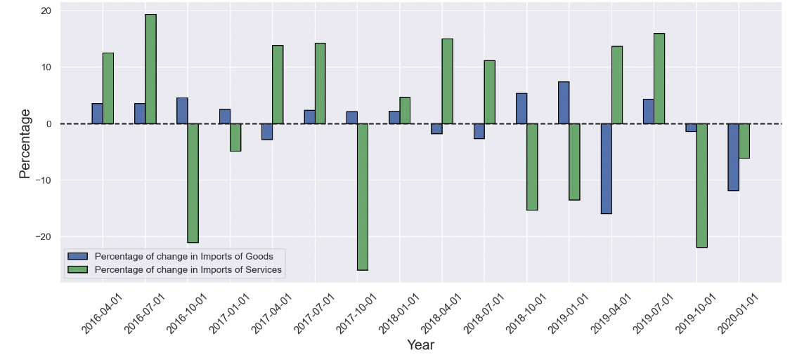

Figure 13: Change of Imports based on the previous quarter in the EU countries (%) from 2016 – 2019

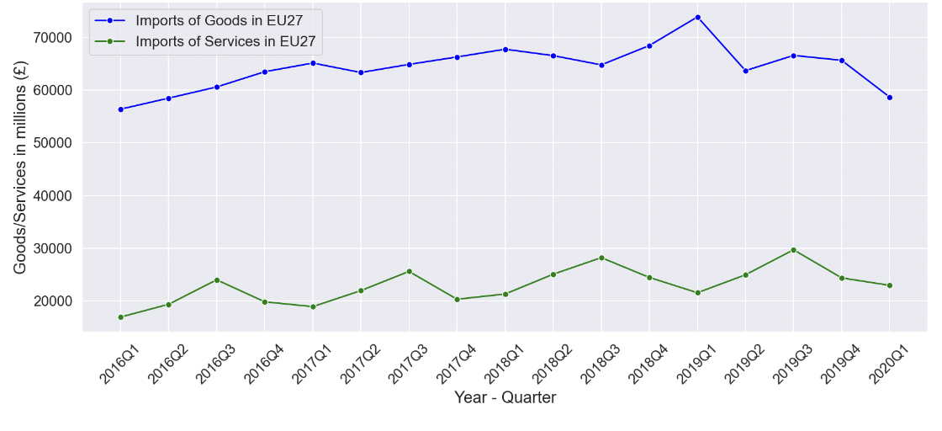

Figure 14: Imports in EU countries per quarter in millions (£) from 2016 – 2019

The imports of goods and services in EU countries can be seen on Figure 13 and Figure 14. Starting with the 3rd quarter of 2016, imports in goods increased and services decreased a lot with the percentage of 21.05% compared to the past quarter. Now, on the 2nd quarter of 2017 goods decreased 2.83% where services increased 4.84%. On the 2nd quarter of 2019 goods increased 13.66% and services decreased 15%. An increase has been noticed on the 3rd quarter of 2019 whereas on the 1st quarter of 2020 both imports of goods and services decreased 11.91% and 6.17% respectively.

For the imports in Non-EU countries, goods and services on the 3rd quarter of 2016 and on the 2nd quarter of 2017 increased. On the 2nd quarter of 2019 goods decreased a lot with a percentage reaching -21.59% where services increased. The 3rd quarter of 2019 goods and services increased again compared to the past quarter and then on the 1st quarter of 2020 both goods and services decreased with 4.27% and 8.25%.

**Top EU Countries that UK Exports Goods and Services**

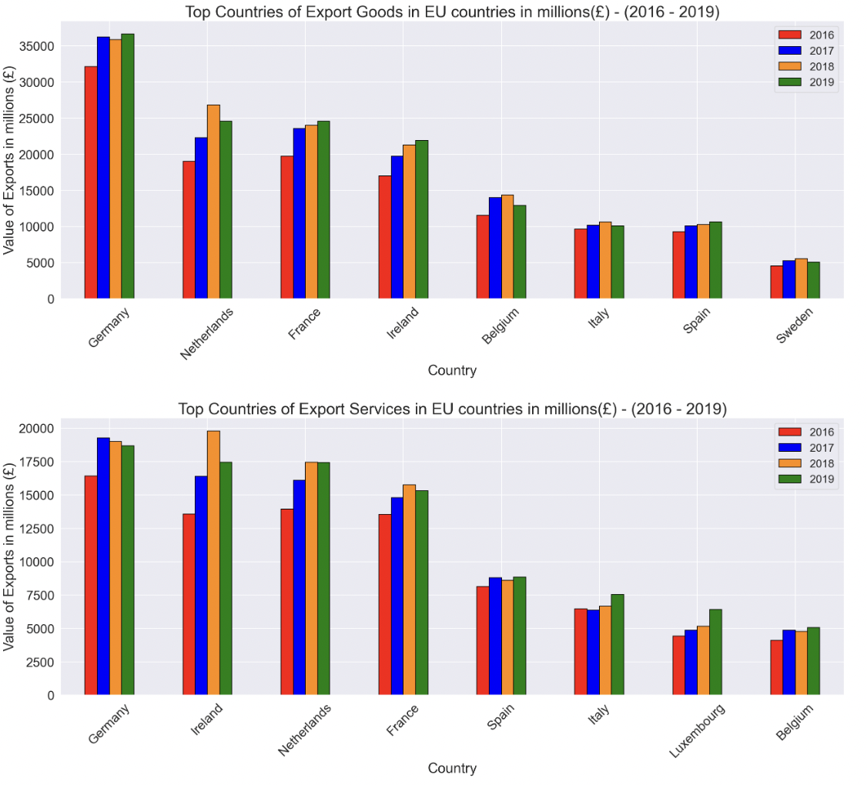

Figure 15: Top Exports of Goods/Services in EU countries in millions (£) from 2016 – 2019

The next part of this analysis is to plot the top countries which UK exports goods and services in EU and Non-EU countries and see the effects of years, whether they increase or decreases in millions (£) each year.

Looking at Figure 15, Germany and Netherland are the top EU countries that UK exports goods the most where France and Ireland are following. UK’s exports to Germany increased on 2017, they slightly drop on 2018 and then again increase in 2019. As for the exports in Netherland, they increase until 2018 and they slightly drop. For the exports in services, the top EU country is still Germany and then Ireland, Netherlands and France. The exports in Germany increase on 2017 and then steadily decrease whereas in Ireland increase significantly until 2018 and then drop down.

**Top Non-EU Countries that UK Exports Goods and Services**

For the exports of goods to Non-EU countries, the countries with the highest exports of UK are to the United States including Puerto Rico and China. UK’s exports to both countries were increasing from 2016 until 2019. On the other side, the top exports of services to Non-EU countries were to the United States including Puerto Rico which was increasing in those 4 years and to China which was increasing until 2018 and then slightly decreased (Appendix, Figure A13)

**Top 2 EU Countries that UK Export Goods and Services Quarterly**

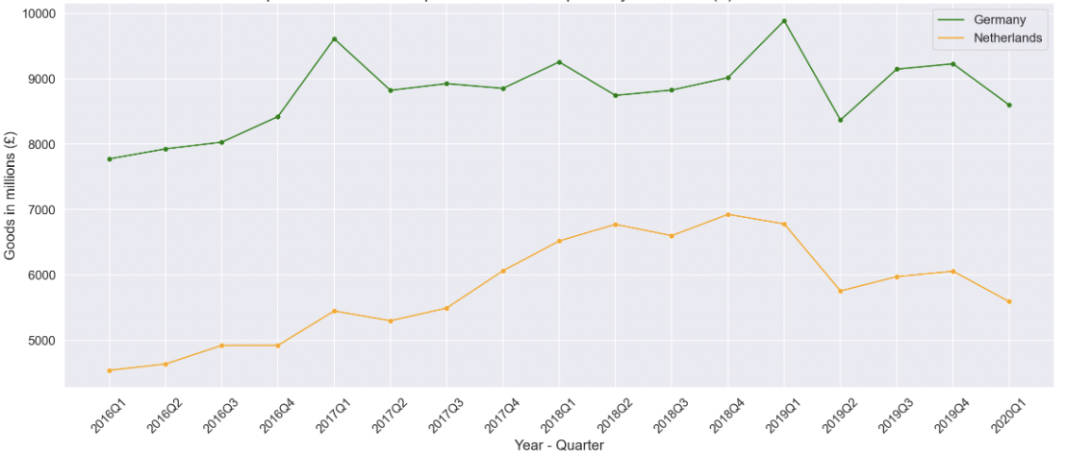

Figure 16: Exports of Goods in Top 2 EU countries quarterly in millions (£) from 2016 – 2019

After identifying the top countries which UK exports, a line graph has been created to see how the values in millions (£) changed on those two countries.

The line graph on Figure 16 shows that the UK top exports in Goods in EU countries are to Germany and Netherlands. As before, the next steps are to compare the 5 announcements right after the referendum to identify any changes. On the 3rd quarter of 2016 and 2nd quarter of 2017 the exports to Germany and Netherlands increased in contrast to the 2nd quarter of 2019 where the exports on both countries decreased dramatically. The 3rd quarter of 2019 the exports increased and then on the 1st quarter of 2020 a decrease has been observed.

Accordingly for the EU countries, UK top exports in Services to Germany and Ireland, in the first 4 announcements UK exports for both countries kept increasing and only on the 1st quarter of 2020 there was a decrease in Germany and Ireland (Appendix, Figure A14).

**Top 2 Non-EU Countries that UK Export Goods and Services Quarterly**

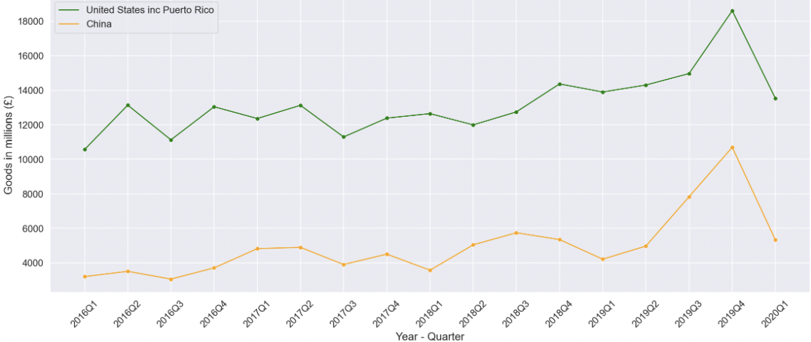

Figure 17: Exports of Goods in Top 2 Non-EU countries quarterly in millions (£) from 2016 – 2019

For the top two Non-EU countries that UK export goods as it shows on Figure 17, on the 3rd quarter of 2016 exports on both countries decreased. On the following 3 announcements in 2017 and 2019 there was increase and then on the 1st quarter of 2020 there was a dramatical both US inc Puerto Rico and China.

As for the top two Non-EU countries UK export services, US and Switzerland, on the 3rd quarter of 2016 both increase and on 2nd quarter of 2017 US increased whereas UK’s exports of services slightly decreased to Switzerland. On the 2nd quarter of 2019 exports to US increased and to Switzerland decreased. Going to the 3rd quarter of 2019 exports of services on both countries increased in oppose to the 1st quarter of 2020 where they decreased (Appendix, Figure A15).

**Top EU Countries that UK Imports Goods and Services**

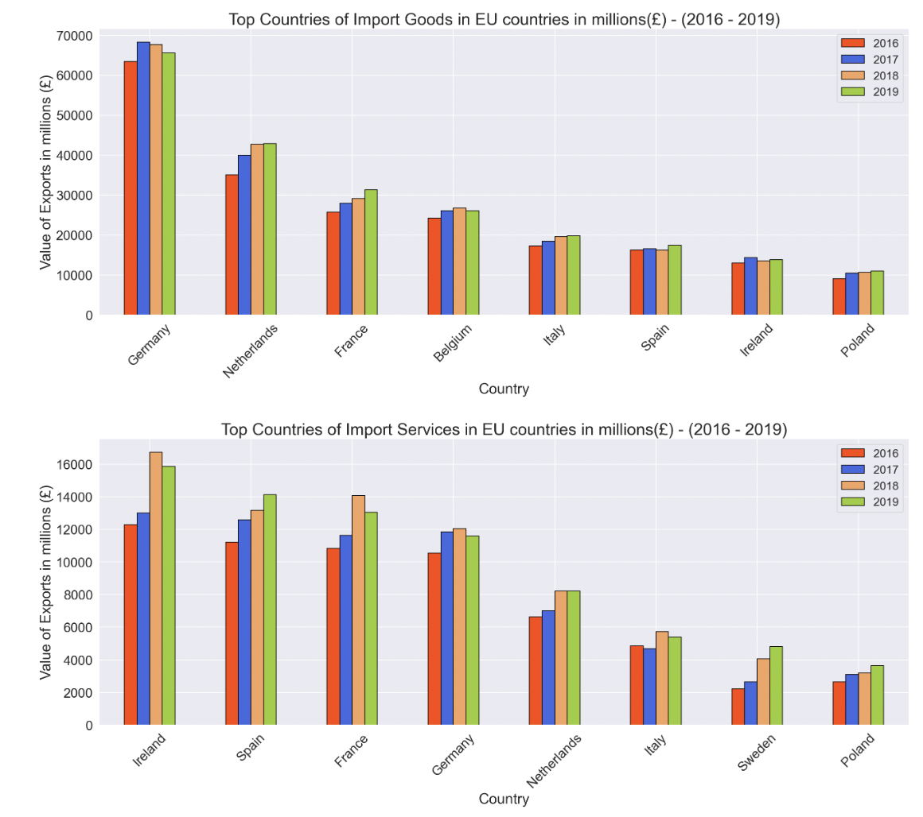

Figure 18: Top Imports of Goods/Services in EU countries in millions (£) from 2016 – 2019

Moving to Figure 18, the top two EU countries that UK imports goods are Germany and Netherland. Imports from Germany were increased until 2017 and then decreased whereas Netherlands was only increasing. For the top two countries UK import services, Ireland was increasing until 2018 and then dropped slightly and Spain had steadily increased in those 4 years.

**Top Non-EU Countries that UK Exports Goods and Services**

The top two Non-EU countries that UK import goods more was China and United States including Puerto Rico. Both countries were steadily increasing where on the other hand the top ones that UK import services were again the United States including Puerto Rico and Japan which both increased from 2016 until 2019 (Appendix, Figure A16).

**Top 2 EU Countries that UK Import Goods and Services Quarterly**

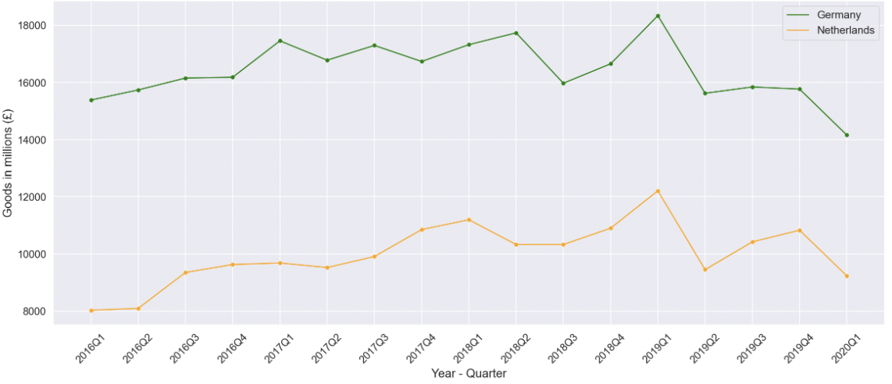

Figure 19: Imports of Goods in Top 2 EU countries quarterly in millions (£) from 2016 – 2019

On Figure 19 there are the two top EU countries that UK import goods. On the 3rd quarter of 2016 both imports from these countries were increased. On the 2nd quarter of 2017 imports of Germany and Netherlands decreased where on the 2nd quarter they again decreased but this time dramatically. The 3rd quarter of 2019 they increased and then on the 1st quarter of 2020 decreased again.

The top two countries in EU that UK import services are Ireland and Spain. During the first four announcements UK increased the import from both countries and on the last announcement the results on the 1st quarter on 2020 had a decrease on both of them with Spain being the one with the most dramatical decrease (Appendix, Figure A17).

**Top 2 Non-EU Countries that UK Import Goods and Services Quarterly**

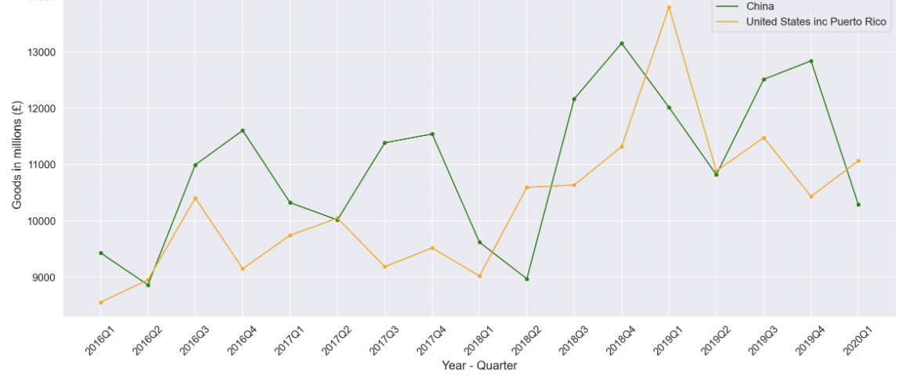

Figure 20: Imports of Goods in Top 2 Non-EU countries quarterly in millions (£) from 2016 – 2019

Figure 20 shows the top two countries which UK import goods, China and United States inc Puerto Rico. For the 3rd quarter of 2016 there was increase on both countries. On the 2nd quarter of 2017, imports of goods from China decrease whereas from US they increased. Going to the 2nd quarter of 2019 UK imports from both countries decrease where on the 3rd quarter of 2019 they increased. China’s imports to UK decrease on the 1st quarter of 2020 in oppose to US where they increase.

For the UK import of services, the top two countries to trade were United States inc Puerto Rico and Japan. In the first 4 announcements US increased whereas Japan remained mainly stable and only on the last announcement on the 3rd quarter of 2019 the UK’s imports from United States inc Puerto Rico decreased where Japan haven’t changed (Appendix, Figure A18).

**Top Categories of Goods and Services that UK Export to EU countries**

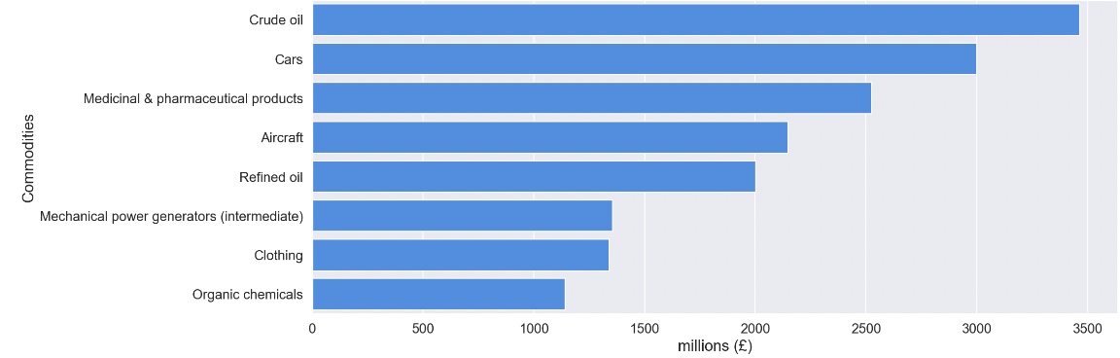

Figure 21: Top 10 Categories of Good Exports in EU countries in millions (£) from 2016 – 2019

The first part of this analysis is to find the top 10 categories (commodities) of goods/services UK export as it shown on Figure 21 and then a selection of the top 4 have been made to see any fluctuations of the trends of the top categories based on the 5 important UK announcements after the Brexit referendum.

The same plot has been made for the top 10 categories of services UK export (Appendix, Figure A19).

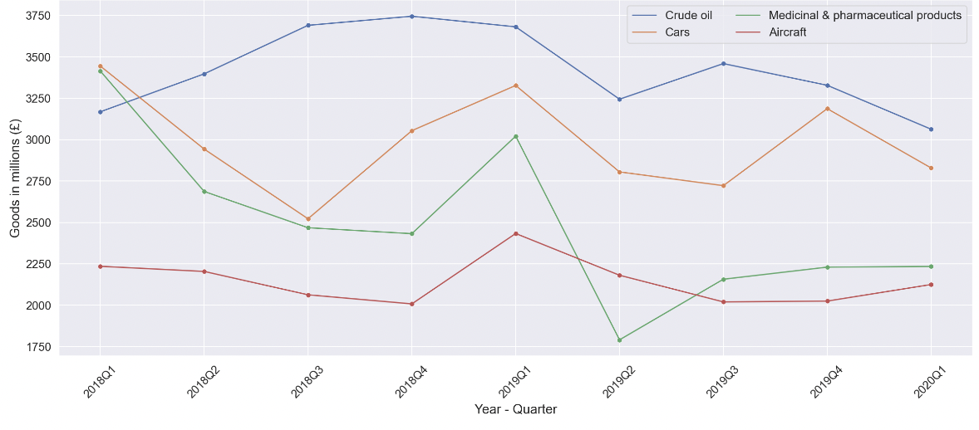

Figure 22: Top 4 Exports of Goods in EU countries quarterly in millions (£) from 2018 – 2019

Figure 22 shows the trends of the top four UK categories of exports in millions (£) quarterly. Because of lack of data a comparison of only 3 out of 5 announcements has been made. On the 2nd quarter of 2019 all four categories decreased. Then on the 3rd quarter of 2019 exports of Cars and Aircraft decreased whereas Medicinal and Crude oil increased. On the 1st quarter of 2020 Aircraft and Medicinal increased whereas Crude oil and Cars decreased.

For the export of services in EU countries, the top categories were the Other Business Services, Travel, Financial and Transportation. On the first three announcements all four services were increased. On the 3rd quarter of 2019 only Financial decreased and on the 1st quarter of 2020 the three services decreased and only Financial increased (Appendix, Figure A20).

**Top Categories of Goods and Services that UK Export to Non - EU countries**

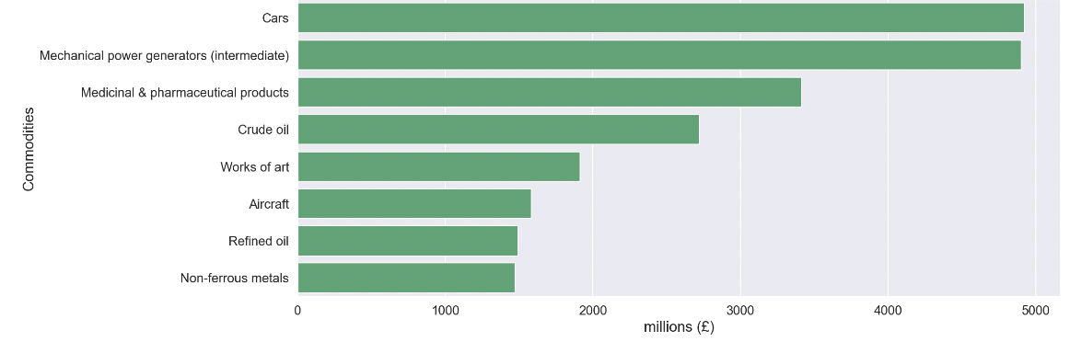

Figure 23: Top 10 Categories of Good Exports in Non-EU countries in millions (£) from 2016 – 2019

On Figure 23 the results show the top 10 categories of goods exported from UK to Non-EU countries. The same plot has been created in order to show the top 10 categories of services exported to Non-EU countries (Appendix, Figure A21).

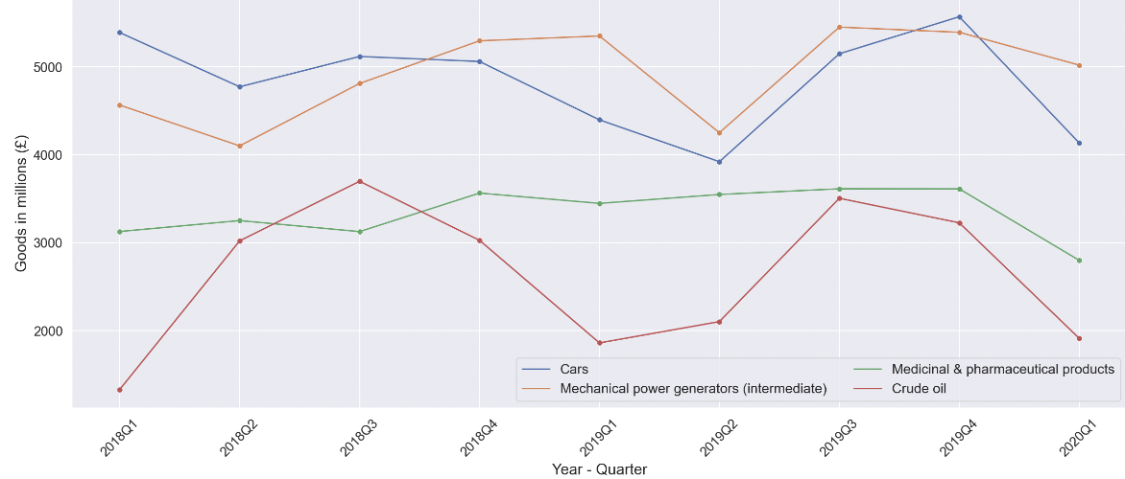

Figure 24: Top 4 Exports of Goods in Non-EU countries quarterly in millions (£) from 2018 – 2019

Following the same steps, on Figure 24 it can be seen that on the 2nd quarter of 2019 the Crude oi and Medicinal increased where Mechanical and Cars decreased. On the 3rd quarter of 2019 all four categories of Goods increased in contrast to the 1st quarter of 2020 where they all decreased.

From the analysis of the top categories of services exported, the top 4 were Other Business Services, Travel, Financial and Insurance and Pension. The 3rd quarter of 2016 Insurance and Travel decreased where Financial and other Businesses increased. Moving to the 2nd quarter of 2017 Insurance and Travel increased where Financial and Other Businesses decreased. On the 2nd quarter of 2019 only Financial decreased where on the 3rd quarter of 2019 only insurance decreased and the rest of them increased. At last, on the 1st quarter of 2020 Travel and Other Businesses decreased whereas Financial and Insurance increased (Appendix, Figure A22).

#### **Top Categories of Goods and Services that UK Import from EU countries**

With the same plots that have been made before the top 10 categories of goods and services imported in UK from EU countries have been found (Appendix, FigureA23 and Figure A24).

The top four categories of goods imported to UK from EU countries were Cars, Medicinal & Pharmaceutical products, Miscellaneous electrical goods (intermediate) and Refined Oil. On the2nd quarter of 2019 imports of Cars and Medicinal decreased dramatically (Refined Oil decreased but not that much) and Miscellaneous electrical goods increased slightly. On the 3rd quarter of 2019 all four imports of goods decreased with Cars and Medicinal to have the greatest decrease (Appendix, Figure A25).

On the other hand, the top four categories of services imported from EU countries were Travel, Transportation, Other Business Services and Telecommunications. For the 3rd quarter of 2016 and 2nd quarter of 2017 all four imports of services were increased. On the 2nd quarter of 2019 Telecommunications remained stable were the rest of them increased. On the 3rd quarter of 2019 2019 Transportation and Travel increased where Other Businesses and Telecommunications decreased and finally on the 1st quarter of 2020 Telecommunications increased where the rest three services decreased (Appendix, Figure A26).

#### **Top Categories of Goods and Services that UK Import from Non - EU countries**

Bar plots have been made to find the top 10 categories of goods and services imported in UK from Non - EU countries (Appendix, Figure A27 and Figure A28).

From the analysis of the top categories of goods imported from Non-EU countries, the highest ones where Crude Oil, Clothing, Mechanical power generators (intermediate) and Refined Oil. The trends on the 2nd quarter of 2019 showed that Clothing decreased and the other three increased. On the 3rd quarter of 2019 all four imports of goods increased and then on the 1st quarter of 2020 Mechanical power increased where the other three goods decreased (Appendix, Figure A29).

The same way used to find the top four categories of services imported from Non-EU countries. They were Other Business Services, Financial, Travel and Transportation. At first on the 3rd quarter of 2016 all four categories increased and then on the 2nd quarter of 2017 Other Business and Travel increased and other two almost remained the same. On the 2nd quarter of 2019 Transportation slightly decreased where the other three increased, then on the 3rd quarter of 2019 Financial decreased and the other three increased. Finally on the 1st quarter of 2020 all four import services decreased.

### **4.2.3 Timeline after Brexit (2020 - 2021)**

Brexit is recent so the analysis is only for two years from 2020 and 2021. At first the top 10 countries that UK exports goods and Services has been found with the values in terms of millions of pounds (£).

Table 3: Top 10 countries that UK Exports Goods in 2020 and 2021 in millions (£)

|  |  |  |
| --- | --- | --- |
| **Country** | **2020** | **2021** |
| United States inc Puerto Rico | 45973 | 47098 |
| Germany | 32635 | 29595 |
| Netherlands | 20160 | 27085 |
| Ireland | 21923 | 21834 |
| France | 18786 | 19441 |
| China | 18049 | 18793 |
| Belgium | 10701 | 14939 |
| Switzerland | 12101 | 10309 |
| Italy | 8726 | 9112 |
| Spain | 8148 | 7878 |

From Table 3 the top country that UK export the most on 2020 and 2021 were United States inc Puerto Rico with 46973 million (£) in 2020 and 47098 on 2021 where the second highest country that UK exports is Germany with 32635 in millions of pounds in 2020 and 29595 on 2021.

Accordingly, the top two countries UK imports goods from on those two years where China with 54801 and 63557 on 2020 and 2021 respectively. The second higher country is Germany with 56853 on 2020 and 53759 on 2021 (Appendix, Table A1).

Table 4: Top 10 countries that UK Exports Services in 2020 and 2021 in millions (£)

|  |  |  |
| --- | --- | --- |
| **Country** | **2020** | **2021** |
| United States inc Puerto Rico | 82709 | 85102 |
| Ireland | 17461 | 19491 |
| Germany | 17020 | 16988 |
| Netherlands | 15607 | 14870 |
| France | 12778 | 12246 |
| Switzerland | 12236 | 12146 |
| China | 8127 | 8168 |
| Luxembourg | 6386 | 8086 |
| Canada | 5790 | 6077 |
| Singapore | 5450 | 5676 |

On Table 4 the two 2 countries export services from UK for 2020 and 2021 were United States inc Puerto Rico with an impressively high amount of 82709 and 85102 whereas Ireland had only 17461 and 19491.

As for the top two countries that UK import services during those two years, was US again with 38738 million (£) and 43657 where the second country was France with 11154 and 10607 for 2020 and 2021 (Appendix, Table A2).

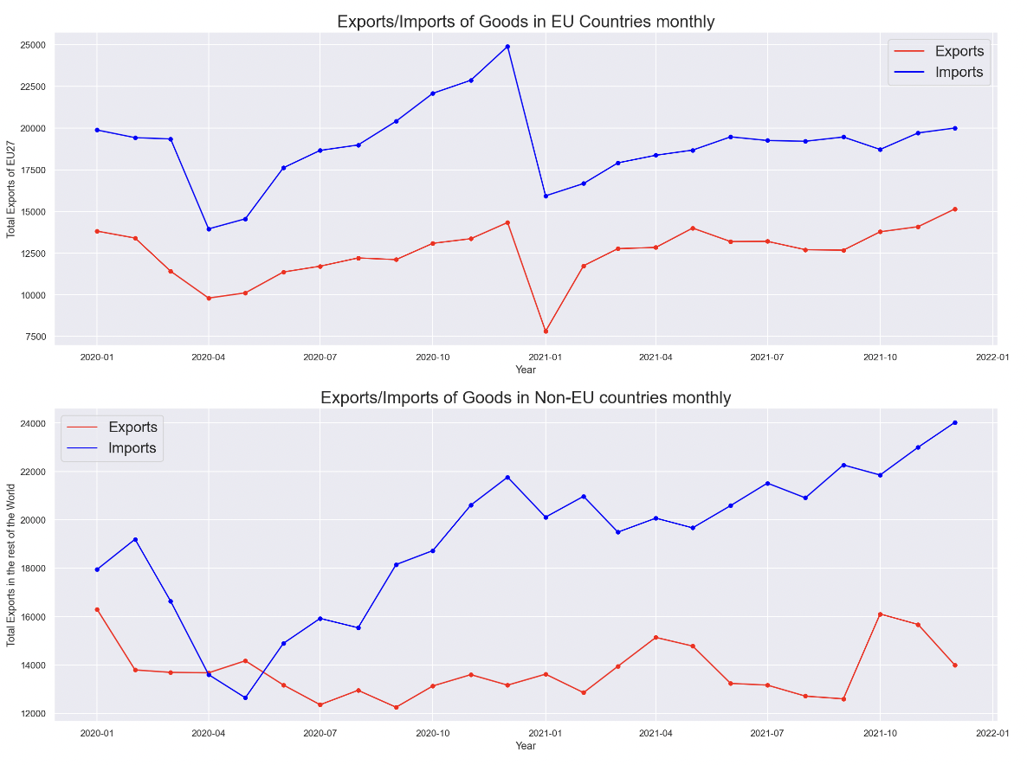

Figure 25: Exports/Imports of Goods in EU and Non-EU countries monthly in millions (£) (2020 - 2021)

Looking Figure 25, the exports and imports of Goods in EU countries were decreased dramatically on the 2nd quarter of 2020 and on the 1st quarter of 2021 where on the rest periods both exports and imports were steadily increasing. For the trade of goods in Non-EU countries it can be noticed that the imports had a big drop on the 2nd quarter and then they were increased with small fluctuations. The imports were fluctuating with noticeable drops on 3rd quarter of 2020 and on the 3rd quarter of 2021.

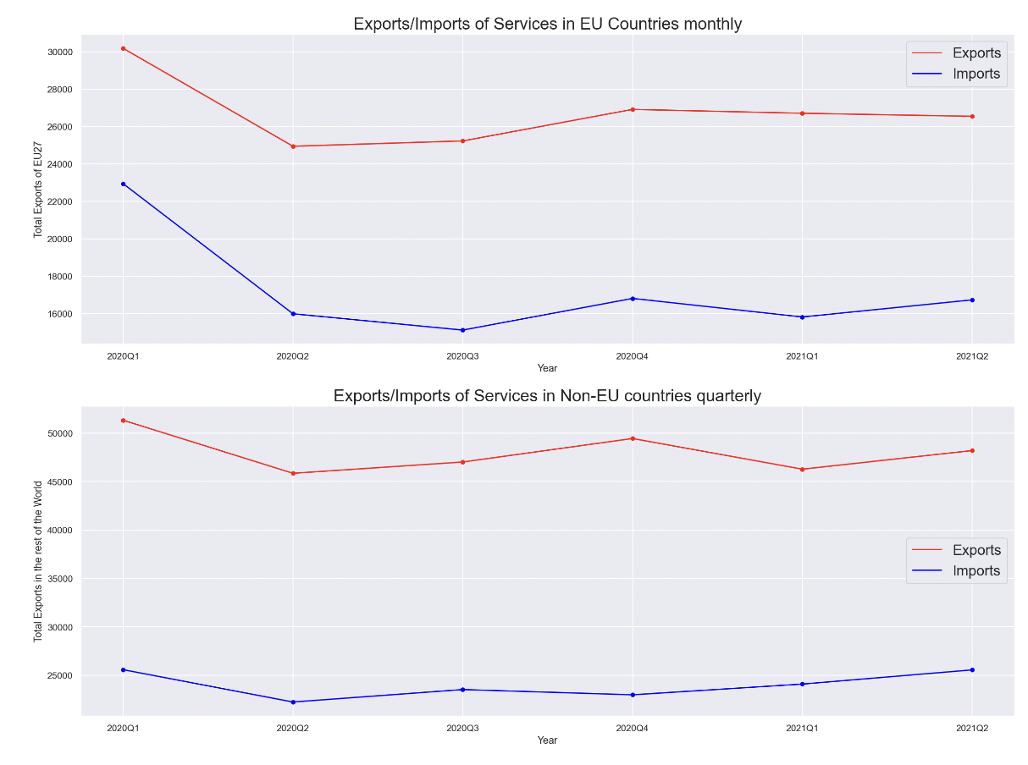

Figure 26: Exports/Imports of Services in EU and Non-EU countries Quarterly in millions (£) (2020 - 2021)

Going to Figure 26, on the first plot of the trade of services in EU countries, both exports and imports were decreasing until the 3rd quarter of 2020, then the next quarter increase and again decrease. On the other hand, for exports of services in Non-EU countries decreased on the 2nd quarter of 2020 and on the 1st quarter of 2020 whereas the imports decreased on the 2nd quarter of 2020 and on the 4th quarter of 2020.

An extensive analysis has been made after the Brexit in order to find the top categories of goods and services UK traded on 2020 and 2021 and the results showed that the top categories before and after Brexit were alike (Appendix, Figures A31 – A34).

## **4.3 Predictive Analysis**

For this part a Time Series Analysis has been made in order to prepare the data for the ARIMA model for the predictions. Predictions have been made for the trades in goods and services worldwide.

### **Forecasting the scenario if the Brexit never happened**

From the Brexit referendum and until the Brexit a lot of announcements have been made which some of them could have affected the trades of UK. On this forecasting part the aim was to predict what would have happened if Brexit had never interfered at all. The data used for this prediction were from 1999 until 2015 (a year before Brexit).

#### **Export of Services Worldwide**

The first forecast was for the trade in services (imports and exports). Starting with, the first thing that has to be done is to plot the data as it is, plot the 1st differencing and the second differencing as well as their autocorrelation plots. This needs to be done to identify if the data are stationary or not.

Another way to test the stationarity is a statistical function in python called Augmented Dickey Fuller Test (ADF). This test shows the p-value. If the p-value is greater than the significance level which is 0.01 then the null hypothesis is rejected, and so the data are not stationary. Now if the p-value is less than 0.01 then the data are stationary.

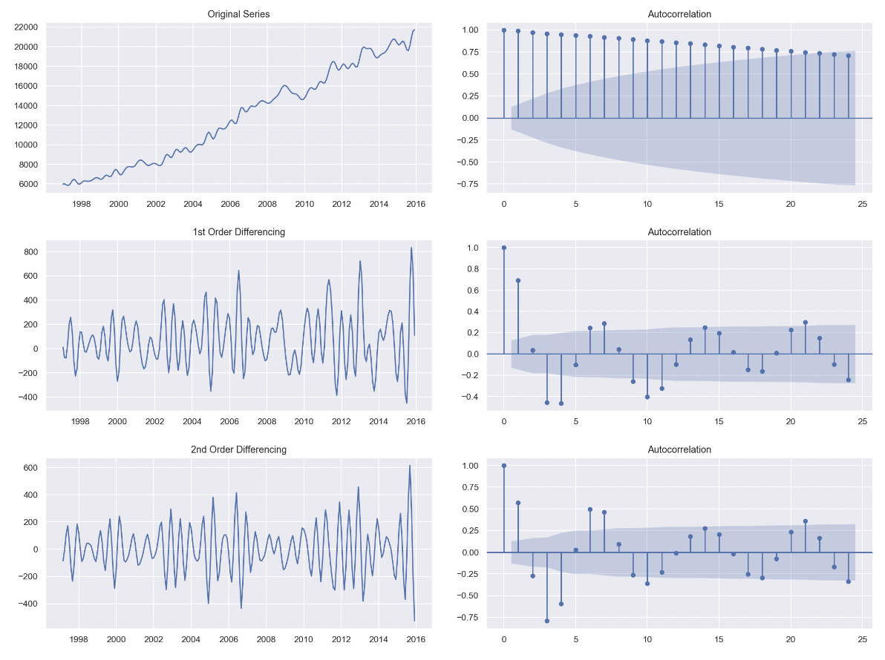

Figure 27: 1st and 2nd Differencing and Autocorrelation plots for trade in Services Worldwide

After the differencing, it has to be decided how many differences are needed in order for the data to be stationary. Looking on Figure 27 to understand visually if stationarity succeeded any signs of trends have to be removed as it can be seen on the 1st number of differences where the data lost their upward trend so that is why the 1st differencing selected (d = 1).

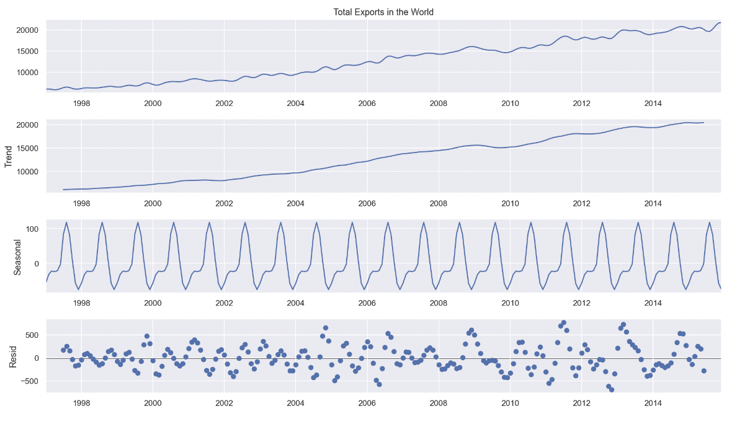

Figure 28: Seasonal Decompose plot for trade in Services Worldwide

After finding the times of differencing, the use of the Seasonal Decompose plot helps to understand if the data have any seasonality or not. This can be identified on the seasonal plot on Figure 27 where the trend goes up and down during a year which means that seasonality exists. That lead to the fact that the model that is going to be used here is ARIMA with seasonality which is called SARIMAX.

Table 5: Dickey Fuller test after differencing for Export in Services Worldwide

|  |  |
| --- | --- |
| **Dickey Fuller Test** | |
| Test Statistic | -3.843285 |
| p-value | 0.002494 |
| Number of Lags Used | 14.000000 |
| Number of Observations Used | 212.000000 |
| Critical Value (1%) | -3.461578 |
| Critical Value (5%) | -2.875272 |
| Critical Value (10%) | -2.574089 |

The results of the Augmented Dickey Fuller test on Table 5 shows that the p-value is 0.002494 which means that the Null Hypothesis has been rejected and the data after 1 time of differencing are stationary.

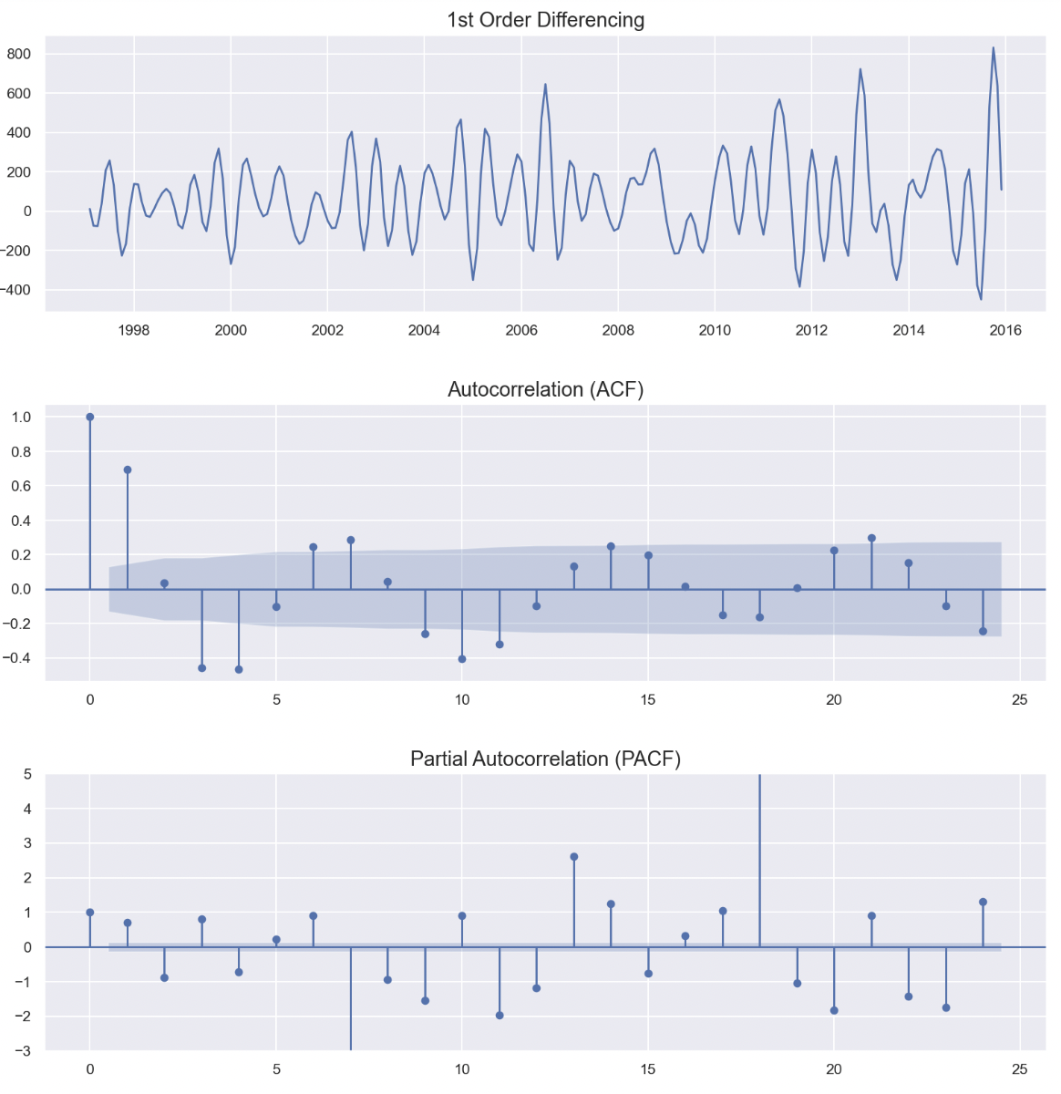

Figure 29: 1st Differencing - Partial Autocorrelation - Autocorrelation plots for trade in Services Worldwide

After selecting the number of differences, Autocorrelation (PACF) and Partial Autocorrelation (ACF) plots need to be created to find the best parameters of p (AR) and q (MA) to build the best ARIMA model (p,d,q) or P, Q and m for the SARIMAX model (P,D,Q,m) (Figure 29).

The number of AR are the lags that are impacting the present values looking at the PACF plot. This can be done by the number of “lollipops” that are before they enter the confidence interval on PACF and in here the p = 5. On the other hand, the same way is used to find the correlation in respect of the lags which is on ACF and so q = 1.

Because the model is seasonal the next step is to find the ideal values for P,D,Q and m. To find the seasonal parameters the same ACF and PACF models are used. The last position of the “lollipop” that is out of the confidence level on PACF is the P and the number of the “lollipops” that are out of the confidence level on ACF plot is the Q.

For this prediction, the P randomly decided to be 1 although it can be any number because there is no line on the confidence level and Q is again decided to be 1. For the D which is the number of differences in the seasonal model it can be found based on the base model as well. The maximum number of differences that a model can have (seasonal and not seasonal) is two so if d = 1 used for the non-seasonal model then D can be 0 or 1 for the seasonal model. Here the differences for the seasonal model decided to be D = 1. The final parameter for the seasonal model is m which is the seasonality of the data and because the data are monthly the m is going to be 12.

The final parameters that resulted from the analysis of the plots for the SARIMAX were (5,1,1) (1,1,1,12) with AIC = 1558.188. After selecting the parameters manually, python has another way called “auto_arima” which can automatically find the best parameters based on the lower AIC and the model here was (5,1,2) (0,0,1,12) with AIC = 1494.942. But even with “auto_arima” sometimes model is not good and that is why the best way to find the parameters is using a mixture manually and automatically until the lower AIC is succeeded. Finally, the model used was SARIMAX (5,1,2) (1,1,1,12) with AIC = 1459.228 being lower than the one of auto arima.

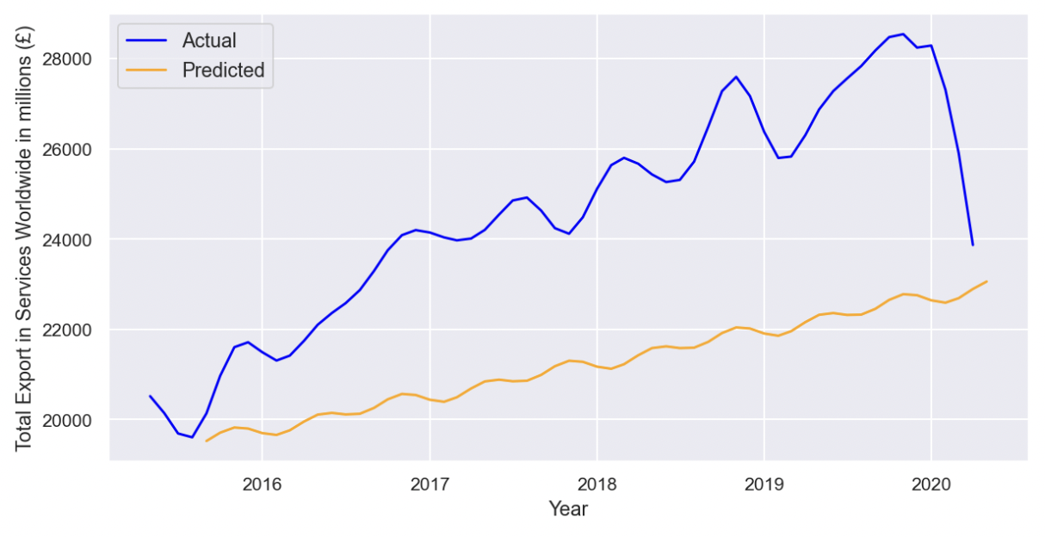

Figure 30: Actual and Predicted exports of Services Worldwide in millions (£)

Finally, after using the ARIMA model the results of the predictions were as can be seen on Figure 30. The predicted trades of services worldwide if the Brexit was never announced and happened were almost two times lower than the actual ones. Moreover, the fluctuations of the actual data were more intense compared to the predicted ones which they increase and decrease with a lower amount.

#### **Import of Services Worldwide**

After plotting and applying differencing to the data (Appendix, Figures A35 and Table A3) and identifying if there is any seasonality from seasonal decompose (Appendix, Figure A36), a selection from the parameters of p, d, q, P, D, Q and m has been made (Appendix, Figure A37) and the manual parameters selected were SARIMAX (0,1,2) (0,0,3,12) with AIC = 1597.267. The auto arima parameters found SARIMAX (5,2,2) (0,0,0,12) with AIC = 1239.167. After mixing them, a better model has been found, SARIMAX (5,2,2) (0,1,1,12) with AIC = 1191.800. As mentioned before, the lower the AIC is, the better the ARIMA model would be.

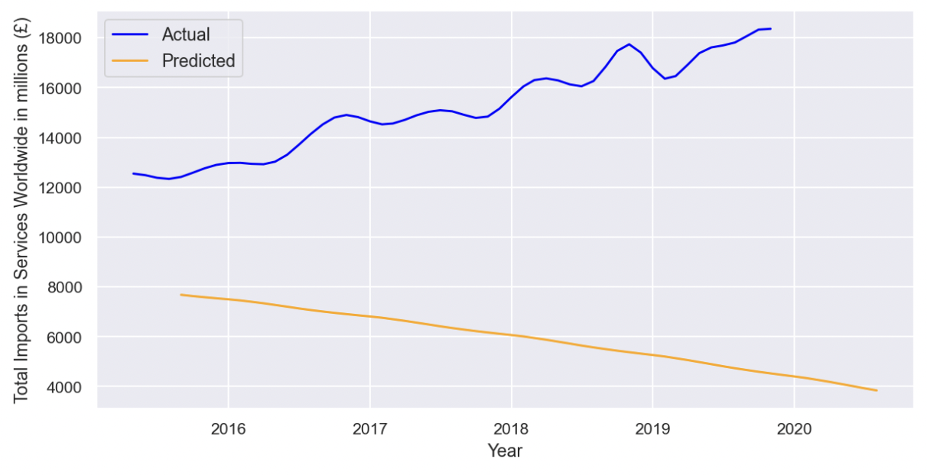

Figure 31: Actual and Predicted Imports of Services Worldwide in millions (£)

On Figure 31 the predicted import of services worldwide were lower and they were kept decreasing whereas the actual data were increasing with small fluctuations.

#### **Import of Goods Worldwide**

For the import of goods worldwide, a simple plot and plot with differencing for the data have been made (Appendix, Figures A38 and Table A4) and seasonal decompose to see if any seasonality exist (Appendix, Figure A39). Afterwards a selection from the parameters of p, d, q, P, D, Q and m has been made (Appendix, Figure A40) and the manual parameters selected were SARIMAX (0,1,0) (1,1,0,12) with AIC = 2553.918. The auto arima parameters found SARIMAX (0,1,0) (0,0,0,12) with AIC = 2664.458 In the end, a better model has been found using the manual and the auto one, SARIMAX (0,1,0) (1,1,1,12) with AIC = 2515.652

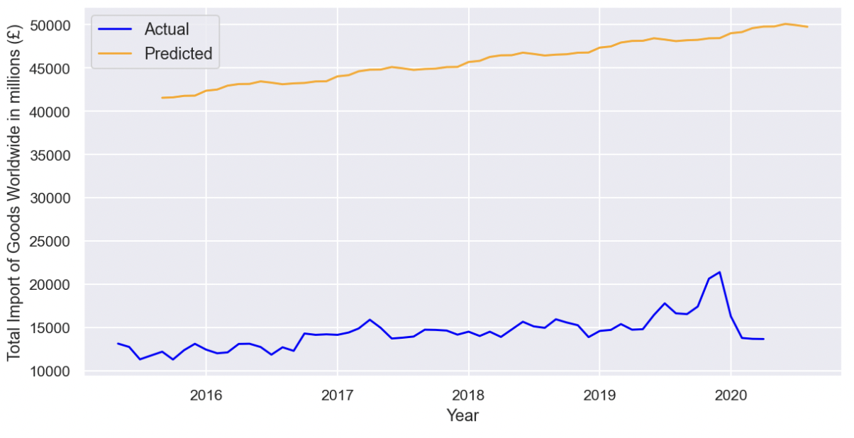

Figure 32: Actual and Predicted imports of Goods Worldwide in millions (£)

Looking on the Figure 32 of the import of goods worldwide, the first think noticed is that the predicted data was far higher than the actual ones. They both seem to stay generally around on the same range of values although predicted values are more stable whereas the actual ones shows more fluctuations.

#### **Export in Goods Worldwide**

For the exports in Goods Worldwide a plot of the original data have been made as well as the differencing ones with the ADF test to see if there is stationarity ( Appendix, Figure A41 and Table A5). The seasonality identified from seasonal decompose plot (Appendix, Figure A42) and then ACF and PACF plotted to find p, d, q, P, D, Q parameters for the model. The manual model was SARIMAX (0,1,1) ( 0,1,0,12) with AIC = 2575.527, the auto arima found SARIMAX (0,1,0) ( 0,0,0,12) with AIC = 2670.905 and then finally selected SARIMAX (0,1,0) ( 1,1,1,12) with lower AIC = 2520.609.

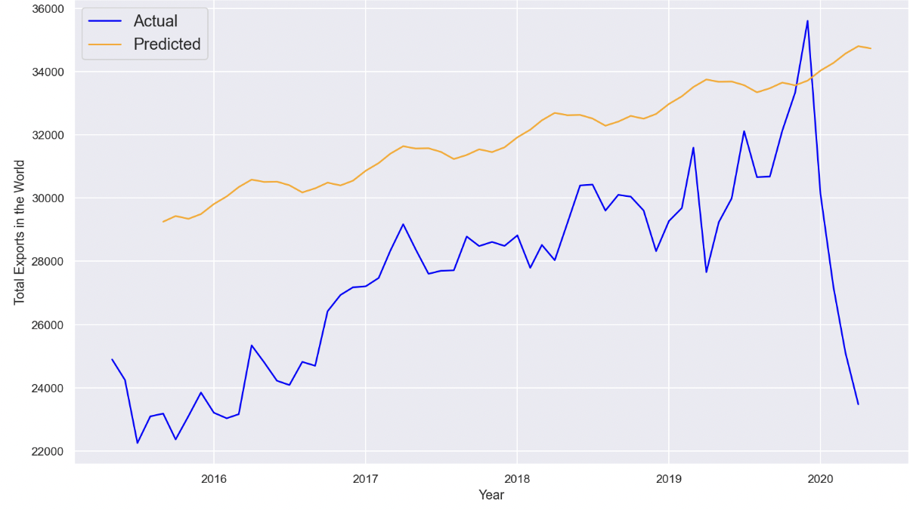

Figure 33: Actual and Predicted trade of Goods Worldwide if the Brexit never happened

The results on Figure 33 shows that in all years between 2016 until later on 2020 the predicted data are above the actual. The Actual data were increasing on those years with multiple fluctuations during them in contrast to the predicted data showing that the trade of goods would be increasing.

### **Forecasting the future**

For this part a forecasting has been made to create an image on how Brexit would affect the trades in the next years. The data used for this prediction were from 1999 until 2022.

#### **Export in Services Worldwide**

The time series and selection for the model for the forecasting were as used for the predictions on section 4.3.1. At first the original series and the differencing of them have been plotted (Appendix, Figure A44 and Table A6) and then created a seasonal decompose plot to see if there was any seasonality (Appendix, Figure A45). The next step was to find the values of parameters p, d, q, P, D, Q with the PACF and ACF plot (Appendix, Figure A46). The parameters that have been found manually was SARIMAX (1,1,1) ( 2,0,2,12) with AIC = 2904.787, the auto arima found SARIMAX (1,1,1) ( 2,0,2,12) with AIC = 2887.504 and then finally selected SARIMAX (1,1,1) ( 2,1,2,12) with lower AIC = 2786.343.

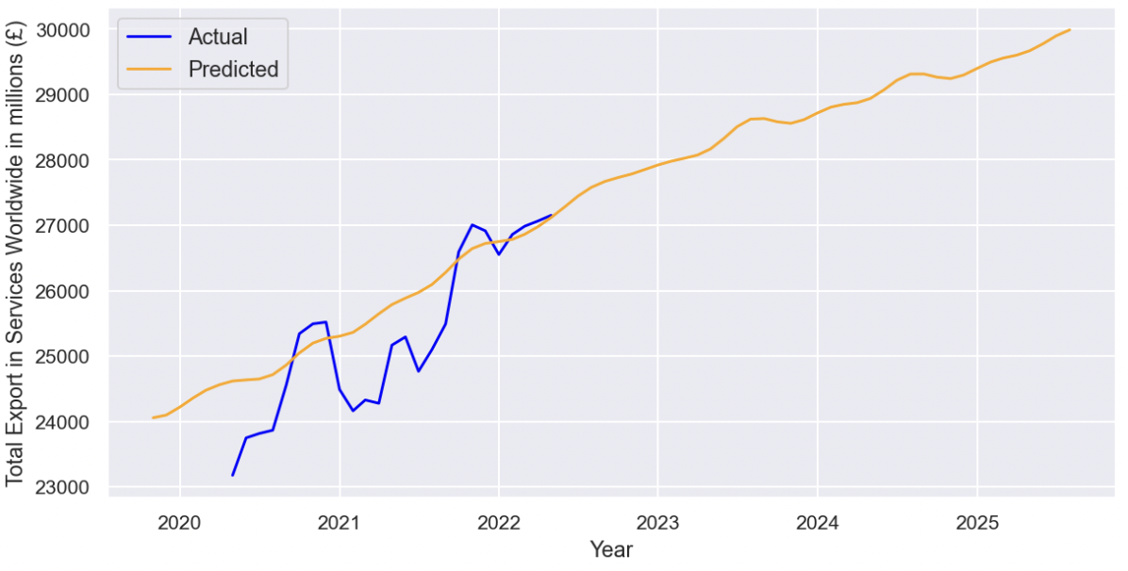

Figure 34: Actual and Predicted Exports of Services Worldwide in millions (£)

On Figure 34 the future predictions of exports in services worldwide steadily increased from 2020 and for the next years whereas the actual data seems to have dropped drop in 2021 and then started increasing again.

#### **Imports of Services Worldwide**

Moving now to the time series analysis and predictions of goods in EU countries, a plot of the original data with the differencing along with the Augmented Dickey Fuller Test have been made (Appendix, Figure A47 and Table A7). The next step was to plot the seasonality (Appendix, Figure A48) and then the Autocorrelation and Partial Autocorrelation plots to get all the parameters for the seasonal ARIMA model (Appendix, Figure A49). The parameters from the manual way were SARIMAX (1,1,2) (4,1,2,12) with AIC = 2139.789 where the parameters from auto arima were SARIMAX (4,1,0) (2,0,0) with AIC = 2069.429. Finally, the model used was SARIMAX (5,1,1) (2,1,0,12) with a lower AIC = 2020.081.

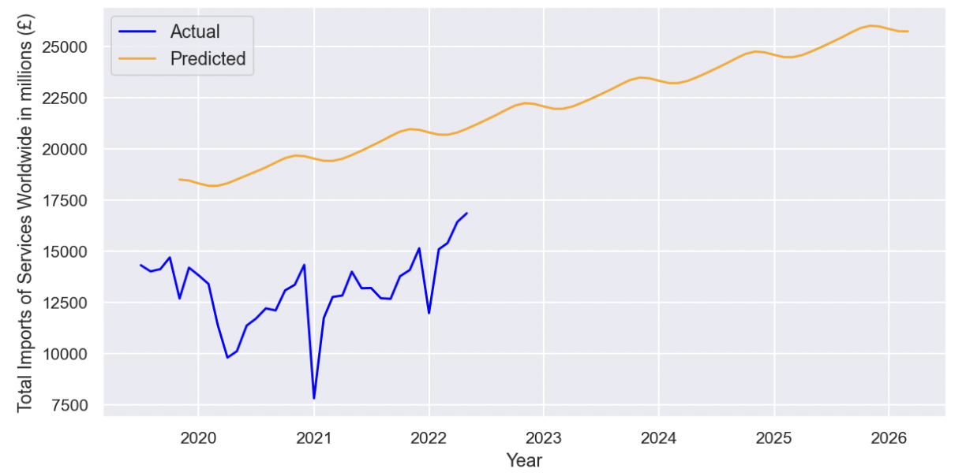

Figure 35: Actual and Predicted Imports of Services Worldwide in millions (£)

The Figure 35 shows the predictions of imports services worldwide for the next years. It can be noticed although the actual data have dropped continuously especially in 2021 whereas the predicted are steadily increasing and they are higher than the actual data.

#### **Import of Goods Worldwide**

#### The first thing needed to be done to find the best parameters for the Arima model was to plot the raw data and its 1st and 2nd difference as well as the ADF test results to see if the data became stationary (Appendix, Figure A50 and Table A8). After finding d, a check for seasonality needed (Appendix, Figure 51) and then the plots of PACF and ACF for the p, d, q, P, D, Q and m parameters (Appendix, Figure 52). The model found from the plots was SARIMAX (1,1,1) (2,1,0) with AIC = 4035.266 and from auto arima the parameters were SARIMAX (1,1,0) (0,0,1) with AIC = 4035.671. Mixing the values of the parameters, the final parameters were SARIMAX (1,1,1) (2,1,1,12) with AIC = 3892.498.

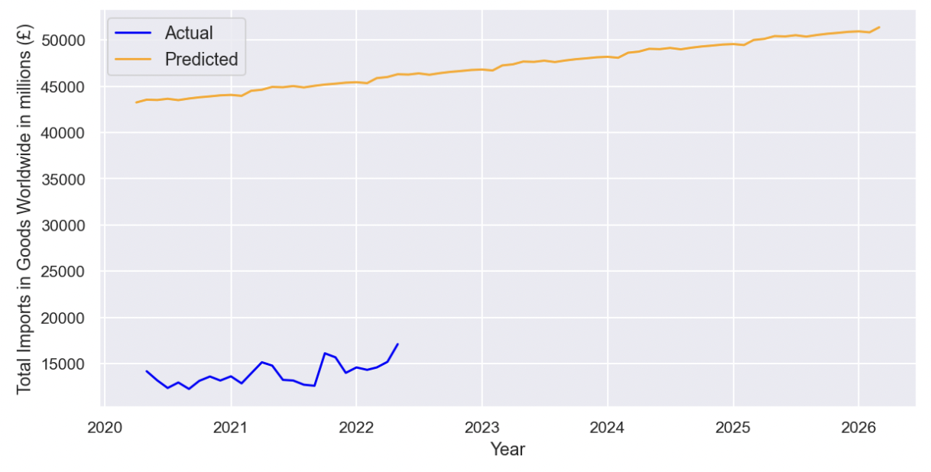

Figure 36: Actual and Predicted Imports of Services Worldwide in millions (£)

#### Figure 36 shows the predictions of imports in services worldwide. Although the actual data until 2022 have a small increase with drops on those years, the predictions seem to keep increasing throughout the next years and they are significantly higher in terms of imports in millions (£).

#### **Export of Goods Worldwide**

The exact same steps used from the previous areas to create the predictions used here as well. From plotting and identifying the number of differences (Appendix, Figure A53 and Table A9) to check from seasonality (Appendix, Figure A54) and then finally identifying manually the ARIMA parameters from ACF and PACF plots (Appendix, Figure A55). The manual parameters found were SARIMAX (1,1,2) (1,1,1,12) with AIC = 3806.748 and automatically SARIMAX (1,1,0) (0,0,0,12) with AIC = 3957.987. The model used finally based on the manual and auto one was SARIMAX (1,1,0) (1,1,1,12) with a lower AIC = 3805.716.

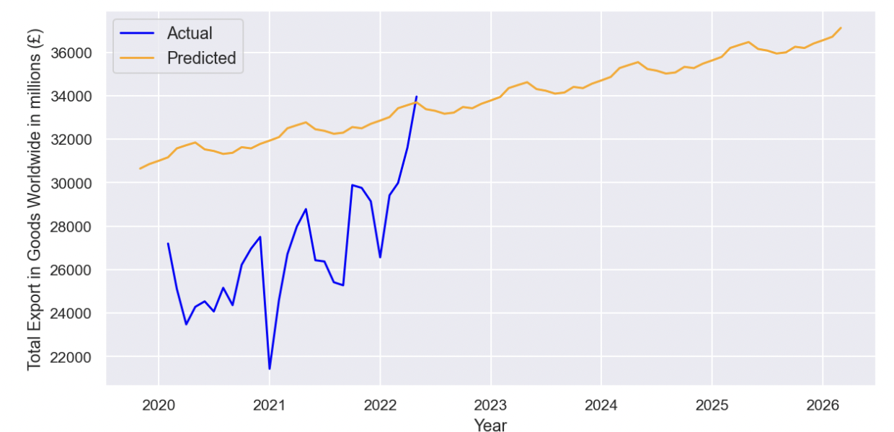

Figure 37: Actual and Predicted Imports of Services Worldwide in millions (£)

Looking at Figure 37 for the predictions worldwide the actual until 2022 were increasing with bold fluctuations whereas the predicted ones were increasing with small decreases every year.

# Evaluation & Discussion

This Evaluation and Discussion part of the analysis where an interpretation of the results overall in each category would be given as well as a connection with literature when needed and where it exists.

## **5.1 Descriptive Analysis**

The first step before the project was to provide a much simpler view of the data. Starting with trade in goods annually, it seems that from 1999 until 2020 the most frequent amount of exports that UK use to do in EU countries was between 110000 and 150000 million (£) compared to the Non-EU countries which was between 200000 and 300000 million (£). That means that either UK exported more in Non-EU countries, or the costs of exports were higher due to the trade barriers. For the UK’s imports in goods from EU countries it seems that there is no common value whereas from imports to Non-EU countries the values were between 250000 and 425000 million (£) which were high.

On the other hand, the exports in services seemed to be commonly higher than goods in EU countries whereas the opposite observed from Non-EU countries. Moreover, the UK’s imports were overall lower from both EU and Non-EU countries. The results here showed that the value in million of (£) were more in EU countries where they were not any trade barrier and that means clearly that the export of services was higher in EU than Non-EU countries.

## **Trend Analysis**

**5.2.1 General Analysis**

An overall review in all years from 1999 until 2022 shows that UK exports and imports of Goods and Services from Non-EU countries were mostly from United States inc Puerto Rico where from EU countries were Germany and France.

From the trend analysis it has been observed that the export of goods from UK throughout the years was always higher than services in terms of millions of (£) to EU and Non-EU countries and they were increasing all these years until the peak in 2019.

One more thing from the general analysis was that the Cars was the top category of Goods that UK imported and exported where for the services the highest category was “Other Business Services” like research and development or professional and management consulting services (EU international trade in other business services, 2022).

### **Timeline Before Brexit Referendum (2009 - 2015)**

For the period before Brexit referendum there was not any important observation because it was mostly included on the general analysis. The only thing noticed is that quarterly the trades of services were more stable in contrast to the trades of goods where they were fluctuating a lot.

### **5.2.3 Timeline from when Brexit announced until it happened (2016 - 2019)**

When the Brexit was announced at first the expectation was to take place within two years of the referendum but that did not happen. A sort of announcements has been made during this period and the aim of this section of the analysis was to see if there was any impact on the trades of UK with EU and Non-EU countries the next quarter of each announcement.

Starting with the exports of goods and services in EU countries the analysis showed that from the 5 important announcements, on three of them goods decreased and only once services slightly dropped down. For the imports of goods and services, three quarters have an impact on services and one on goods. On the other hand, for exports to Non-EU countries only one of 5 dates affected the trades, and two announcements affected the imports from Non-EU countries. The overall conclusions were that during these announcements the exports and imports of goods and services within the EU countries were affected enough whereas there was not any big impact to Non-EU countries.

In order to gain a clearer view whether the trades of UK impacted from those announcements, a further analysis is presented to identify the impacts of them on the top countries (Hamroush S., 2019) and the top categories of goods and services (Eurostat Statistics, 2022).

The top countries UK export and import goods and services in EU were Germany and Netherlands and Ireland and Spain. On the export and import of goods in EU countries, 2 out of 5 announcements had an impact on them where for the import, on three of those dates both countries had a decrease. On the other hand, there was not any consequence on imports and export of services on the top countries for the UK trades in Europe. The top countries UK export and import goods and services in Non-EU countries were US, China, Switzerland and Japan. The trades of goods to \the Non-EU countries had a decrease on at least half of the announcements whereas the trade on services did not show any significance change. Overall, the UK’s trades (exports and imports) had a significant impact during those 5 announcements after the Brexit referendum mainly in goods from both EU and Non-EU countries in oppose to the trade in services which they did not show any important changes.

The next step was to find any impacts on the top four categories of goods and services in the announcements after the Brexit announced. Looking at the effects on the European site, the import and export of the top categories of goods affected a lot whereas the imports showed a decrease only in one or two of those dates. Moving to the results of the trades to the Non-EU countries all exports imports in goods and services had a on three or more of the five announcements. This led us to the conclusion that in EU countries only the trade in goods decreased whereas in Non-EU countries the impact was for both trades in the categories of goods and services.

### **5.2.4 Timeline after Brexit until today (2020 – 2021)**

On the 1st of May 2021 the new trade and cooperation agreement between UK and EU countries came into force saying that there is a free trade in goods but a limited mutual market access in services (EU trade relations with the UK, 2021).

Starting with the top 10 countries that UK exports goods the most, it is generally noticed that the exports in millions (£) in most of them increased which means it may be because of the new trade agreement of free trade on goods although the opposite seems to be happening with the imports of goods especially in EU countries (Casey A., 2022). The Exports in services are increasing and the imports are decreasing. This could be the reason that the costs of exporting are higher and the imports because of the agreements are less so that’s the decrease on the values in millions (£).

The quarterly exports and imports in goods of those two years after Brexit increasing in EU countries if take into consideration the trade agreements where in Non-EU countries only imports were increasing which that was noticed on the previous years as well. On the other hand, trades of services in EU countries have a negative slope (again because of the trade and cooperation agreements) whereas the trades of services in Non-EU countries are hardly increasing or decreasing.

## **Predictive Analysis**

The evaluation on this part is for the predictions on the imports and exports of goods and services in total terms worldwide. A comparison has been made between the actual data right after the Brexit referendum until it happened with the forecasts.

### **Forecasting the scenario if the Brexit never happened**

The data used on this forecasting scenario were until 2015 (right before Brexit referendum) in order to have a better view on the predictions without any inference of the announcements.

To start with, the predictions of the services worldwide seem to be lower than the actual data. This shows that if the announcement never happened and no Brexit was on the table that the export of services would have been lower although more stable with fewer fluctuations. On the other hand, the predicted imports of services in the whole world seems to be lower than the actual ones as well as decreasing whereas the actual data were increasing. The conclusion of those two predictions led to the fact that in the forecasting scenario of no Brexit both imports and export of services would have been much lower than the actual. Also, the announcements had indeed affected the trades of services probably because in the future trade barriers were unpredictable and so UK continued to trade as long as it could with the free trade barriers.

Moving to the predictions of trade in goods, the first thing noticed was that the predicted imports were way too high compared to the actual ones in contrast to the export of goods which predicted and actual ones seemed to be closer. Evaluating those two predictions now, it is obvious that during those years from 2016 – 2019 the Brexit plan affected the trade in goods. More specifically, if the Brexit never announced the imports of goods predicted to be much more in terms of millions (£) but the actual ones were higher probably because the other countries were started to look for other trade areas to turn to. The UK’s exports of goods on the other hand predicted to be close to the actual data because exports were higher on UK in all years.

On Douch *et al* (2018) a quite similar analysis on the impact of the announcements in control period and the treatment one that affected by the announcements have been made to understand the trade effects. The results there showed the actual exports and imports of goods and serviced worldwide (EU and Non-EU countries) were lower than the ones that have not treated with any announcements. The same thing notice on the predictions of goods if Brexit never happened where similar results found here for the imports.

### **Forecasting the future**

For the forecasting of the future data have been used from 1999 until 2022 to have a more accurate view of the predictions.

Starting with the import and exports of services worldwide, the results showed that the trades in terms of millions (£) were predicted to increase in the future. A good explanation of that is because with the new trade agreement between UK-EU (EU trade relations with the UK, 2021) the trades barriers in services would not be free so the values would increase in terms of millions of pounds. For the goods, the predictions were higher and seemed that they would increase in the future. The interpretation of that is the years before, as noticed in the analysis, the exports were higher and now they will keep increasing because of the free trade agreement and cooperation.

Running back to the literature review, one of the closest scenarios that the majority of the paper focused was the “Soft Brexit” where it says that there are no trading tariffs between EU-UK. The findings of Latorre M.C *et al* (2019) showed a drop on the trades in EU and Non-EU countries whereas on this the prediction made here it seems that the trades will increase on both exports and imports.

# Conclusions & Future Work

Brexit was a big change not only to the UK’s economy but to the whole world. Europe was one of the most important trade areas of the UK and it was expected that with Brexit a wave of consequences would come in the end. Almost two years after UK left EU and it still unclear what the changes would be. That is why this project focused on the impacts of the referendum on the trades so the past can enlighten what the future would bring.

When the project first started, the main questions were to traceback to the time before Brexit and get a better understanding on how the trends were moving. Then to investigate if the Brexit announcements affect the UK international trades with other countries and what would happen if the Brexit was never announced. Last, an important question was to answer what will happen in the future now that UK left the EU.

Before analysing the data the expectation from the literature review was that the exports would always be higher than imports in both goods and services. Then right after the Brexit announcement it was expected that those dates would affect in total the trades of UK and in the case that Brexit never happened the trades would be as it was now. For the future, the trades of both goods would stay the same where a decrease would be evident on services because of the trade barriers.

Some of the expectations were indeed right where some other not so much. Exports of goods and services where above imports in all years and on both EU and Non-EU countries. From 2016 until 2019 when the important announcements of Brexit have been made, an impact on the trades was detected on EU countries whereas there was not any big change for the Non-EU countries. The predictions if the Brexit never happened showed the exports and imports of services would have been lower than the actual ones whereas the imports and imports of goods would have been the same and slightly higher. The findings for the future predictions on the other hand were that trades of goods and services would increase in the future because services would be higher in terms of millions of pounds with the same quantity due to the non-free trade barriers where the goods would be trading with free barriers.

During the project some limitations have been noticed. First of all the analysis was not enough with only the use of exports and imports in terms of millions of pounds. It would be easier and clearer if data of international trades would be available in terms of quantities. One more limit of the analysis was due to the lack of time the predictions were only for the whole world but it would be ideally better if it had be done for EU and Non-EU countries separately. Moreover, the data after Brexit were not enough because it is still early and the data are for almost two years. That limited the ability to interpret with actual data the consequences of Brexit on the international trade.

The aim of this project is to give a better understanding on what the impacts of Brexit were and to predict what the future results would be. A lot of analysis and predictions have been left for the future due to the lack of time and data. Further and deeper analysis can be made with the analysis of each country that UK traded the most and least, better and more accurate predictions with new data for the next years and the use of more categories of data would give a more detailed analysis with more accurate results.

# References

1. Statista (2016). Results of the United Kingdom's European Union membership referendum on June 23, 2016. Available at: <https://www.statista.com/statistics/570118/eu-referendum-results/>
2. European Union (2012). Consolidated version of the Treaty on European Union, art. 50, 2012 OJ C 326. Available at: <https://eur-lex.europa.eu/legal-content/EN/TXT/?uri=celex%3A12012M%2FTXT>
3. European Commission (2016). UK Referendum on Membership of the European Union: Questions & Answers. Available at: <https://ec.europa.eu/commission/presscorner/detail/en/MEMO_16_2328>
4. Carl N. (2018). CSI Brexit 4: People’s stated reasons for voting Leave or Remain. CSI Nuffield.
5. Hammond P. (2016). Alternatives to EU Membership (Archived). GOV UK. Available at: <https://www.gov.uk/government/speeches/alternatives-to-eu-membership>
6. Dhingra S., Ottaviano G.I., Sampson T. and Reenen, J.V. (2016). The consequences of Brexit for UK trade and living standards
7. Dhingra S., Huang H., Ottaviano G., Paulo Pessoa J., Sampson, T. and Van Reenen, J. (2017). The costs and benefits of leaving the EU: trade effects. Economic Policy, 32(92), pp.651-705
8. Looi Kee H. and Nicita A. (2017). Short-Term Impact of Brexit on the United Kingdom's Export of Goods. World Bank Policy Research Working Paper No. 8195
9. Cappariello R. (2017). Brexit: estimating tariff costs for EU countries in a new trade regime with the UK. Bank of Italy Occasional Paper, (381).
10. Brakman S., Garretsen H. and Kohl T. (2018). Consequences of Brexit and options for a ‘Global Britain’. Papers in regional science, 97(1), pp.55-72.
11. Hosoe N. (2018). “Impact of border barriers, returning migrants, and trade diversion in Brexit: Firm exit and loss of variety”. Economic Modelling, vol 69, pp.193 - 204
12. Byrne S. and Rice J. (2018). Non-tariff barriers and goods trade: a Brexit impact analysis (No. 6/RT/18). Central Bank of Ireland.
13. Douch M., Eds T.H. and Soegaard, C. (2018). The trade effects of the Brexit announcement shock. Warwick Economics Research Papers, 1176.
14. Pisani M. and Vergara Caffarelli F. (2018). What will Brexit mean for the British and euro-area economies? A model-based assessment of trade regimes. A Model-Based Assessment of Trade Regimes (January 29, 2018). Bank of Italy Temi di Discussione (Working Paper) No, 1163.
15. Campos Rodolfo G. and Timini J. (2019). “An Estimation of the Effects of Brexit on Trade and Migration”, Banco de Espana Occasional Paper No. 1912. [online]. Available at: <https://ssrn.com/abstract=3396986>
16. Latorre M.C., Olekseyuk Z. and Yonezawa H. (2020). Trade and foreign direct investment‐related impacts of Brexit. The World Economy, 43(1), pp.2-32.
17. Stack M.M. and Bliss M. (2020). EU economic integration agreements, Brexit and trade. Review of World Economics, 156(3), pp.443-473.
18. Force B.T. (2020). A review of economic analyses on the potential impact of Brexit.
19. Nikolova I. (2021). Challenges For Eu-Uk Trade Relationship In 21st Century. Economy & Business Journal, 15(1), pp.24-35.
20. Fernandes A.P. and Winters L.A. (2021). Exporters and shocks: The impact of the Brexit vote shock on bilateral exports to the UK. Journal of International Economics, 131, pp.103489.
21. Ward M. (2021). Statistics on UK-EU trade. HC Library CBP, 7851.
22. Fucacchia I., Salvatici L and Alan Winters L. (2022). The consequences of the Trade and Cooperation Agreement for the UK’s international trade. Oxford Review of Economic Policy, vol. 38, no.1, pp. 27-49
23. Ballicu G., Aznar A.R., Robinson C. and Tong M. (2022). International Trade, FDI and Productivity. Covid-19 and Productivity, pp. 47-69
24. Fucacchia I., Salvatici L and Alan Winters L. (2022). The consequences of the Trade and Cooperation Agreement for the UK’s international trade. Oxford Review of Economic Policy, vol. 38, no.1, pp. 27-49
25. Hu X. and Guo Y. (2022). How UK Exit from EU Influence UK’s Economy. In 2022 7th International Conference on Financial Innovation and Economic Development (ICFIED 2022) (pp. 2070-2077). Atlantis Press.
26. Yi C.D. (2022). Economic impacts of UK's free trade agreements with Korea, Japan, and EU as a breakthrough of Brexit. The Manchester School
27. Shepotylo O. and Du J. (2022). Brexit and Services Trade New Evidence from the Synthetic Diff-in-Diff Approach. Available at SSRN 4166935.
28. Casey A. (2022) UK trade: June 2022. [online]. Available at: <https://www.ons.gov.uk/economy/nationalaccounts/balanceofpayments/bulletins/uktrade/june2022>
29. (2022). International trade. Office for National Statistics. [online]. Available at: <https://www.ons.gov.uk/businessindustryandtrade/internationaltrade>
30. (2022). UK total trade: all countries, seasonally adjusted. Office for National Statistics. [online]. Available at: <https://www.ons.gov.uk/economy/nationalaccounts/balanceofpayments/datasets/uktotaltradeallcountriesseasonallyadjusted>
31. (2022). Trade in goods: country-by-commodity exports. Office for National Statistics. [online]. Available at: <https://www.ons.gov.uk/economy/nationalaccounts/balanceofpayments/datasets/uktradecountrybycommodityexports>
32. (2022). Trade in goods: country-by-commodity imports. Office for National Statistics. [online]. Available at:

<https://www.ons.gov.uk/economy/nationalaccounts/balanceofpayments/datasets/uktradecountrybycommodityimports>

1. (2022). UK trade in services: service type by partner country, non-seasonally adjusted. Office for National Statistics. [online]. Available at:

<https://www.ons.gov.uk/businessindustryandtrade/internationaltrade/datasets/uktradeinservicesservicetypebypartnercountrynonseasonallyadjusted>

1. (2022). UK trade time series. Office for National Statistics. [online]. Available at:

<https://www.ons.gov.uk/economy/nationalaccounts/balanceofpayments/datasets/tradeingoodsmretsallbopeu2013timeseriesspreadsheet>

1. (2022). Trade in goods: all countries, seasonally adjusted. Office for National Statistics. [online]. Available at:

<https://www.ons.gov.uk/economy/nationalaccounts/balanceofpayments/datasets/uktradeallcountriesseasonallyadjusted/current>

1. Nau D. (2020). ARIMA models for time series forecasting. [online]. Available to: <https://people.duke.edu/~rnau/411arim.htm>
2. Verma Y. (2021). Complete Guide To SARIMAX in Python for Time Series Modelling. Developers Corner.
3. Peixeiro M. (2021). Defining the Moving Average Model for the Time Series Forecasting in Python. Towards Data Science
4. Bush T. (2022). Descriptive Analysis: How-To, Types, Examples. PESTLE ANALYSIS
5. (2022). Data Protection. Office for National Statistics. [online]. Available at: <https://www.ons.gov.uk/aboutus/transparencyandgovernance/dataprotection>
6. (2022). EU international trade in other business services. Eurostat Statistics Explained.
7. Casey A., (2019). UK trade in services by partner country. Office for National Statistics. [online]. Available at: <https://www.ons.gov.uk/businessindustryandtrade/internationaltrade/bulletins/exportsandimportsstatisticsbycountryforuktradeinservices/julytoseptember2019>
8. Gibbs C., (2018). UK trade in services by partner country experimental data. Office for National Statistics. [online]. Available at: <https://www.ons.gov.uk/businessindustryandtrade/internationaltrade/bulletins/exportsandimportsstatisticsbycountryforuktradeinservices/octobertodecember2018>
9. Hamroush S., (2018). International trade in services by partner country. Office for National Statistics. [online]. Available at: <https://www.ons.gov.uk/businessindustryandtrade/internationaltrade/bulletins/exportsandimportsstatisticsbycountryforuktradeinservices/quarter4octobertodecember2017>
10. (2022). United Kingdom – EU - international trade in goods statistics. Eurostat Statistics Explained. [online]. Available at: <https://ec.europa.eu/eurostat/statistics-explained/index.php?title=United_Kingdom-EU_-_international_trade_in_goods_statistics#EU_and_the_United_Kingdom_in_world_trade_in_goods>
11. (2021). EU trade relations with the UK, 2021. European Commission. [online]. Available at: <https://policy.trade.ec.europa.eu/eu-trade-relationships-country-and-region/countries-and-regions/united-kingdom_en#:~:text=The%20EU%20and%20the%20UK,and%20adoption%20by%20the%20Council>.

# Chart, box and whisker chart Description automatically generatedAppendix

Figure A1: Box plots of Goods Quarterly in millions (£)

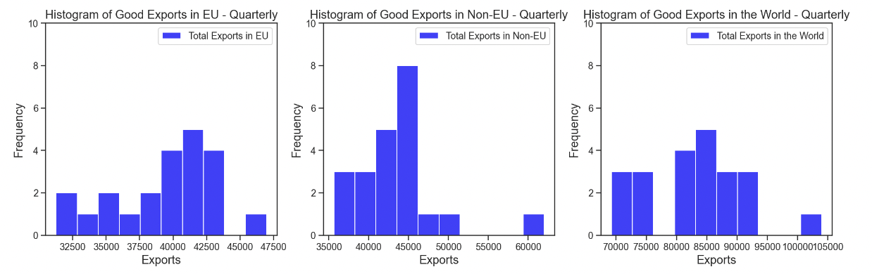

Figure A2: Histograms of Exports in Goods Quarterly in millions (£)

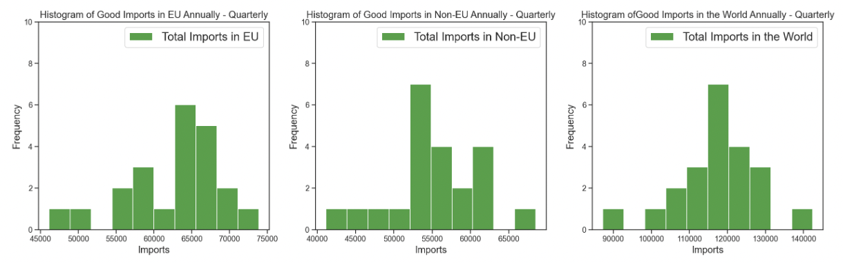

Figure A3: Histogram of Imports in Goods Quarterly in millions (£)

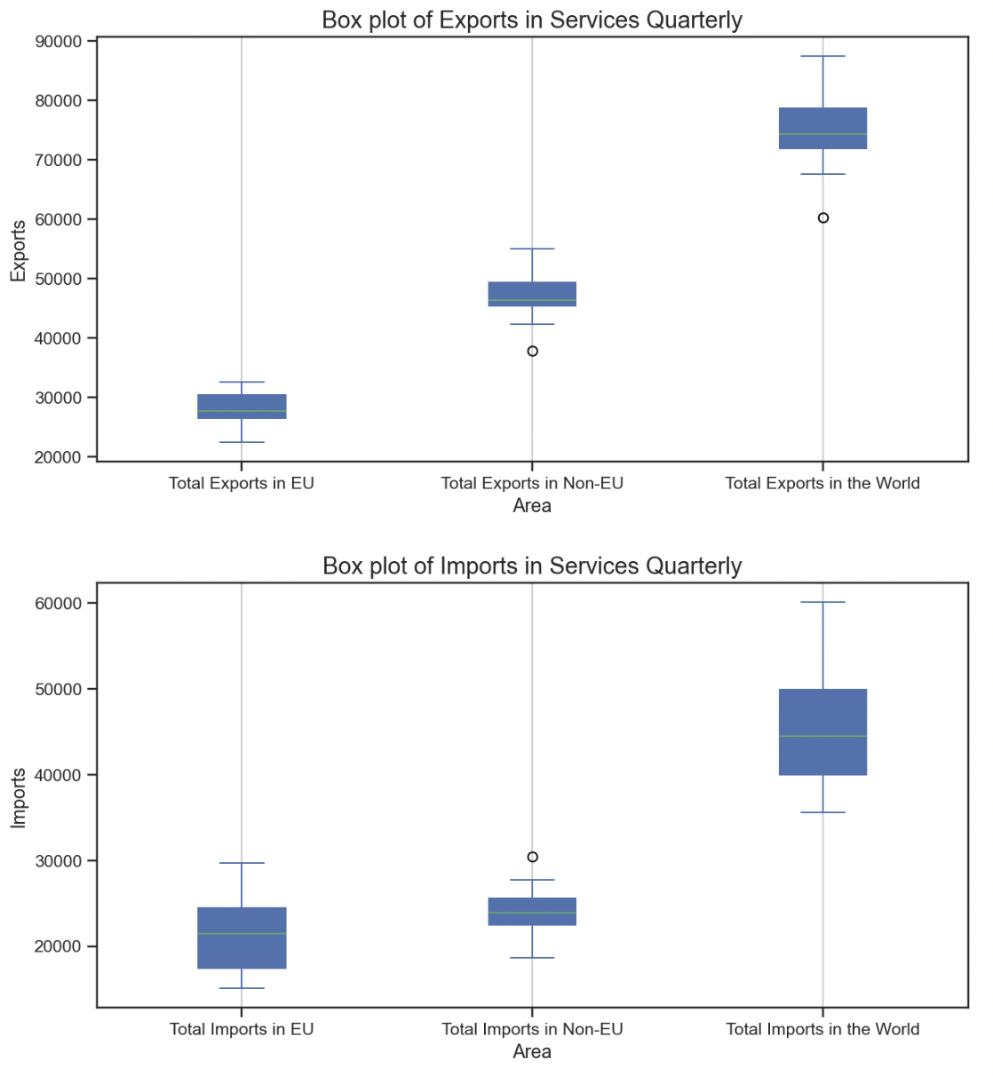

Figure A4: Box plots of Services Quarterly in millions (£)

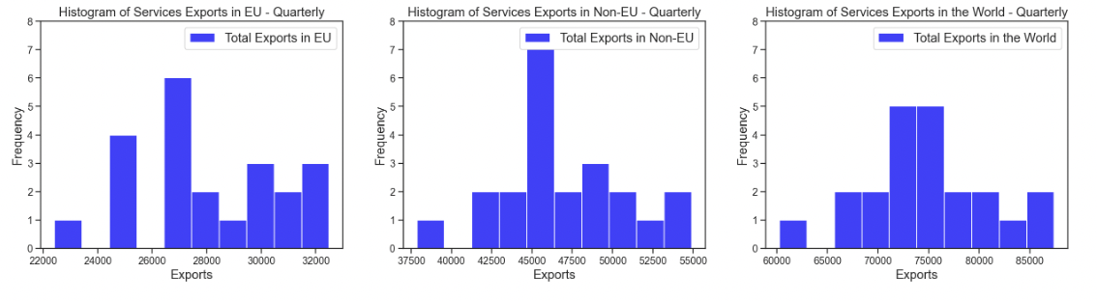

Figure A5: Histograms of Exports in Services Quarterly in millions (£)

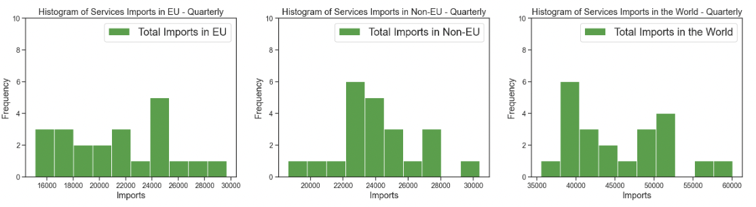

Figure A6: Histograms of Imports in Services Quarterly in millions (£)

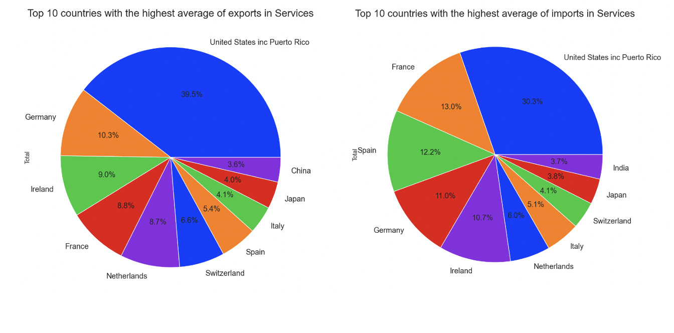Figure A7: Average of the Top 10 higher countries trade Services (%)

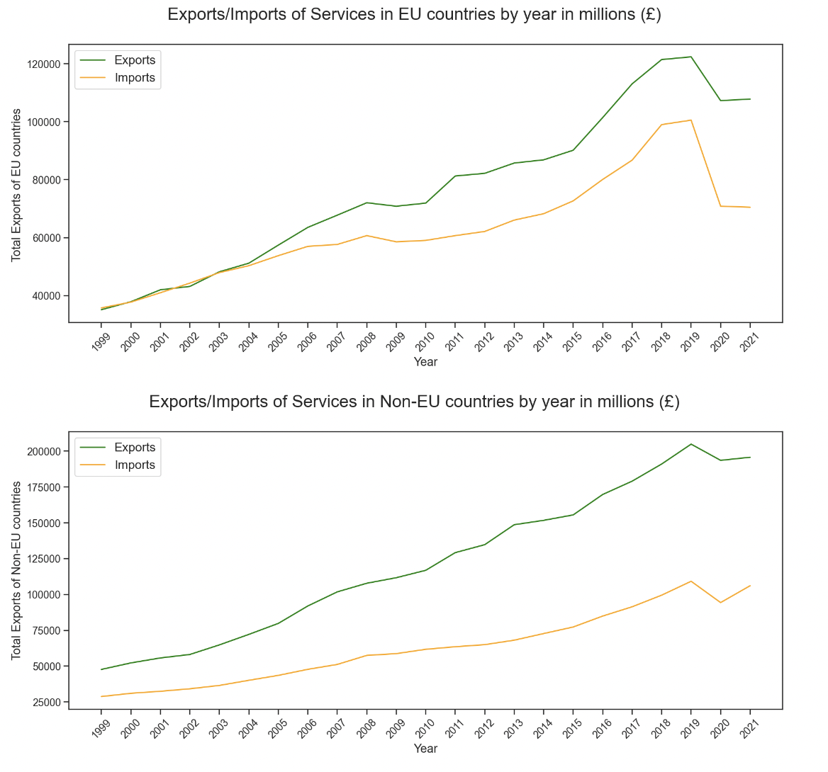

Figure A8: Trade of Services based on the area in millions (£)

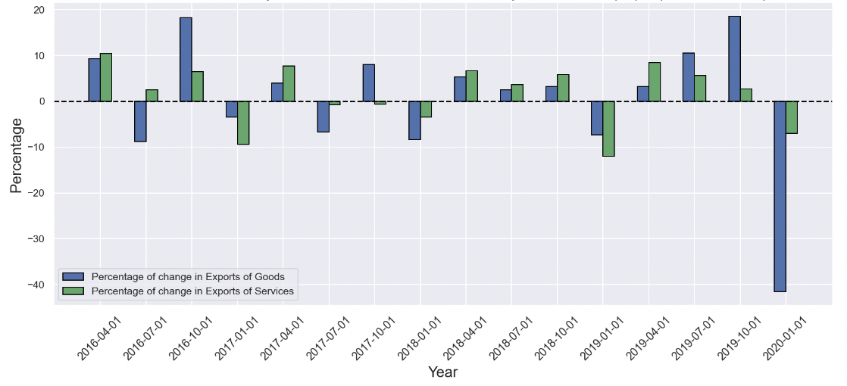

*Figure A9: Change of Exports based on the previous quarter in Non-EU countries (%) from 2016 - 2019*

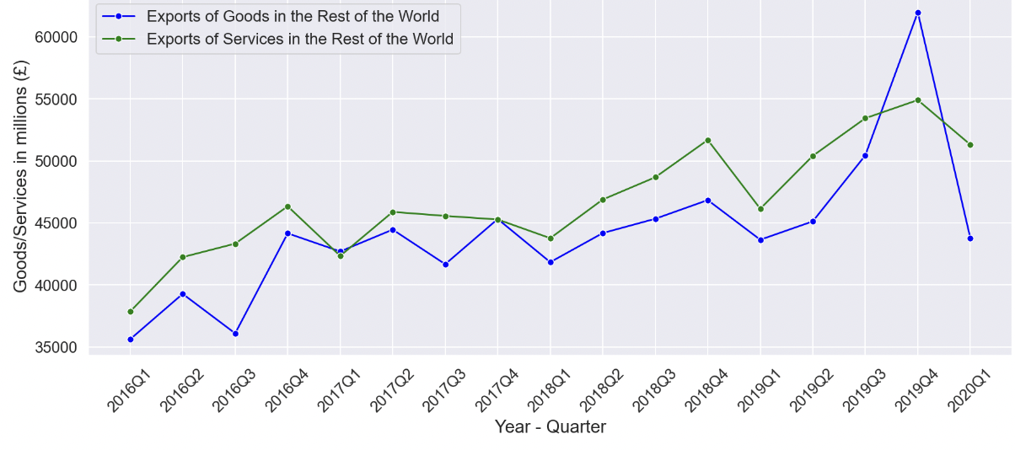

Figure A10: Exports in Non-EU countries per quarter in millions (£) from 2016 – 2019

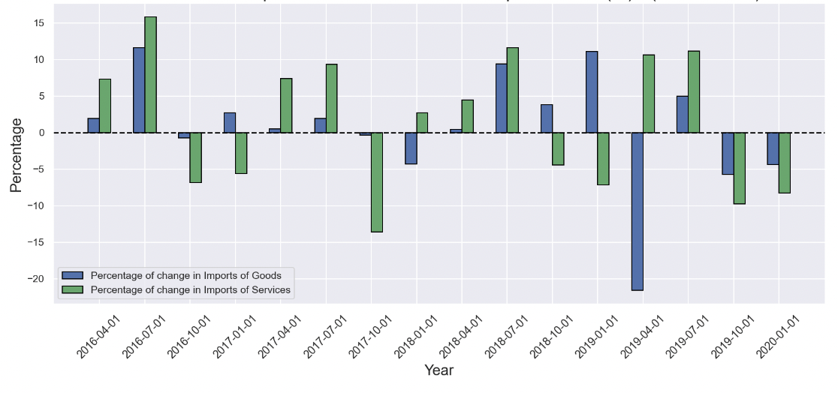

Figure A11: Change of Imports based on the previous quarter in Non-EU countries (%) from 2016 – 2019

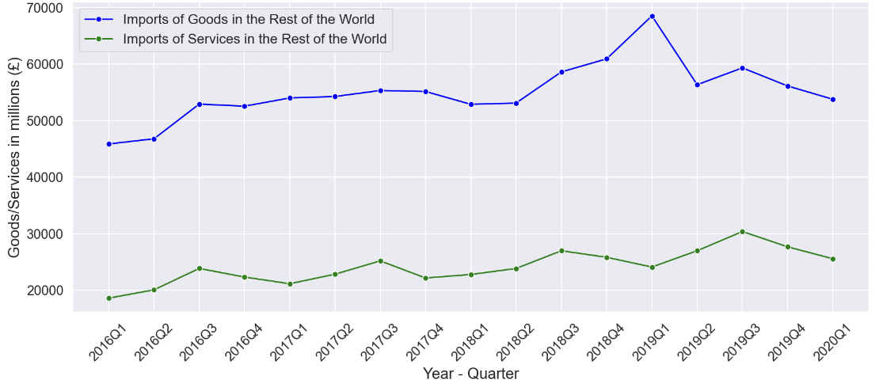

Figure A12: Imports in Non-EU countries per quarter in millions (£) from 2016 – 2019

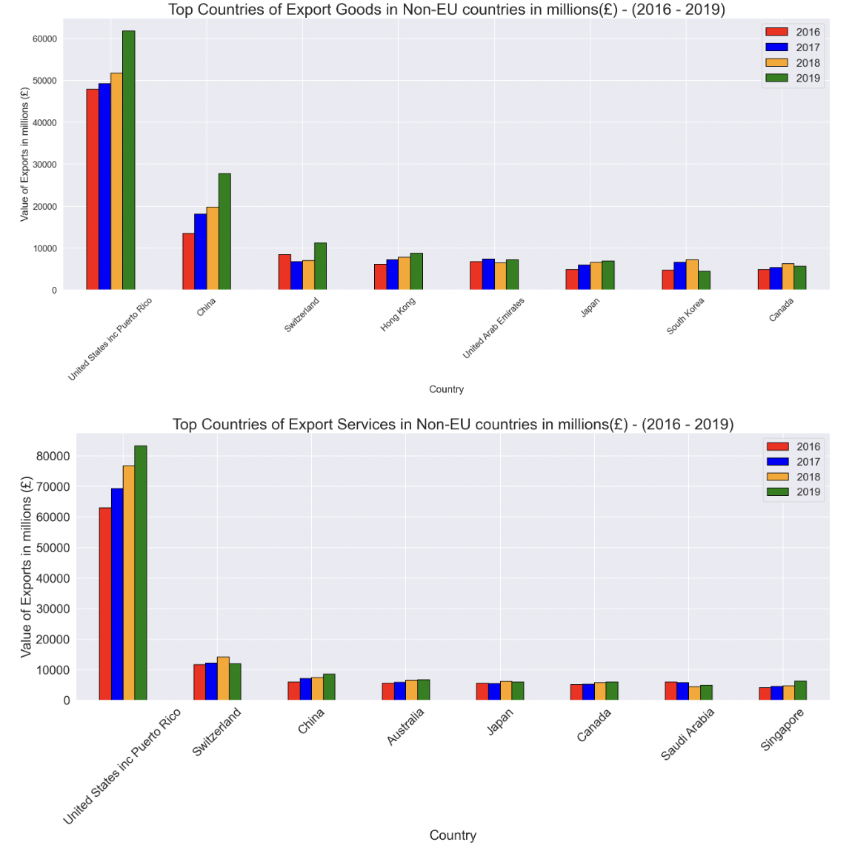

Figure A13: Top Exports of Goods/Services in Non-EU countries in millions (£) from 2016 – 2019

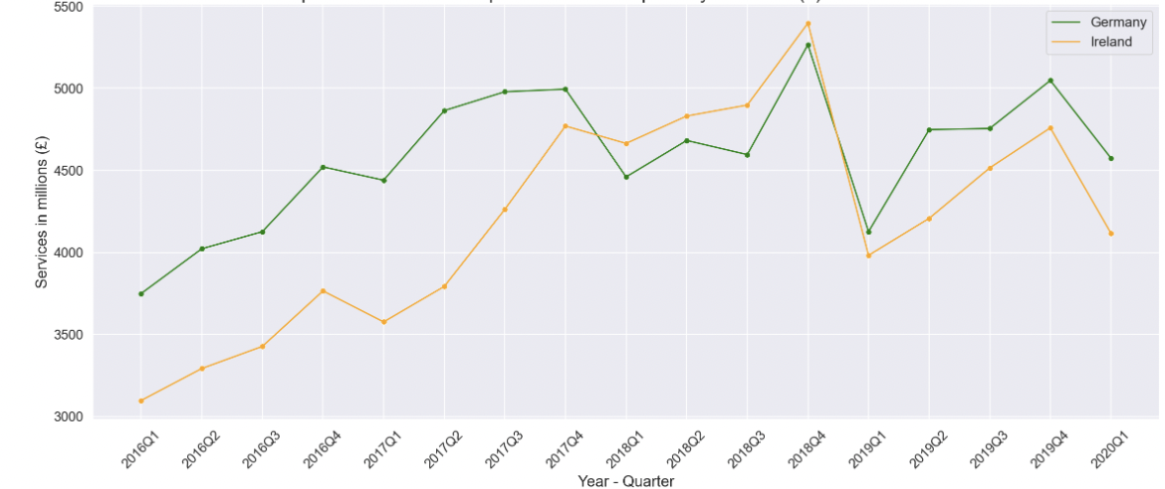

Figure A14: Exports of Services in Top 2 EU countries quarterly in millions (£) from 2016 – 2019

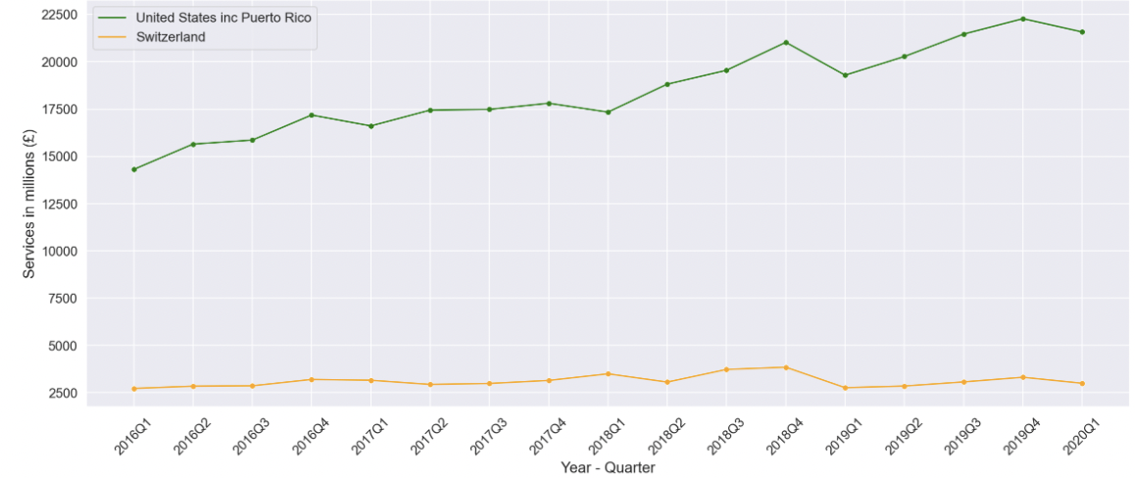

Figure A15: Exports of Services in Top 2 Non-EU countries quarterly in millions (£) from 2016 – 2019

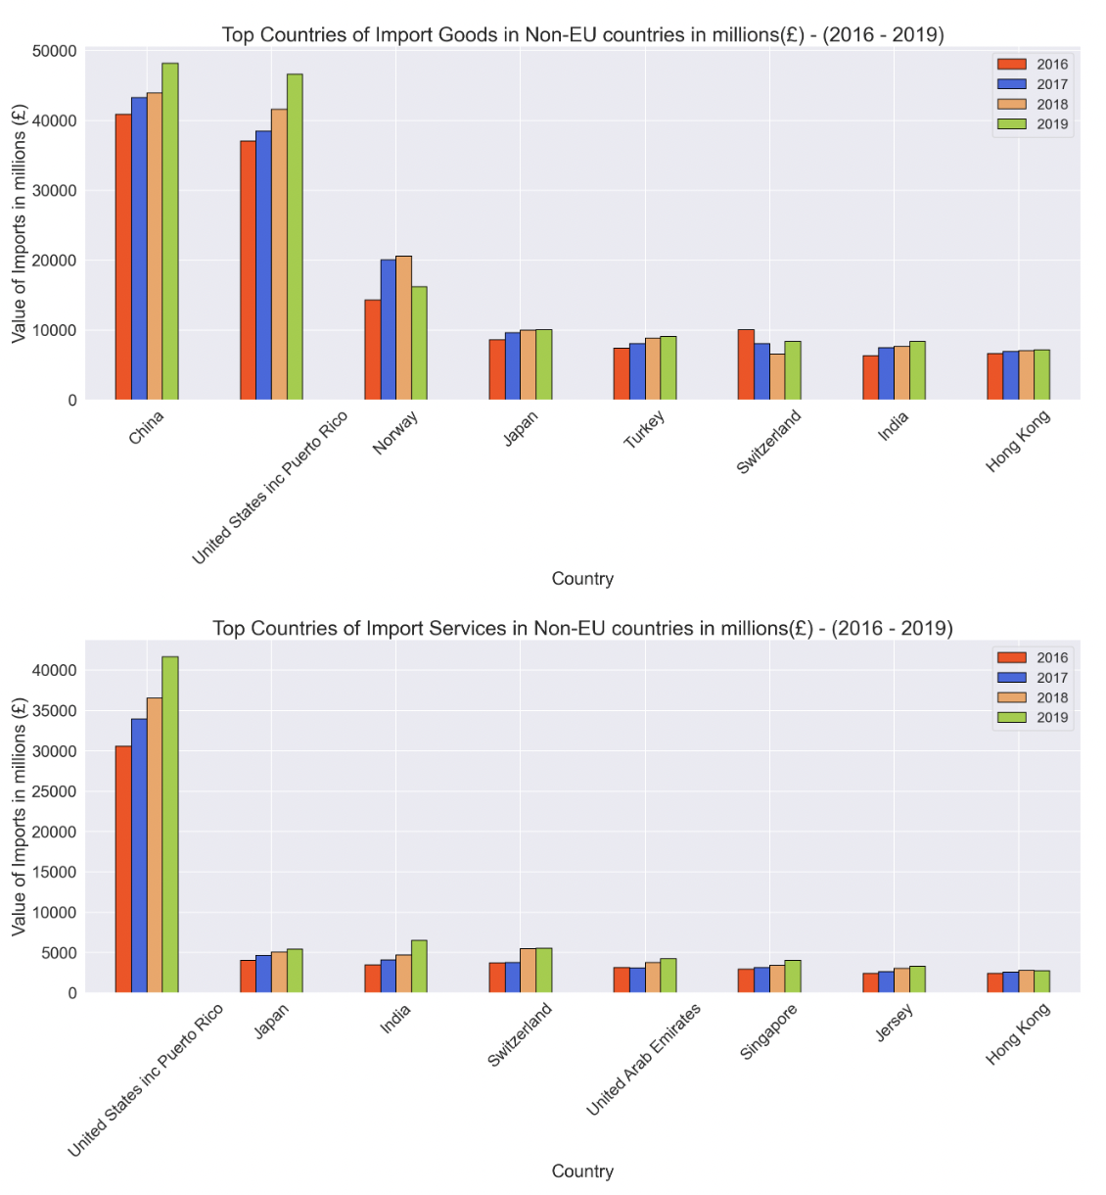

Figure A16: Top Imports of Goods/Services in Non-EU countries in millions (£) from 2016 – 2019

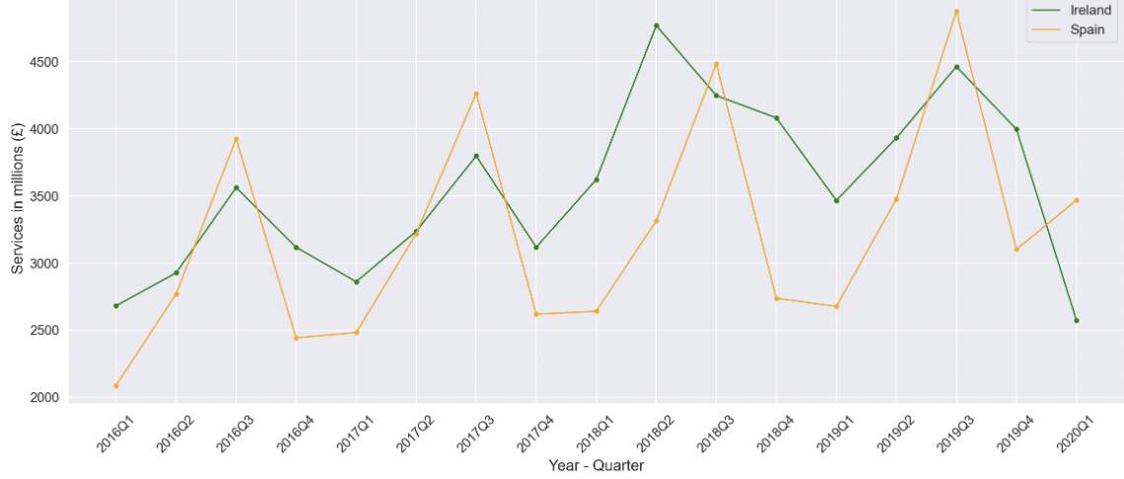

Figure A17: Imports of Services in Top 2 EU countries quarterly in millions (£) from 2016 – 2019

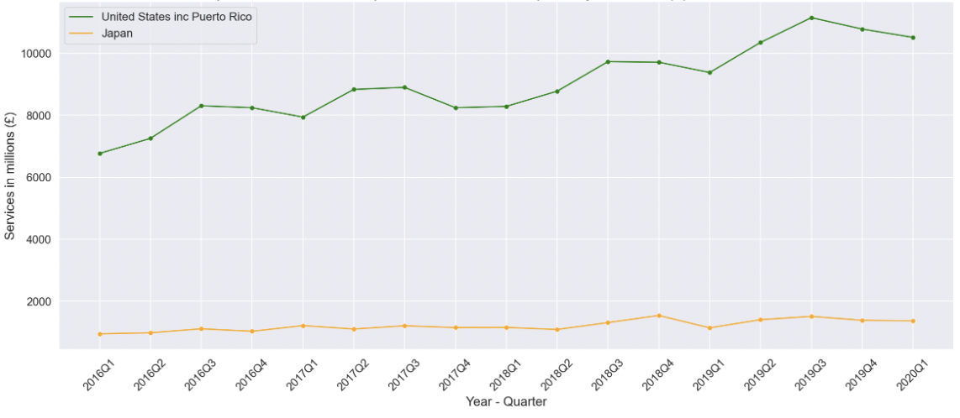

Figure A18: Imports of Services in Top 2 Non-EU countries quarterly in millions (£) from 2016 – 2019

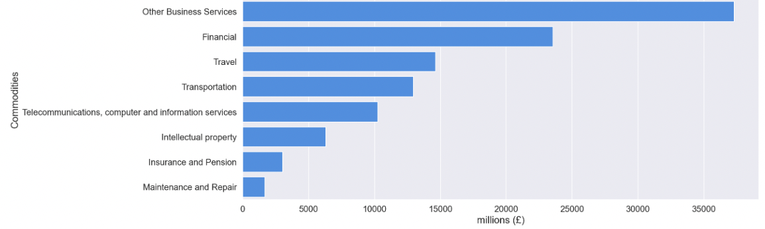

Figure A19: Top 10 Categories of Services Exports in EU countries in millions (£) from 2016 – 2019

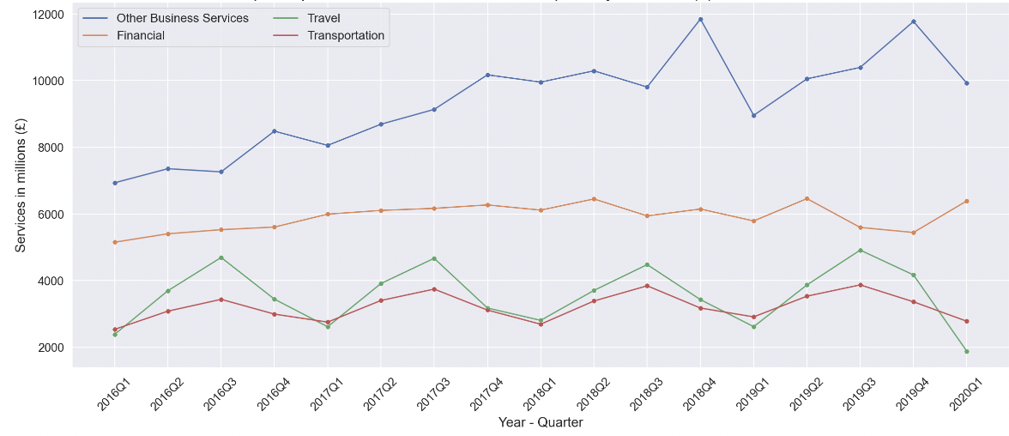

Figure A20: Top 4 Exports of Services in EU countries quarterly in millions (£) from 2016 – 2019

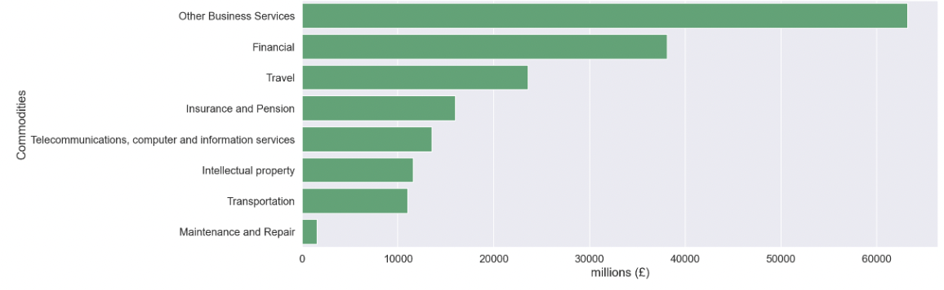

Figure A21: Top 10 Categories of Services Exports in Non-EU countries in millions (£) from 2016 – 2019

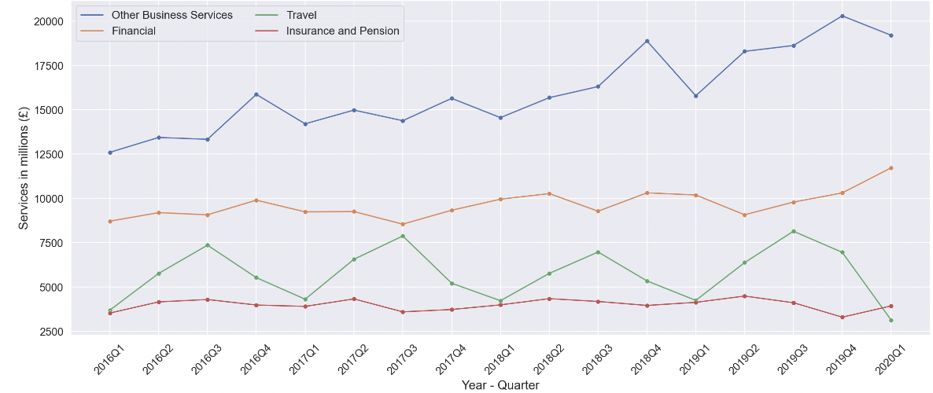

Figure A22: Top 4 Exports of Services in Non-EU countries quarterly in millions (£) from 2016 – 2019

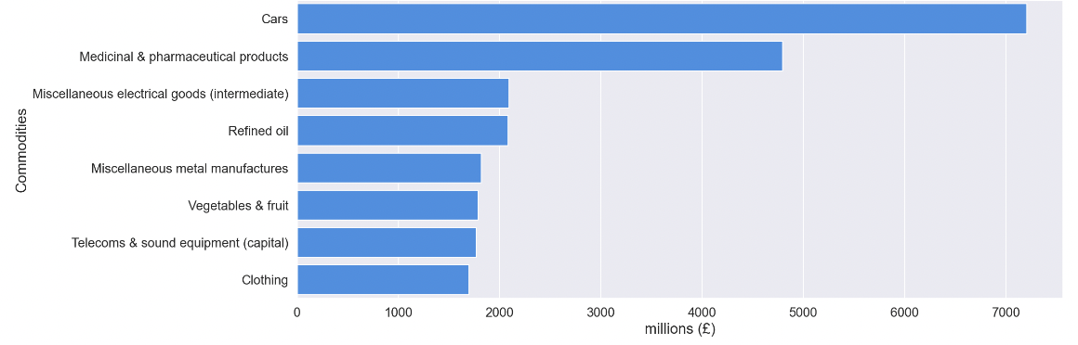

Figure A23: Top 10 Categories of Good Imports in EU countries in millions (£) from 2016 – 2019

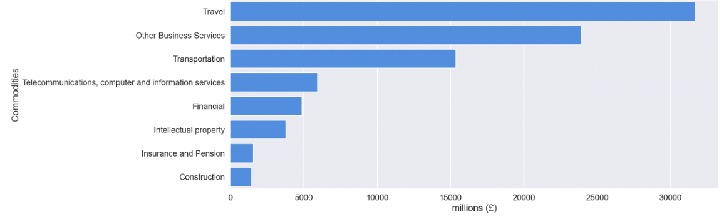

Figure A24: Top 10 Categories of Services Imports in EU countries in millions (£) from 2016 – 2019

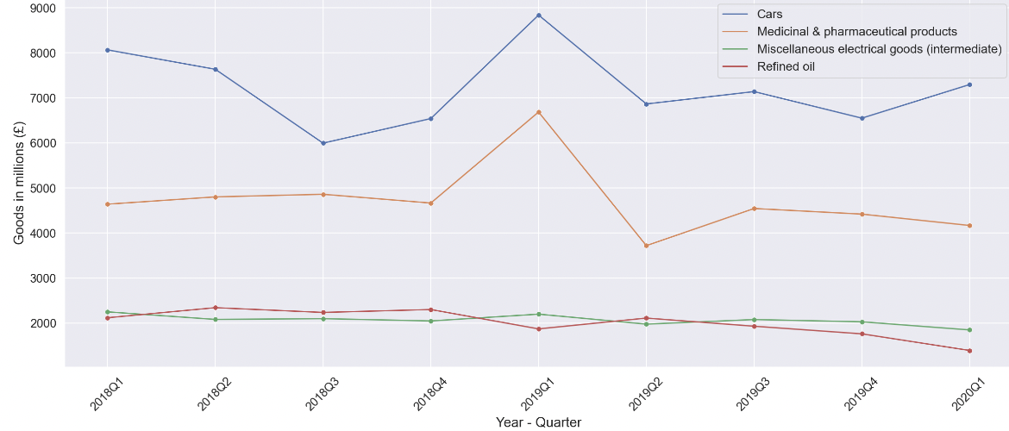

Figure A25: Top 4 Imports of Goods in EU countries quarterly in millions (£) from 2018 – 2019

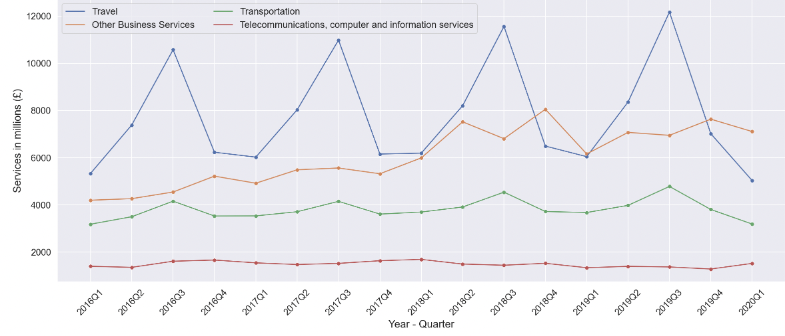

Figure A26: Top 4 Imports of Services in EU countries quarterly in millions (£) from 2016 – 2019

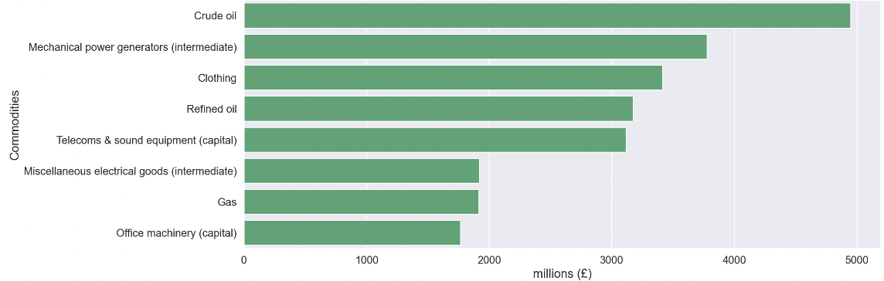

Figure A27: Top 10 Categories of Good Imports in Non-EU countries countries in millions (£) from 2016 – 2019

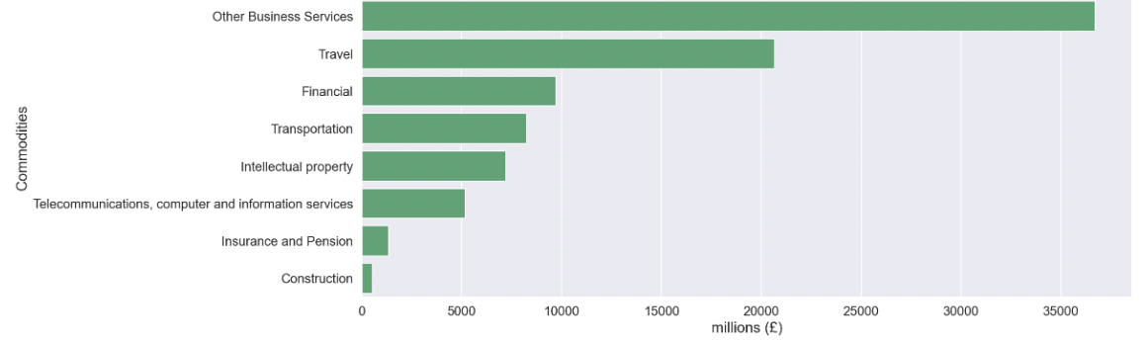

Figure A28: Top 10 Categories of Services Imports in Non-EU countries countries in millions (£) from 2016 – 2019

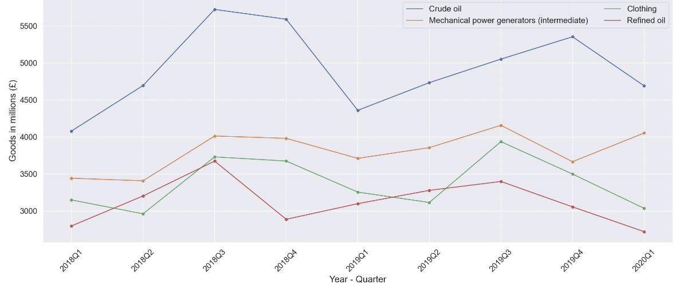

Figure A29: Top 4 Imports of Goods in Non-EU countries quarterly in millions (£) from 2018 – 2019

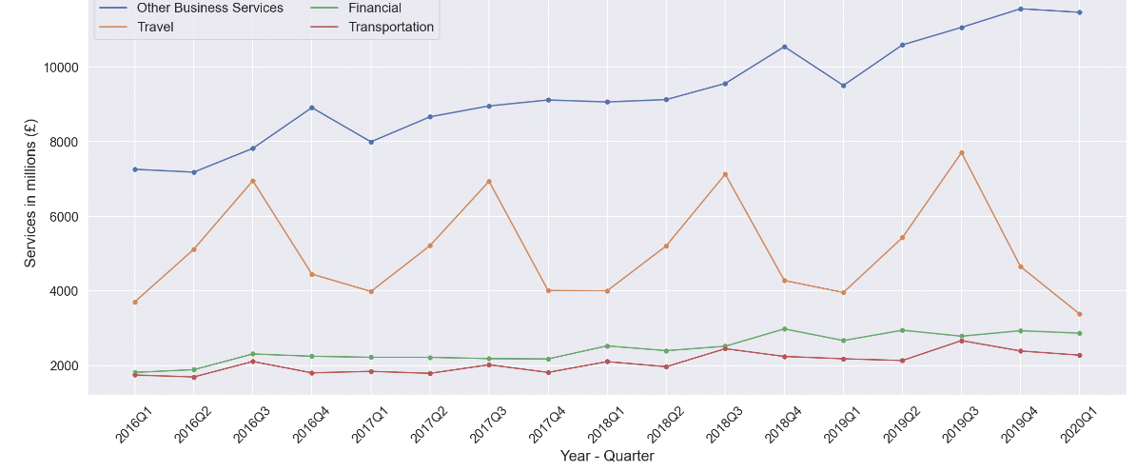

Figure A30: Top 4 Imports of Services in Non-EU countries quarterly in millions (£) from 2016 –2019

Table A1: Top 10 countries that UK Import Goods in 2020 and 2021 in millions (£)

|  |  |  |
| --- | --- | --- |
| **Country** | **2020** | **2021** |
| China | 54801 | 63557 |
| Germany | 56853 | 53759 |
| United States inc Puerto Rico | 37323 | 39379 |
| Netherlands | 36466 | 31786 |
| Norway | 11246 | 27112 |
| Belgium | 23266 | 23331 |
| France | 24389 | 23128 |
| Italy | 17540 | 17604 |
| Spain | 14988 | 14472 |
| Ireland | 13420 | 13861 |

Table A2: Top 10 countries that UK Import Services in 2020 and 2021 in millions (£)

|  |  |  |
| --- | --- | --- |
| **Country** | **2020** | **2021** |
| United States inc Puerto Rico | 38738 | 43657 |
| France | 11154 | 10607 |
| Germany | 9364 | 8896 |
| Spain | 7243 | 7964 |
| India | 5558 | 7479 |
| Switzerland | 4870 | 6279 |
| Ireland | 7991 | 6207 |
| Netherlands | 5967 | 6159 |
| Luxembourg | 4484 | 4871 |
| Jersey | 3406 | 4220 |

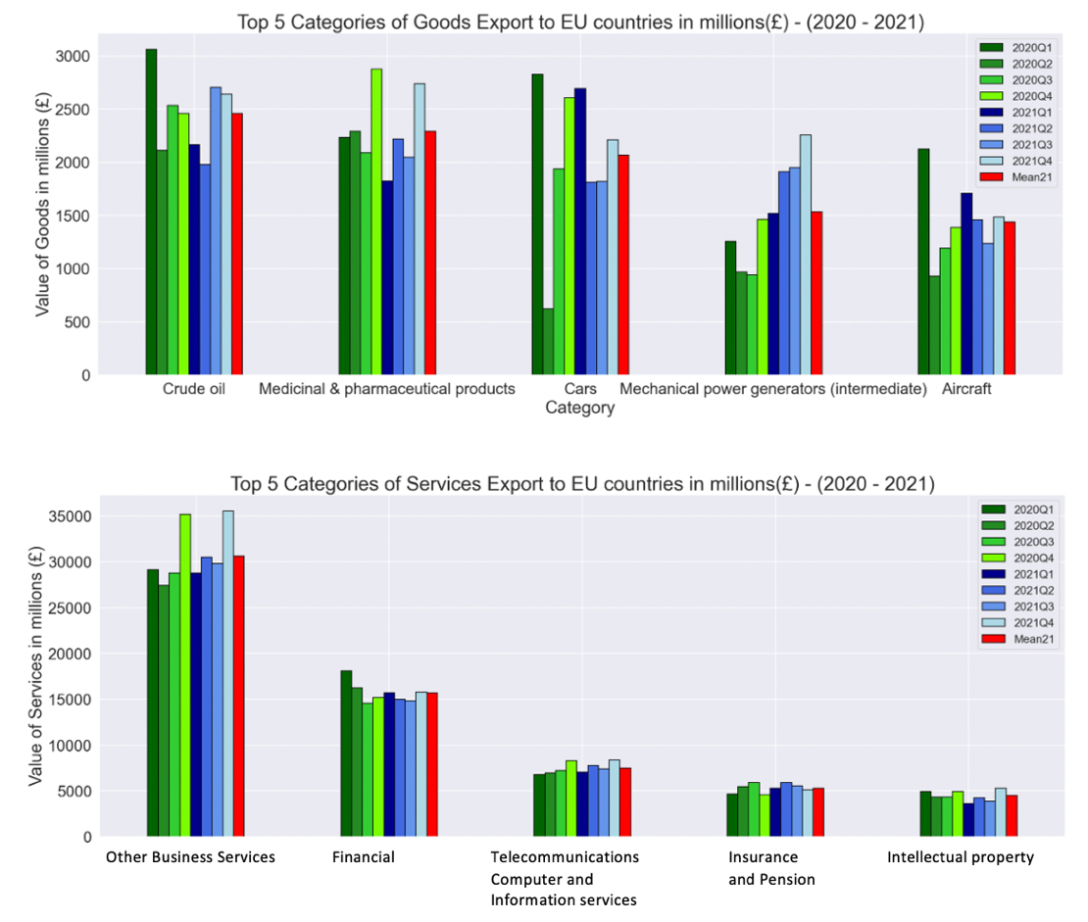

Figure A31: Top 5 Categories of Goods/Services Exports to EU countries in millions (£) in 2020 and 2021 Quarterly

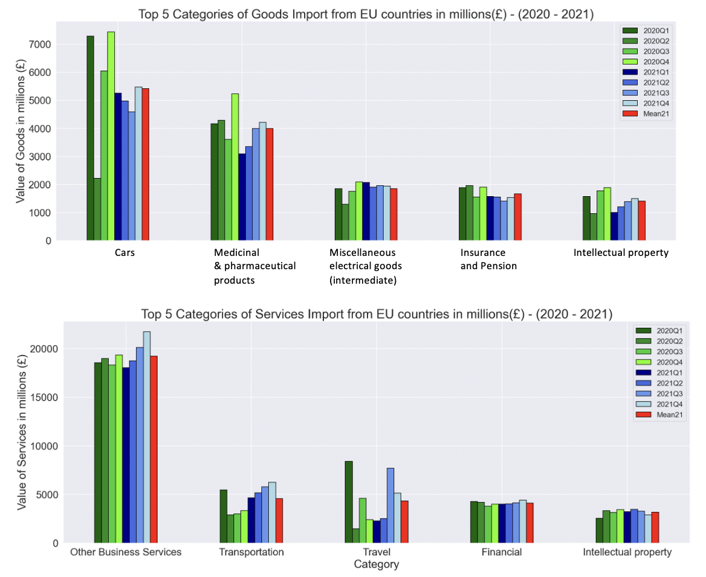

Figure A32: Top 5 Categories of Goods/Services Imports from EU countries in millions (£) in 2020 and 2021 Quarterly

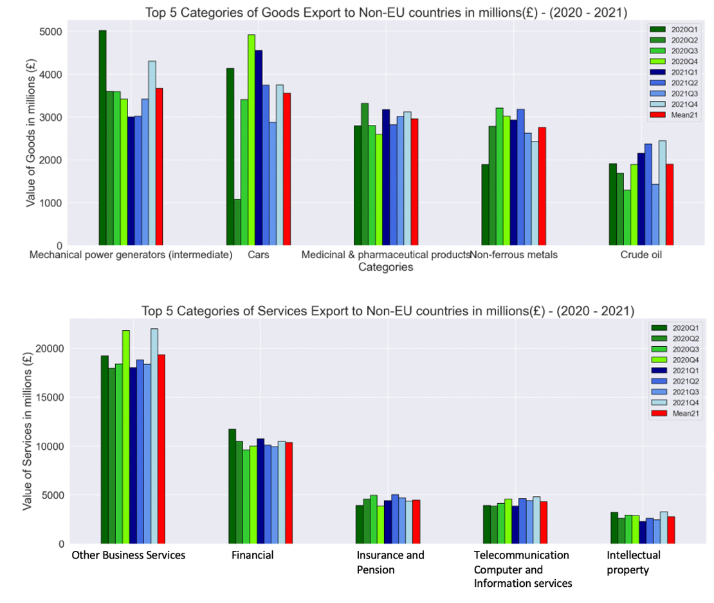

Figure 1: Top 5 Categories of Goods/Services Exports to Non - EU countries in millions (£) in 2020 and 2021 Quarterly

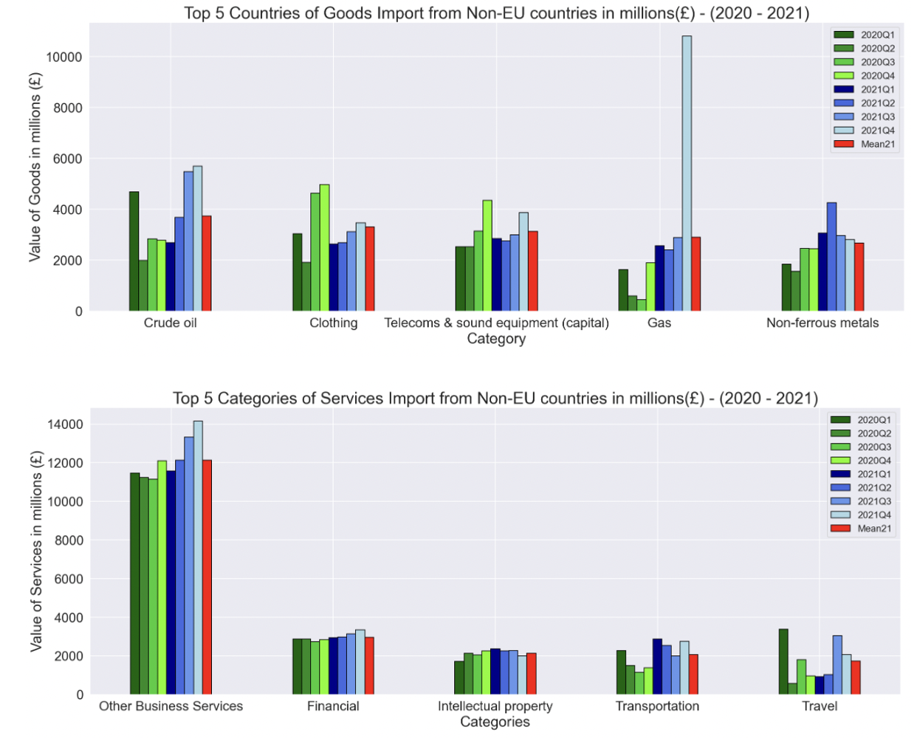

Figure A34: Top 5 Categories of Goods/Services Imports from Non - EU countries in millions (£) in 2020 and 2021 Quarterly

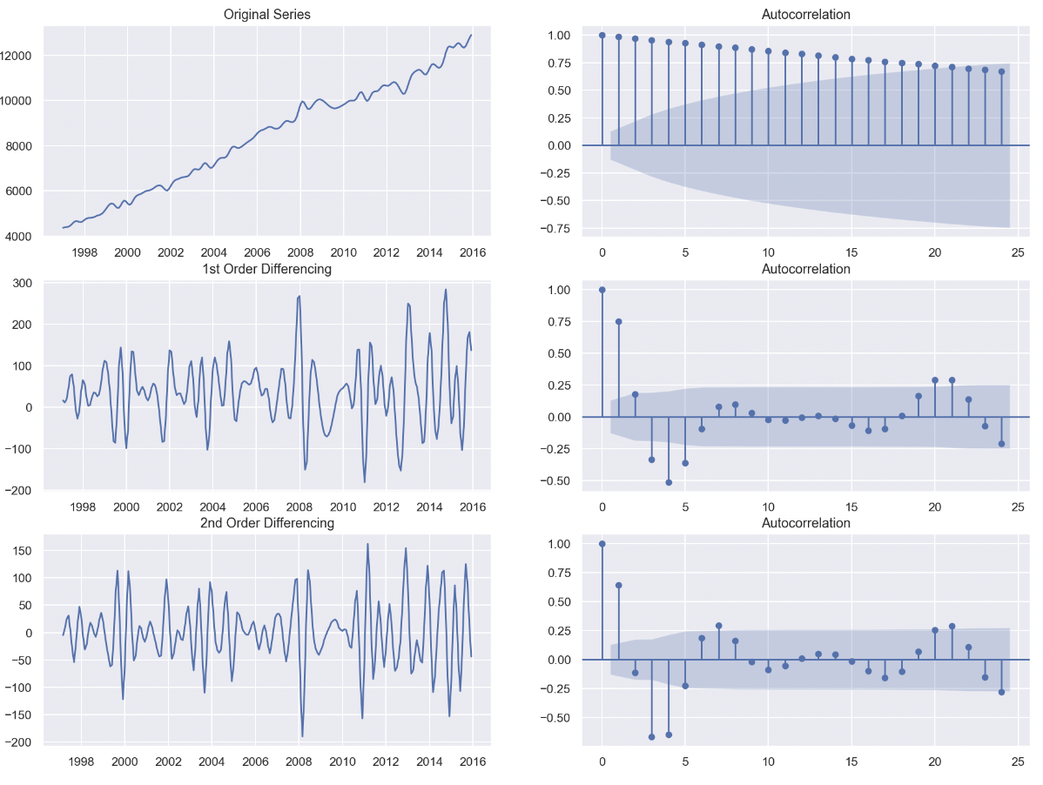

Figure A35: 1st and 2nd Differencing and Autocorrelation plots for Import in Services Worldwide

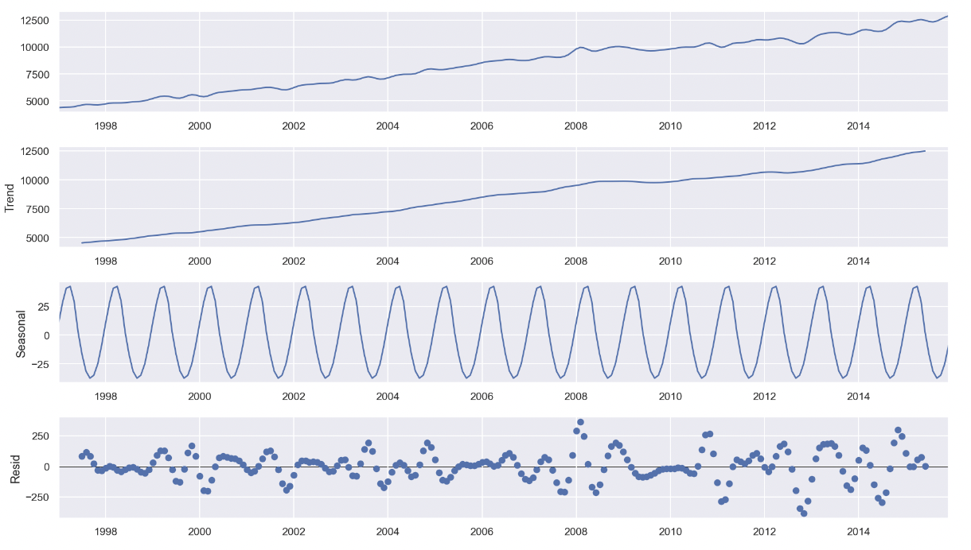

Figure A36: Seasonal Decompose plot for export in Services Worldwide

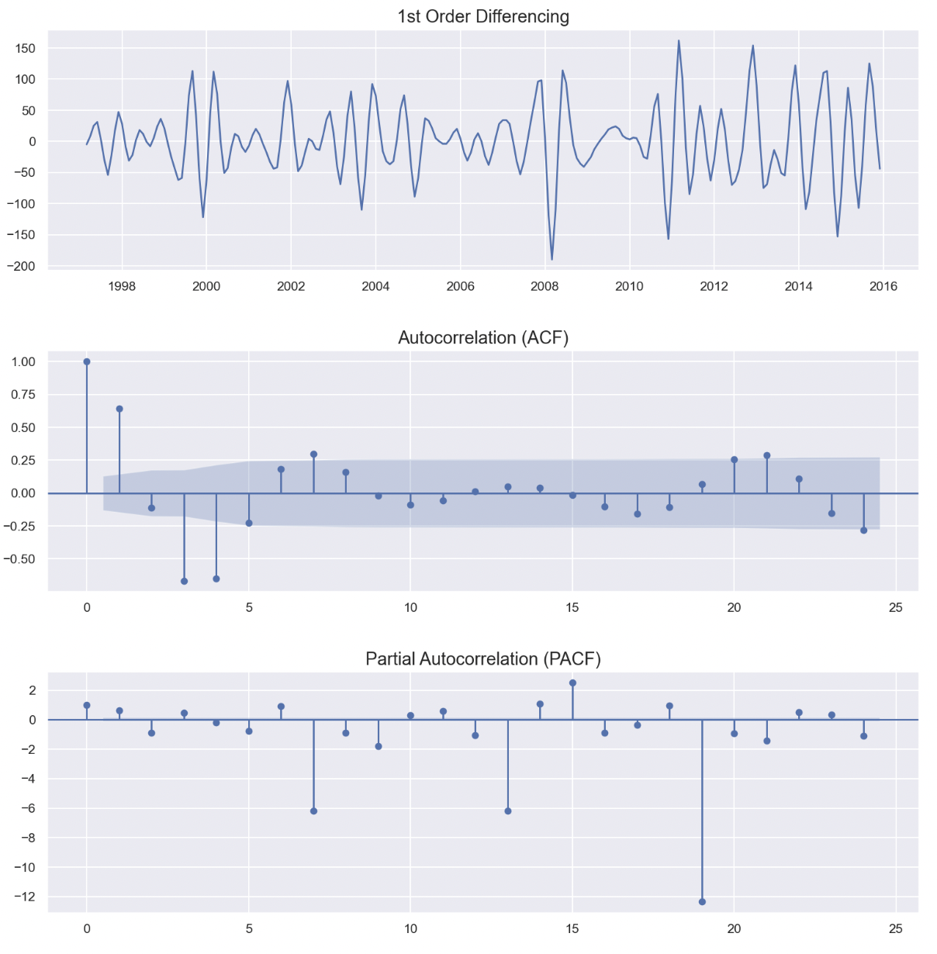

Figure A37: 1st Differencing - Partial Autocorrelation - Autocorrelation plots for Import in Services Worldwide

Table A3: Dickey Fuller test after differencing for import of Services Worldwide

|  |  |
| --- | --- |
| **Dickey Fuller Test** | |
| Test Statistic | -7.770832e+00 |
| p-value | 8.930572e-12 |
| Number of Lags Used | 1.500000e+01 |
| Number of Observations Used | 2.100000e+02 |
| Critical Value (1%) | -3.461879e+00 |
| Critical Value (5%) | -2.875404e+00 |
| Critical Value (10%) | -2.574159e+00 |

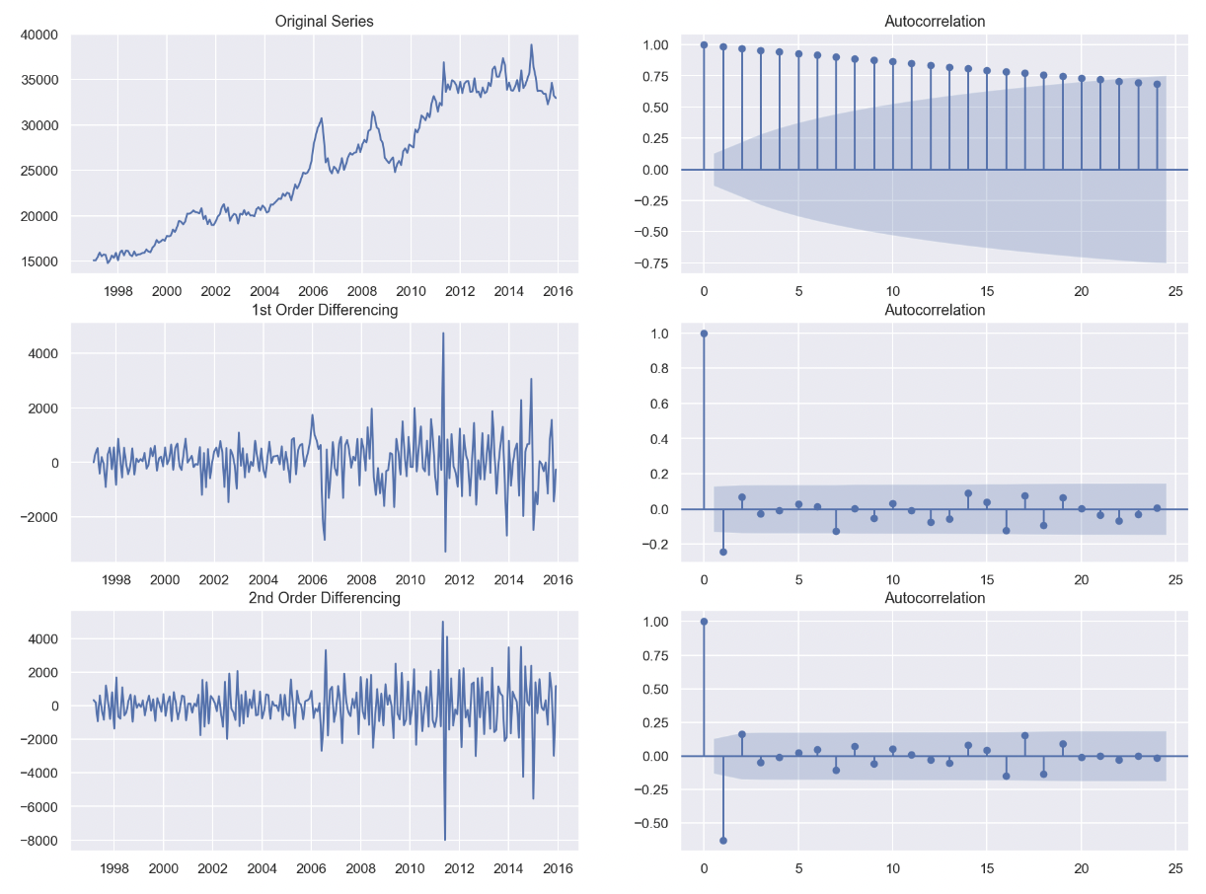

Figure A38: 1st and 2nd Differencing and Autocorrelation plots for Import in Goods Worldwide

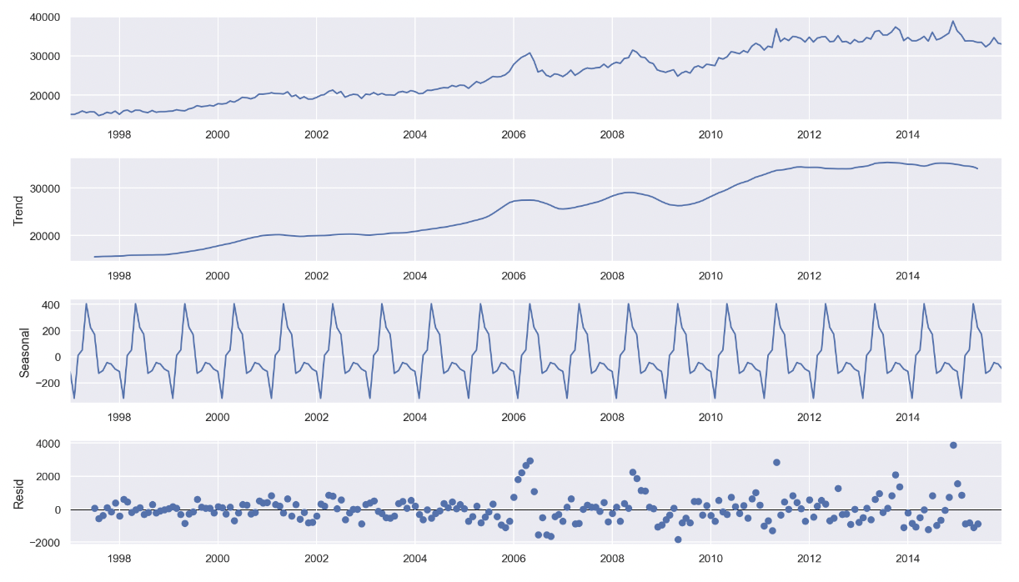

Figure A39: Seasonal Decompose plot for export in Goods Worldwide

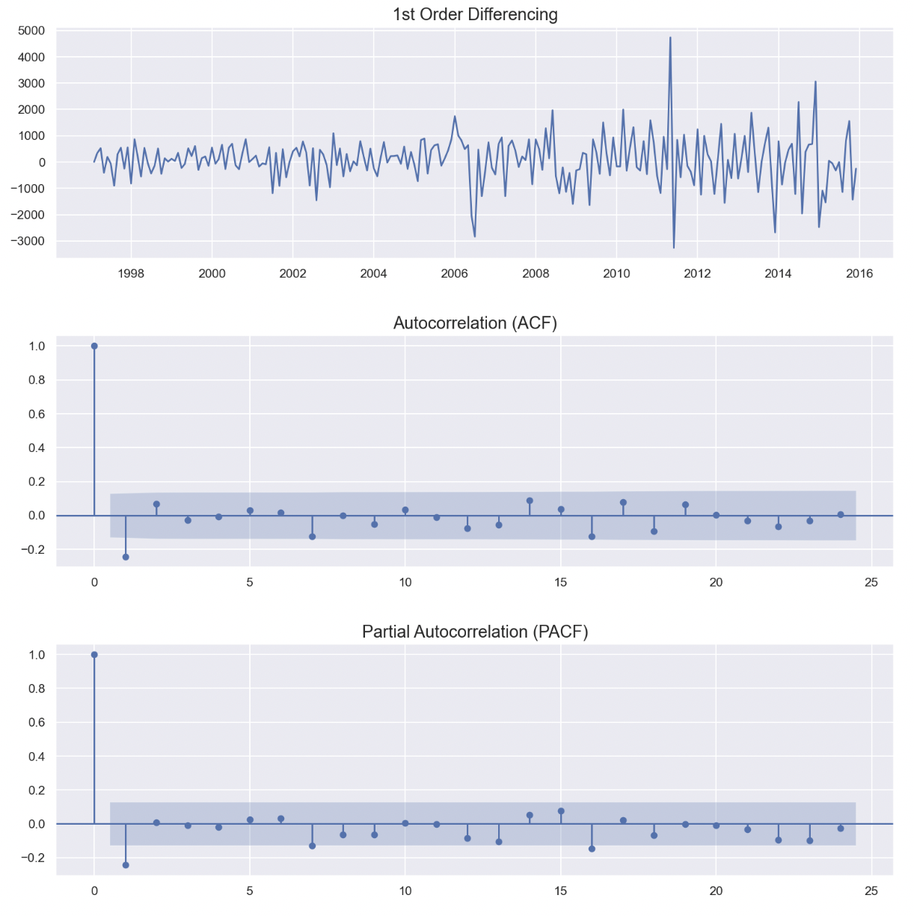

Figure A40: 1st Differencing - Partial Autocorrelation - Autocorrelation plots for Import in Goods Worldwide

Table A4: Dickey Fuller test after differencing for Import of Goods Worldwide

|  |  |
| --- | --- |
| **Dickey Fuller Test** | |
| Test Statistic | -19.173674 |
| p-value | 0.000000 |
| Number of Lags Used | 0.000000 |
| Number of Observations Used | 226.000000 |
| Critical Value (1%) | -3.459620 |
| Critical Value (5%) | -2.874415 |
| Critical Value (10%) | -2.573632 |

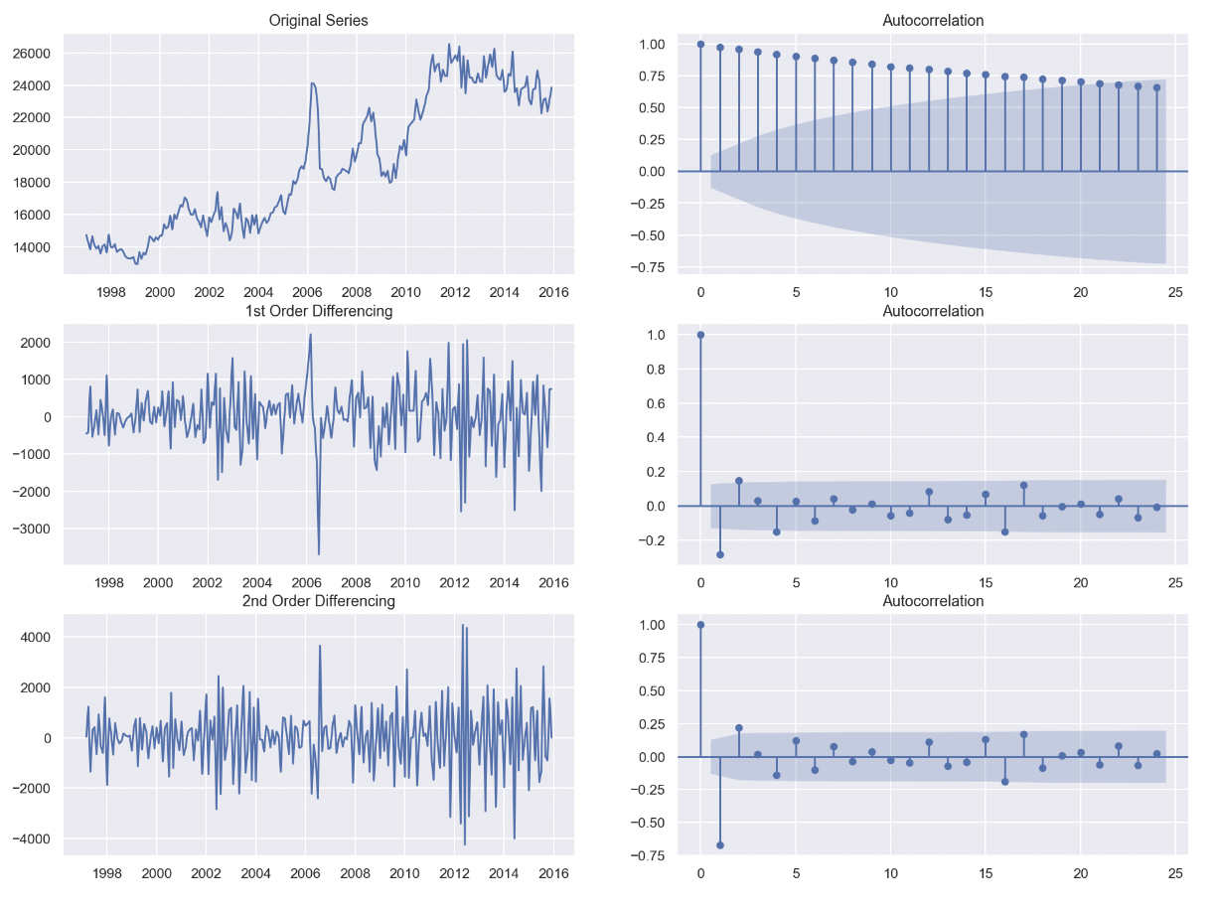

Figure A41: 1st and 2nd Differencing and Autocorrelation plots for Export of Goods Worldwide

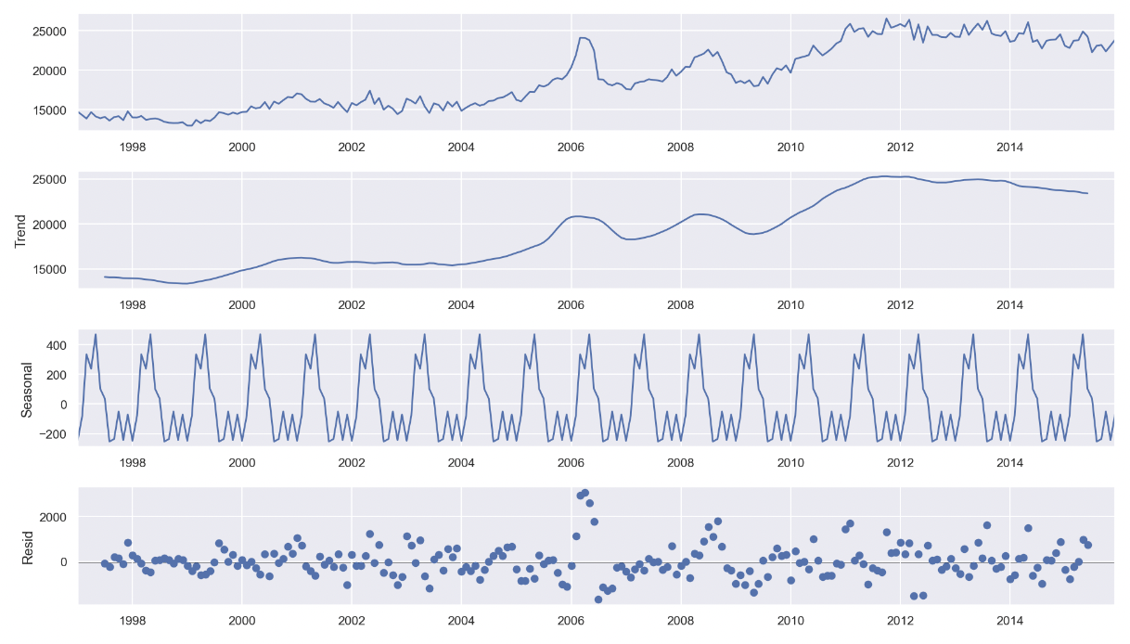

Figure A42: Seasonal Decompose plot for Export of Goods Worldwide

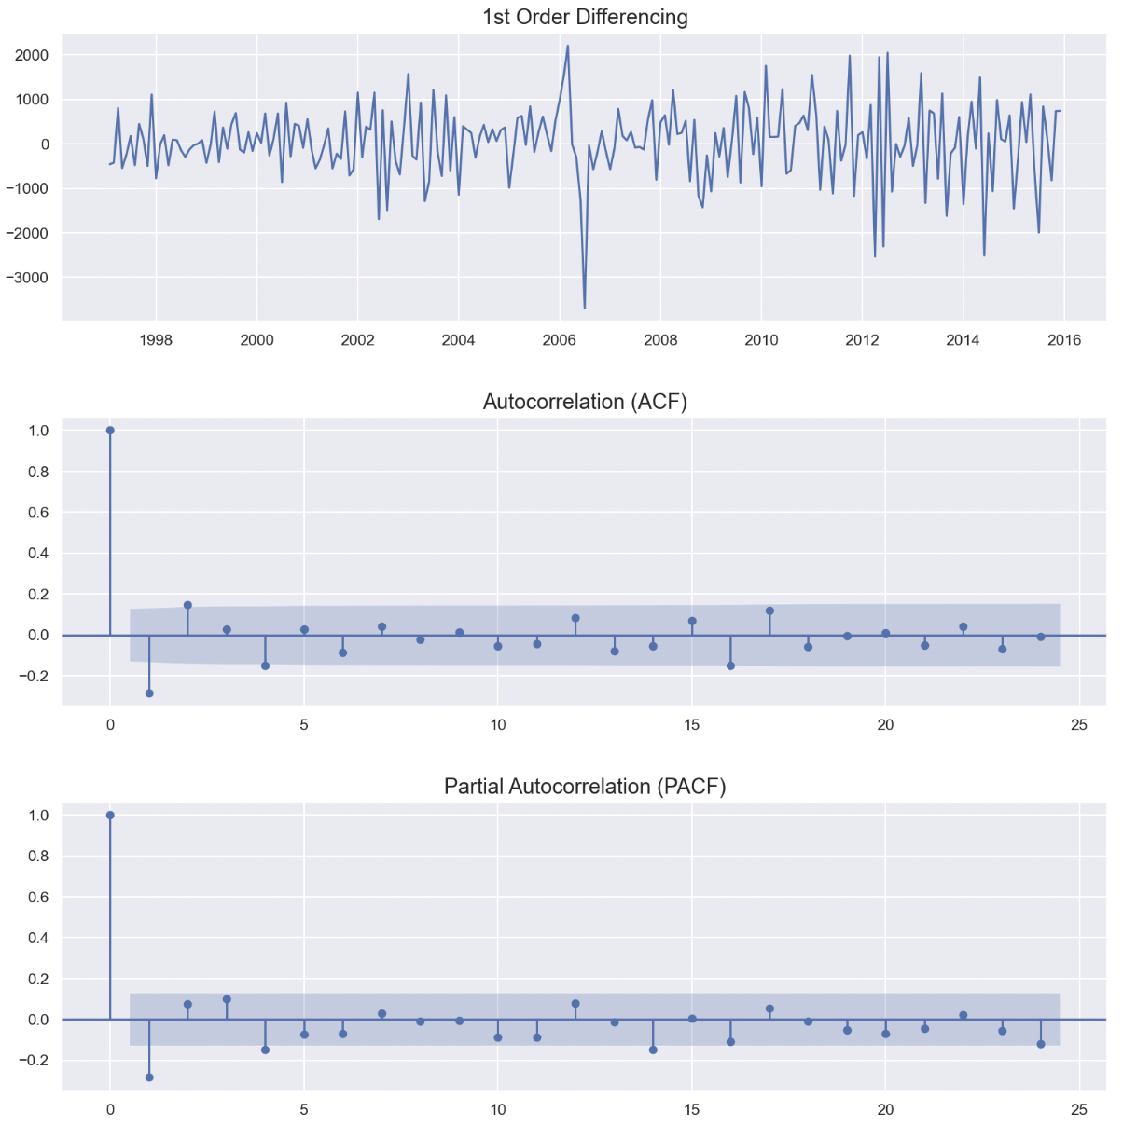

Figure A43: 1st Differencing - Partial Autocorrelation - Autocorrelation plots for Export of Goods Worldwide

Table A5: Dickey Fuller test after differencing for Export of Goods Worldwide

|  |  |
| --- | --- |
| **Dickey Fuller Test** | |
| Test Statistic | -8.089770e+00 |
| p-value | 1.388358e-12 |
| Number of Lags Used | 3.000000e+00 |
| Number of Observations Used | 2.230000e+02 |
| Critical Value (1%) | -3.460019e+00 |
| Critical Value (5%) | -2.874590e+00 |
| Critical Value (10%) | 2.573725e+00 |

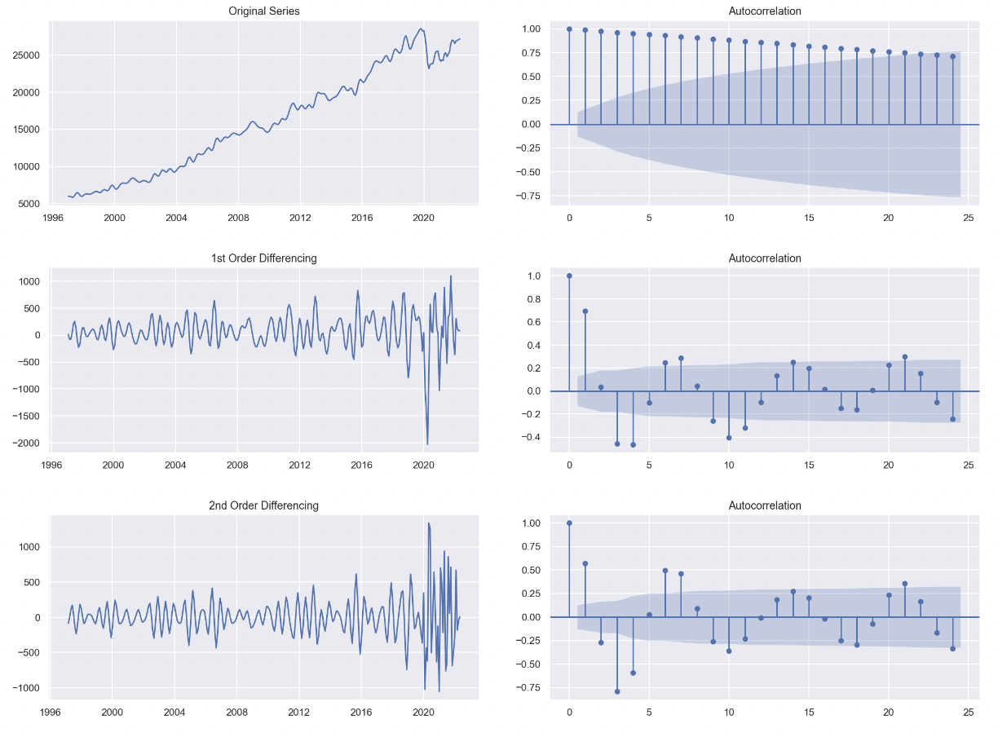

Figure A44: 1st and 2nd Differencing and Autocorrelation plots for Exports in Services Worldwide

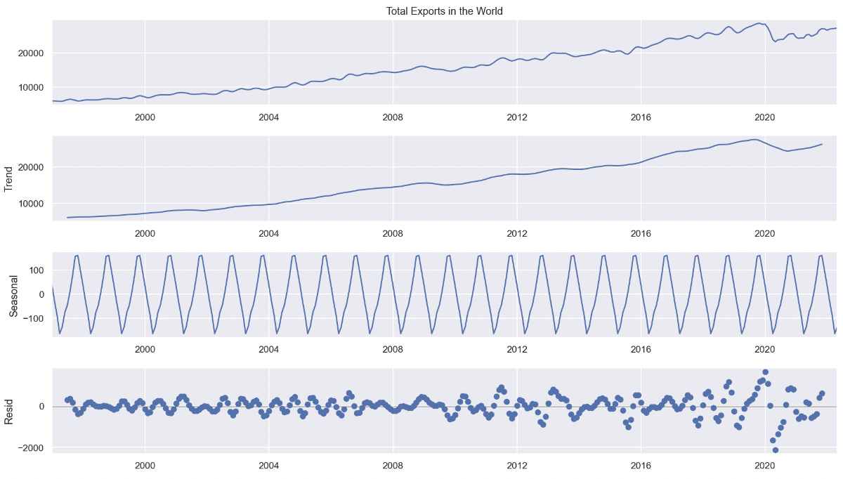

Figure A45: Seasonal Decompose plot for Exports in Services Worldwide

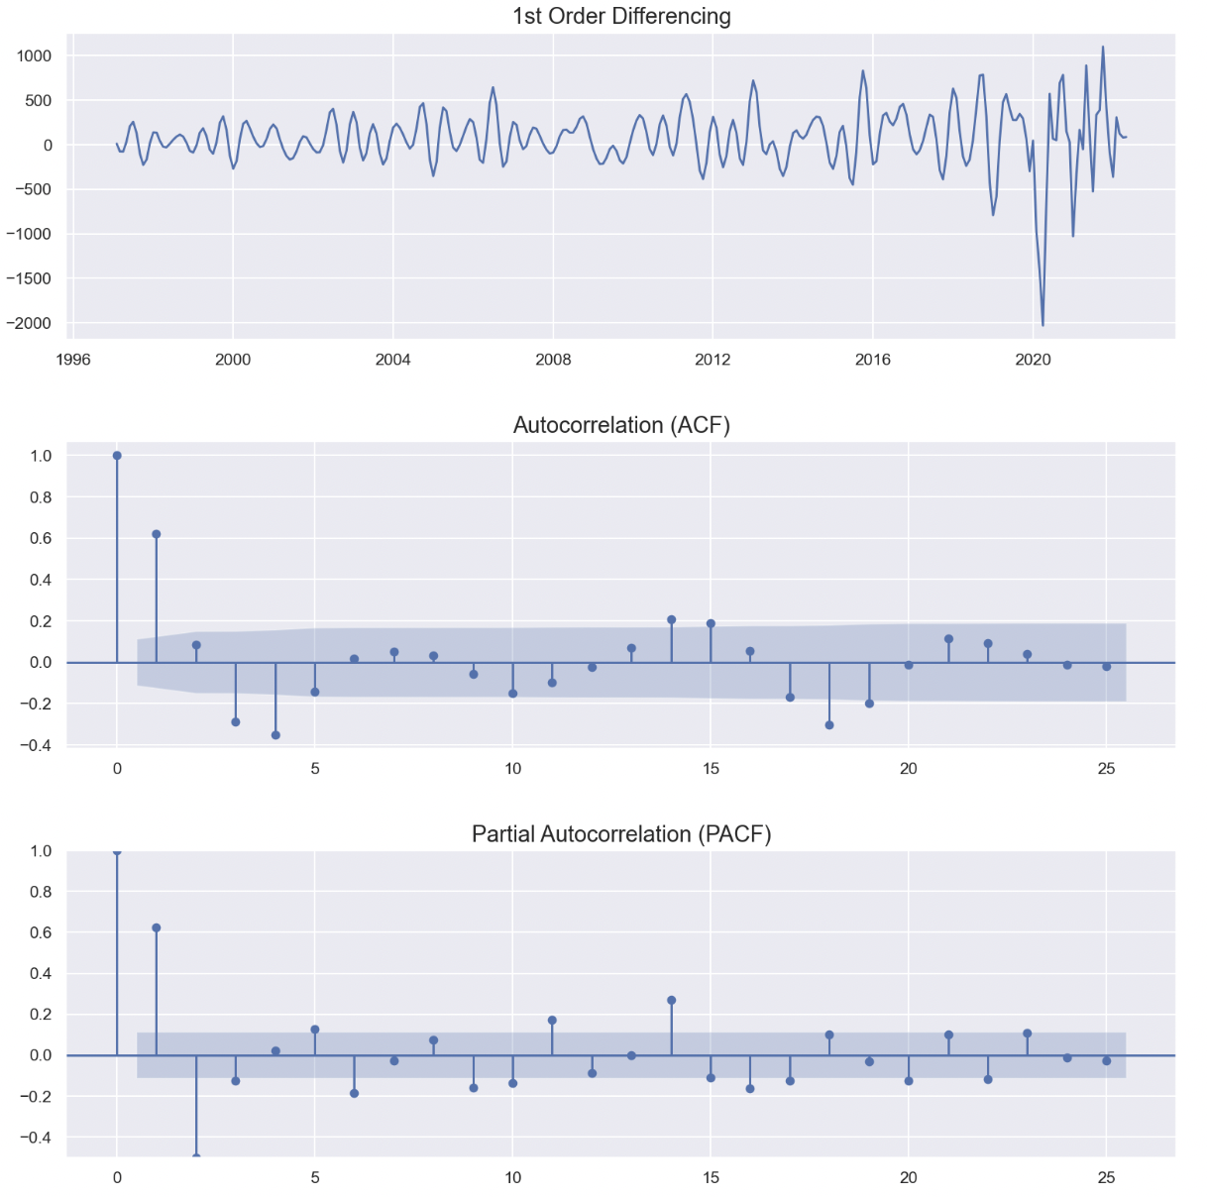

Figure A46: 1st Differencing - Partial Autocorrelation - Autocorrelation plots for Exports in Services Worldwide

Table A6: Dickey Fuller test after differencing for Exports in Services Worldwide

|  |  |
| --- | --- |
| **Dickey Fuller Test** | |
| Test Statistic | -4.828777 |
| p-value | 0.000048 |
| Number of Lags Used | 15.000000 |
| Number of Observations Used | 288.000000 |
| Critical Value (1%) | -3.453262 |
| Critical Value (5%) | -2.871628 |
| Critical Value (10%) | -2.572146 |

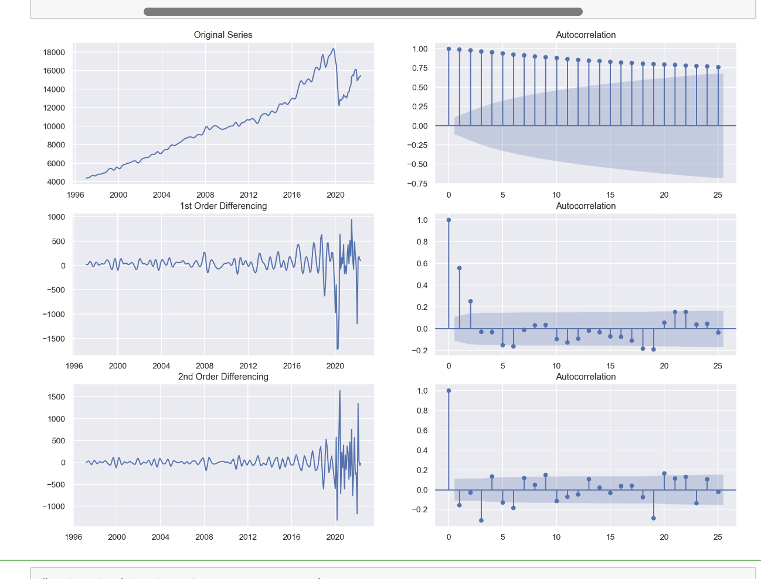

Figure A47: 1st and 2nd Differencing and Autocorrelation plots for Imports in Services Worldwide

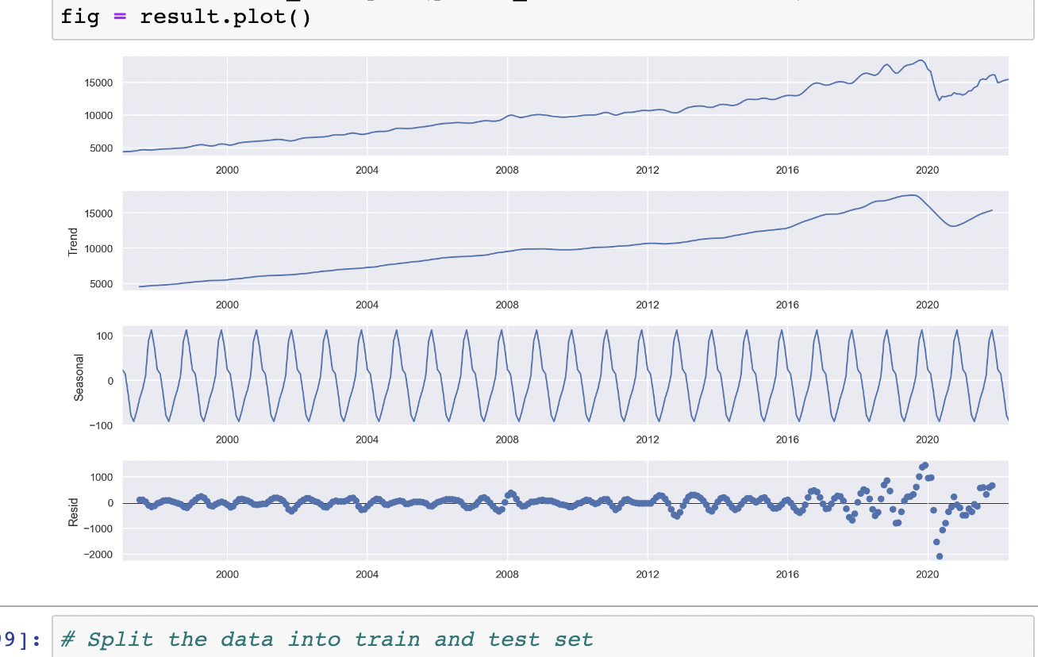

Figure A48: Seasonal Decompose plot for Import in Services Worldwide

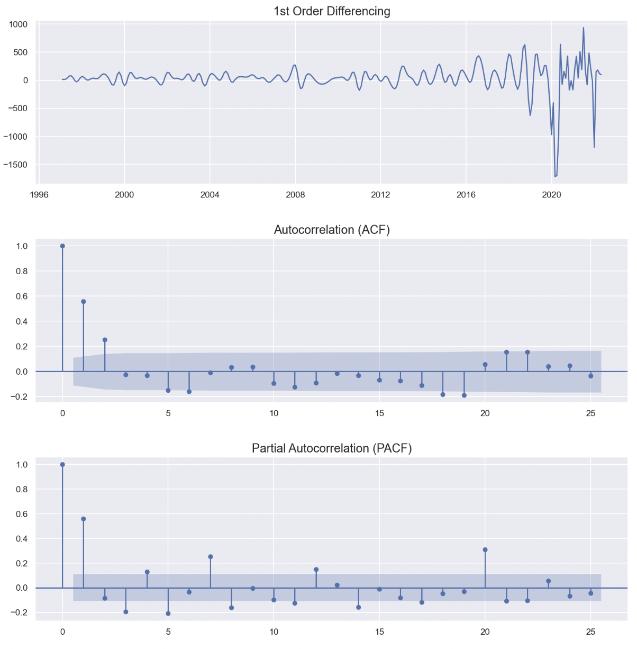

Figure A49: 1st Differencing - Partial Autocorrelation - Autocorrelation plots for Imports in Services Worldwide

Table A7: Dickey Fuller test after differencing for Imports in Services Worldwide

|  |  |
| --- | --- |
| **Dickey Fuller Test** | |
| Test Statistic | -5.139355 |
| p-value | 0.000012 |
| Number of Lags Used | 13.000000 |
| Number of Observations Used | 290.000000 |
| Critical Value (1%) | -3.453102 |
| Critical Value (5%) | -2.871559 |
| Critical Value (10%) | -2.572108 |

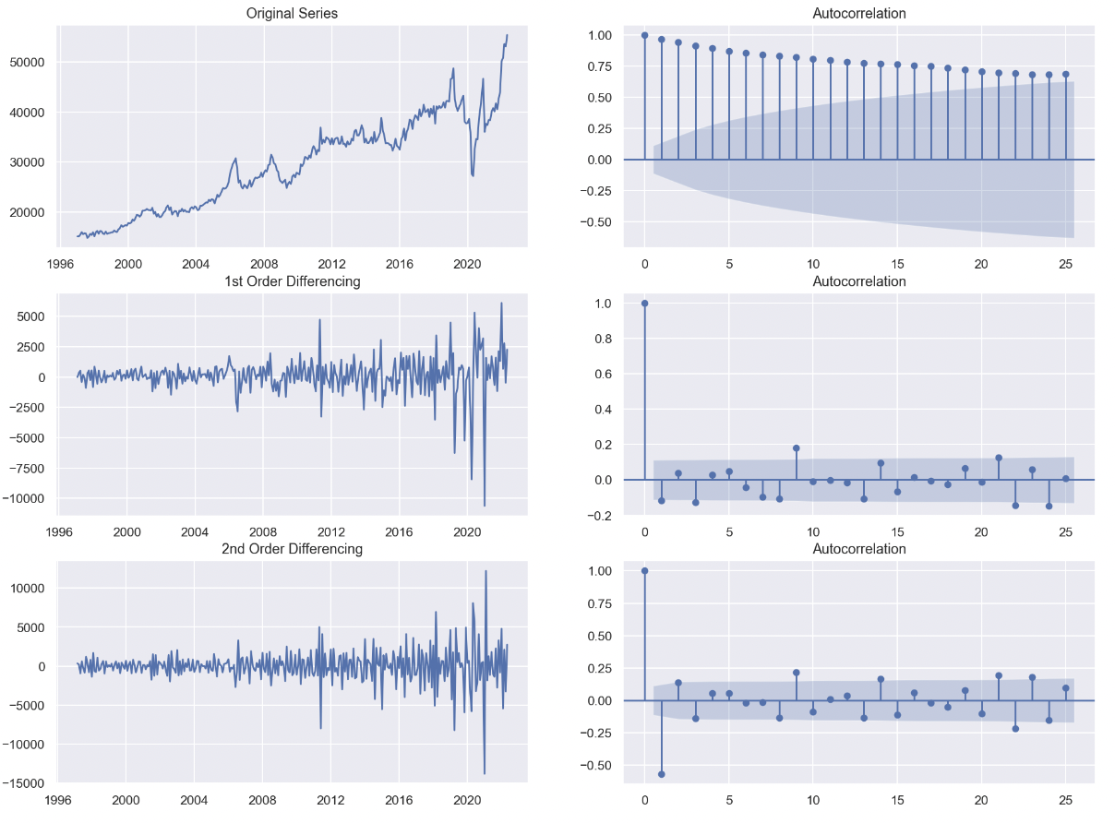

Figure A50: 1st and 2nd Differencing and Autocorrelation plots for Imports in Goods Worldwide

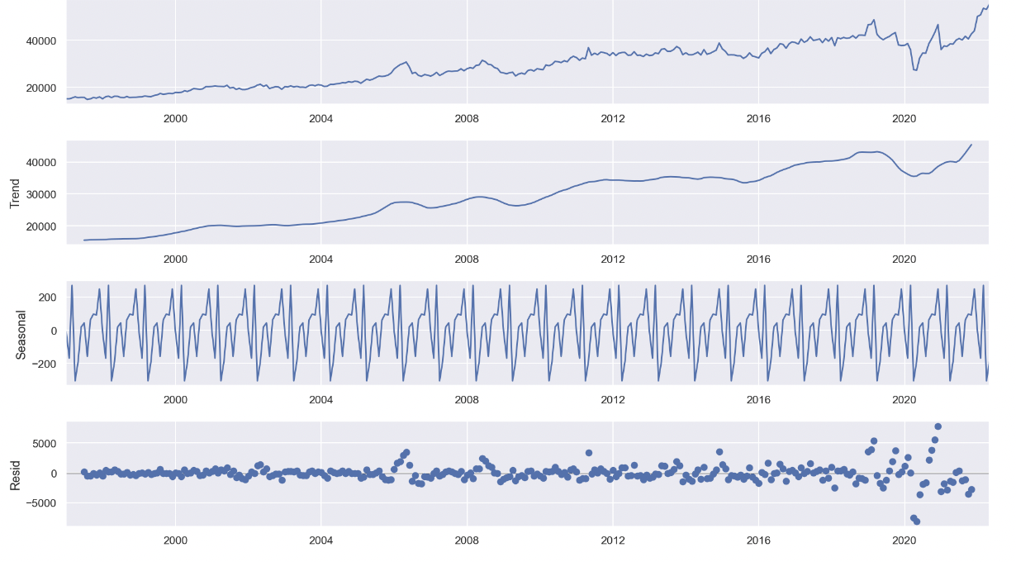

Figure A51: Seasonal Decompose plot for Import in Goods Worldwide

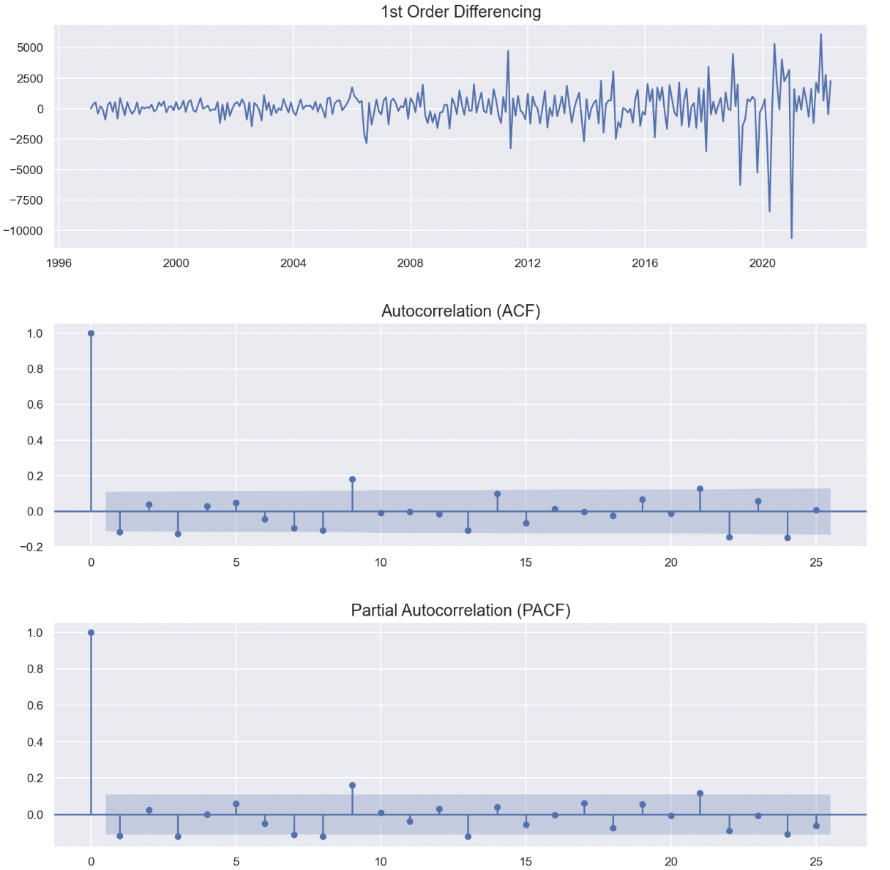

Figure A52: 1st Differencing - Partial Autocorrelation - Autocorrelation plots for Imports in Goods Worldwide

Table A8: Dickey Fuller test after differencing for Imports in Goods Worldwide

|  |  |
| --- | --- |
| **Dickey Fuller Test** | |
| Test Statistic | -5.584682 |
| p-value | 0.000001 |
| Number of Lags Used | 8.000000 |
| Number of Observations Used | 295.000000 |
| Critical Value (1%) | -3.452713 |
| Critical Value (5%) | -2.871388 |
| Critical Value (10%) | -2.572017 |

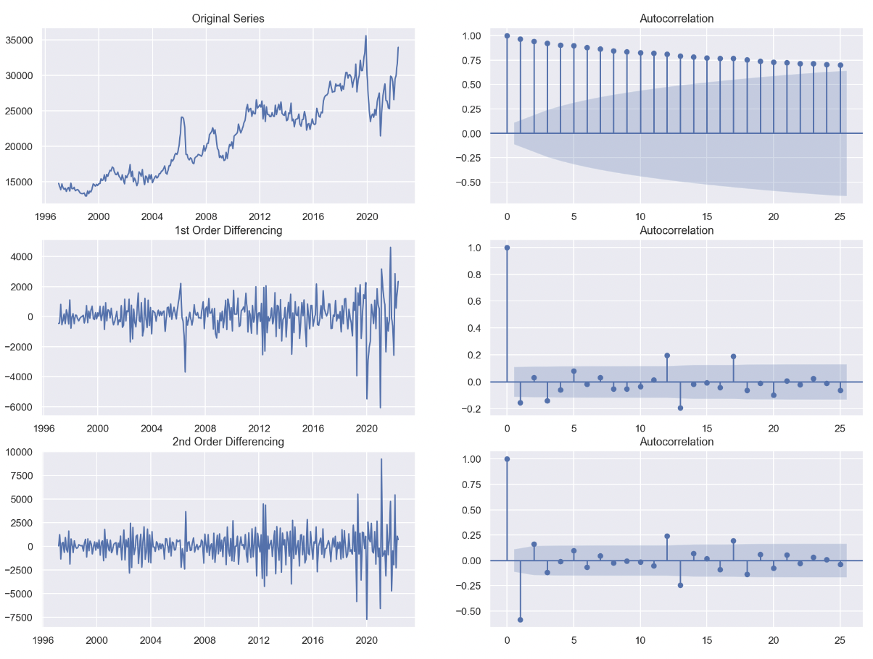

Figure A53: 1st and 2nd Differencing and Autocorrelation plots for Exports in Goods Worldwide

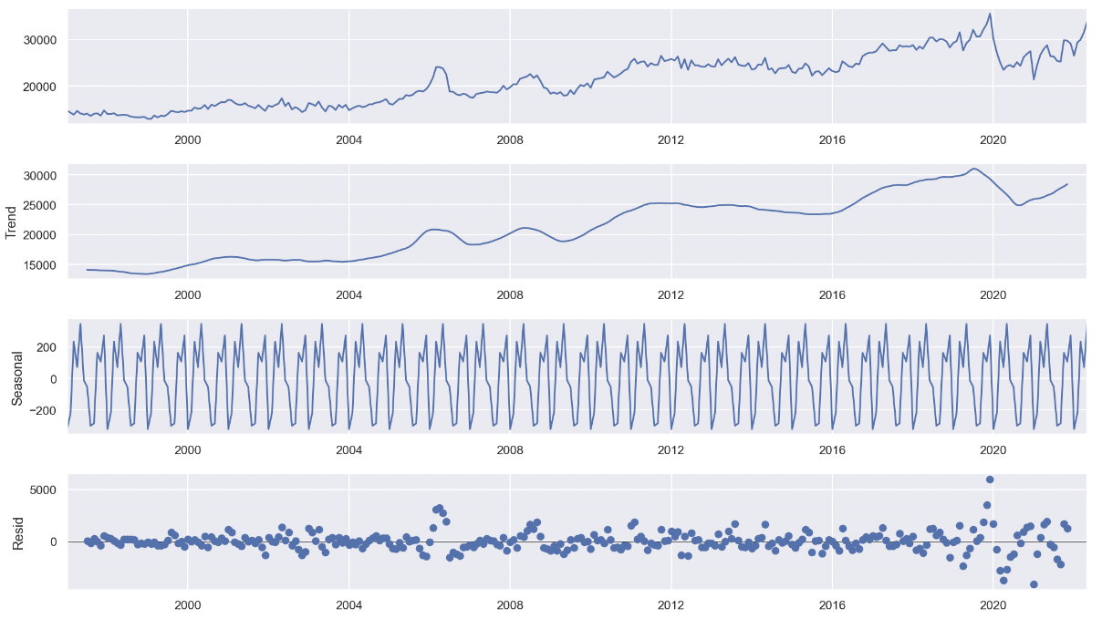

Figure A54: Seasonal Decompose plot for Exports in Goods Worldwide

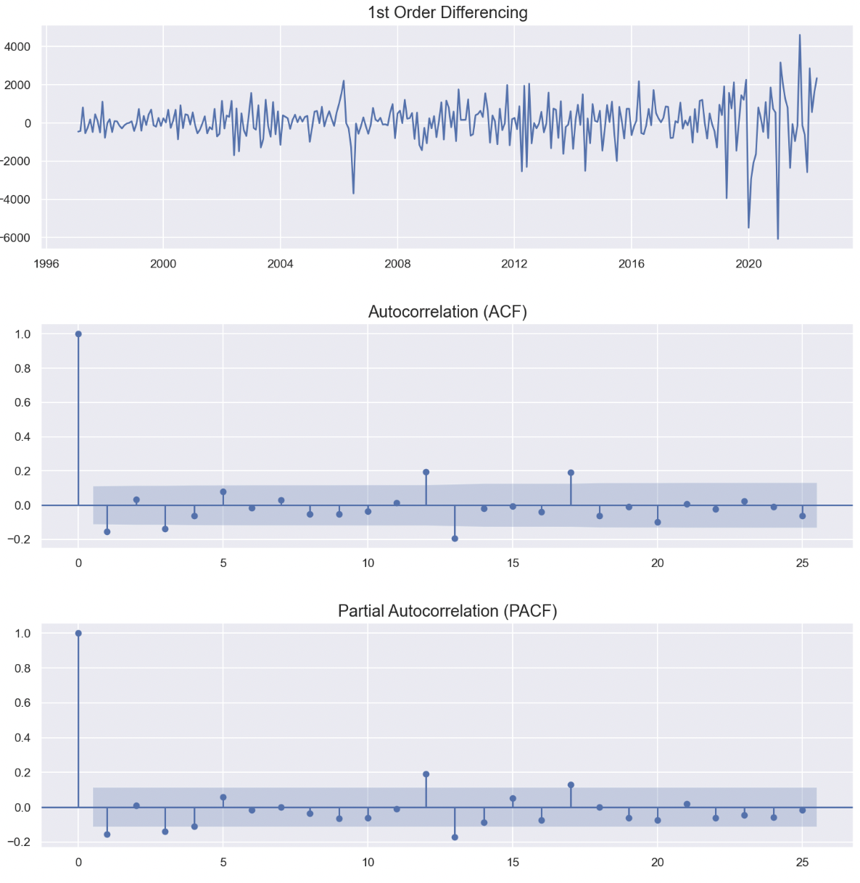

Figure A55: 1st Differencing - Partial Autocorrelation - Autocorrelation plots for Exports in Goods Worldwide

Table A9: Dickey Fuller test after differencing for Exports in Goods Worldwide

|  |  |
| --- | --- |
| **Dickey Fuller Test** | |
| Test Statistic | -4.136182 |
| p-value | 0.000843 |
| Number of Lags Used | 16.000000 |
| Number of Observations Used | 287.000000 |
| Critical Value (1%) | -3.453342 |
| Critical Value (5%) | -2.871664 |
| Critical Value (10%) | -2.572164 |